Annual Progress Report (APR)



2021 Air Quality Annual Progress Report (APR) for Falkirk Council In fulfilment of Part IV of the Environment Act 1995
Local Air Quality Management June 2021

Information | Falkirk Council Details
Local Authority Officer | John Millar
Department | Environmental Health
Address | Abbotsford House, Davids Loan, Falkirk FK2 7YZ
Telephone | 01324 504873
E-mail | JohnA.Millar@falkirk.gov.uk
Report Reference Number | Annual Progress Report 2021
Date | June 2021

Executive Summary: Air Quality in Our Area

Air Quality in Falkirk Council
In 2020, the air quality within the Falkirk Council area continued to be good from 2019.
The Falkirk Council air quality monitoring results for all pollutants measured have shown a decrease in National Air Quality Strategy (NAQS) objective exceedances from 2019 for all pollutants measured. There were two NAQS objective exceedances in 2019 and none were recorded throughout Falkirk Council’s extensive air quality monitoring network in 2020. Please note that travel has been subjected to various national and local restrictions during 2020 and 2021 as a result of the Coronavirus (COVID-19) pandemicRef 1.
An air quality summary report for Falkirk Council in relation to the Coronavirus (COVID-19) specific restrictions has been completed by Ricardo via the Scottish Air Quality website and can be viewed here: http://www.scottishairquality.scot/assets/documents//Falkirk_covid_analysis_updated.html
The Falkirk Town Centre Air Quality Management Action Plan (AQAP) was approved in June 2015 and focuses on long-term key point actions to reduce air pollution in the area rather than short-term fixes. Key measures outlined in the plan include:
- Reducing emissions from individual vehicles.
- Promoting the ECOStars Fleet Recognition Scheme.
- Promoting alternative and sustainable modes of transport.
- To educate and inform the public on air quality issues.

In 2020, Falkirk Council made significant progress in implementing these measures. To illustrate, there are now thirty-nine operational electric vehicle (EV) charging bays throughout the Falkirk Council area with an additional sixty-three (providing various charging capacities: 7, 22, 50, 150kW) being planned to be installed in various locations in the Falkirk Council area in the upcoming year. This action helps to promote alternative, sustainable modes of travel and to achieve measures included in Falkirk Council’s Climate Change and Sustainability Policies.
On the 10th August 2020, the Falkirk Stadium Vehicle Charging Hub was opened and became operational accepting electric vehicles to park and charge-up. The £1.4m facility

has charging capacity for twenty-six electric vehicles - 30% more than the second largest EV facility in Scotland which supports the Scottish Government’s ambition to phase-out the need for new petrol and diesel vehicles by 2032 as outlined in the Renewable and Low Carbon Energy Policy. The Falkirk Stadium Vehicle Charging hub is an integral part of Transport Scotland’s Electric A9 project with the overall aim of improving the electric vehicle charging infrastructure throughout Scotland.
Falkirk Council’s vehicle fleet was enhanced in 2020 which now includes two new electric minibuses and forty electric cars and vans. Further information on the Council’s new electric fleet can be found here: https://www.falkirk.gov.uk/employees/news/article.aspx?aid=6735
The Council also promoted a variety of active and sustainable travel measures in 2020/21 to help reduce overall local traffic emissions. Full details of the progress Falkirk Council is making towards these measures are outlined in Section 2 ‘Actions to Improve Air Quality’.
The 2020 air quality monitoring results (as displayed in Appendix A ‘Tables A.3’ and ‘A.4’) show that all seven automatic nitrogen dioxide (NO2) analysers in Falkirk Council’s air monitoring network achieved both NO2 NAQS (1hr and annual mean) objectives.
Falkirk Council measured particulate matter (PM10) concentrations at seven site locations during 2020. The relevant Scottish NAQS objectives for PM10 were achieved at all seven site locations.
The monitoring sites with the highest recorded annual mean PM10 concentrations in 2020 (but within the Scottish NAQS PM10 objective) were: Main Street, Bainsford (Roadside, 11µg/m3) and A4 Falkirk Haggs (Roadside, 10µg/m3). Over a five-year period (from 2016 to 2020), five sites have recorded PM10 (annual mean) concentration reductions, these were: A4 Falkirk Haggs, A5 Falkirk Hope Street (Roadside), A7 Falkirk West Bridge Street (Roadside), A8 Grangemouth AURN (Urban Background/Industrial) and A10 Grangemouth Municipal Chambers (Urban Background/Industrial). Two sites have recorded concentration increases, these were: A14 Banknock 3 (Urban Background) and A15 Main Street, Bainsford. In 2020, the A14 Banknock 3 monitoring site recorded the greatest number of daily exceedances (one) which remains the same exceedance count from Falkirk Council’s 2020 APR results. This result achieved the NAQS PM10 24-hr objective (50µg/m3 not to be exceeded more than seven times per year). The full results are shown in Appendix A, ‘Table A.6’. Over a five-year period (from 2016 to 2020), one site, A14 Banknock 3, has recorded a PM10 (24-hr mean) concentration reduction. Six

monitoring sites have remained at the same number of 24-hour mean exceedances (zero): A4 Falkirk Haggs, A5 Falkirk Hope Street, A7 Falkirk West Bridge Street, A8 Grangemouth AURN, A10 Grangemouth Municipal Chambers and A15 Main Street, Bainsford.
Particulate Matter (PM2.5) is measured at five site locations within the Falkirk Council area, these are: A4 Haggs, A7 Falkirk West Bridge Street, A8 Grangemouth AURN, A10 Grangemouth Municipal Chambers and A14 Banknock 3. Two sites: A5 Falkirk Hope Street and A15 Main Street, Bainsford have PM10-only monitoring data available for 2020 so a locally-derived correction ratio was used to calculate the PM2.5 results for these sites – further information on estimating PM2.5 results from PM10 measurements using monitoring data can be shown in Appendix C, ‘Supporting Technical Information / Air Quality Monitoring Data’, ‘QA/QC of Automatic Monitoring’,
During 2020 there were no exceedances of the PM2.5 Scottish NAQS objective limit (10µg/m3) at any of the monitoring sites.
The sites with the highest recorded annual mean PM2.5 concentrations in 2020 (within the Scottish NAQS PM10 objective) were: A15 Main Street, Bainsford (6.2µg/m³), A8 Grangemouth AURN (6µg/m3) and A4 Haggs (6µg/m3). Annual data capture was reasonable for A15 Main Street, Bainsford (80%), good for A8 Grangemouth AURN (94%) but very poor for A4 Haggs (29%).
The two sites with the lowest PM2.5 (annual mean) concentrations were: A14 Banknock 3 (3.6µg/m3) and A7 Falkirk West Bridge Street (4.4µg/m3) / A10 Grangemouth Municipal Chambers (4.4µg/m3). Data capture rates were poor for all sites at 63% and 38% / 63% respectively.
Over a five-year period (from 2016 to 2020) one site (A7 Falkirk West Bridge Street) has recorded a PM2.5 (annual mean) concentration reduction. One monitoring site (Banknock 3) has recorded a slight concentration increase. Five sites: A4 Haggs, A5 Falkirk Hope Street, A8 Grangemouth AURN, A10 Grangemouth Municipal Chambers and A15 Main Steet, Bainsford have remained at the same PM2.5 (annual mean) concentrations over this period.
Over a five-year period (from 2016 – 2020) the PM2.5 concentrations recorded at the Grangemouth AURN site remained at the same level of 6 µg/m3. 2019 saw a marginal concentration increase to 8µg/m3 however, this concentration remains reasonably low and within the Scottish NAQS (PM2.5 annual mean) objective. This reduction may be may be attributed to the commissioning of the Tail Gas Treatment (TGT) unit at the INEOS

Grangemouth complex in 2013. Since the commissioning of the TGT unit, SO2 concentrations have reduced within the Grangemouth AQMA. As sulphate species are known to contribute towards the formation of secondary PM2.5, a reduction in SO2 could also impact local PM2.5 concentrations.
In 2020, Falkirk Council monitored SO2 at six site locations. Four of the monitoring sites are located within the Grangemouth AQMA (declared for 15-minute SO2 NAQS objective) and two of the sites are located outwith this AQMA.
There were no exceedances of the SO2 NAQS objectives (15-minute, hourly or daily) recorded at any of the Falkirk Council monitoring site locations during 2020.
The site recording the only exceedance of the 15-minute SO2 NAQS objective during 2020 was Grangemouth AURN (six). No other SO2 exceedances were recorded at any of the other monitoring sites during 2020.
This is the seventh consecutive year that no exceedances of the SO2 NAQS objectives (15-minute, hourly or daily) have been recorded at any site in the Grangemouth AQMA. It is important to stress that although there were exceedances of the 15-minute and 1-hour NAQS objectives, the number of exceedances were below the maximum permitted.
The benzene and 1, 3-butadiene diffusion tube monitoring completed by Falkirk Council in 2020 met the NAQS (annual running mean) objectives for each pollutant respectively.
The Grangemouth Emission Study has now been completed by Sweco consultants and can be shown in Appendix C, ‘Additional Air Quality Works Undertaken by Falkirk Council During 2020’, ‘Grangemouth 2020 Emissions Study’.

Actions to Improve Air Quality
Falkirk Council made significant improvements to its air quality monitoring network during 2020. These improvements included upgrading three Rupprecht and Patashnick (R&P) Tapered Element Oscillating Microbalance (TEOM) particulate (PM10) analysers to combined (PM10+2.5) Palas Fidas 200 analysers at the Falkirk Hope Street, Main Street, Bainsford and Grangemouth Zetland Park sites. These upgrades enabled Falkirk Council to increase its PM2.5 monitoring capability to seven sites in total.
Two new air conditioning systems were installed in the Grangemouth AURN site to replace the older, smaller capacity units that were unsuitable for providing heating / cooling of the site throughout the year.

Scottish Government Local Air Quality Management (LAQM) contribution funding was provided for the commencement of a three-year study of PM2.5 airborne emissions and associated Poly Aromatic Hydrocarbons (PAH) from domestic solid fuel appliances (such as wood burning stoves) within the Falkirk Council area. This study would aim to offer a contribution to improving air quality in the local area and consequently aim to improve overall public health. We would envisage that if successful, the study could be replicated across all local authority areas and to help inform a national discussion within Scotland and further afield.
A new automatic zero scrubber unit was installed in the Bo’ness site to remove the requirement of supplying zero air gases to this site into the future.
The Falkirk Council Environmental Health department now own a fully electric van (Renault Kangoo ZE33), this van is used for all routine air quality site work. See photos below for equipment / vehicle upgrades.

Photo 1 Palas Fidas 200 Combined PM10+2.5 Analyser at the Falkirk Hope Street Site
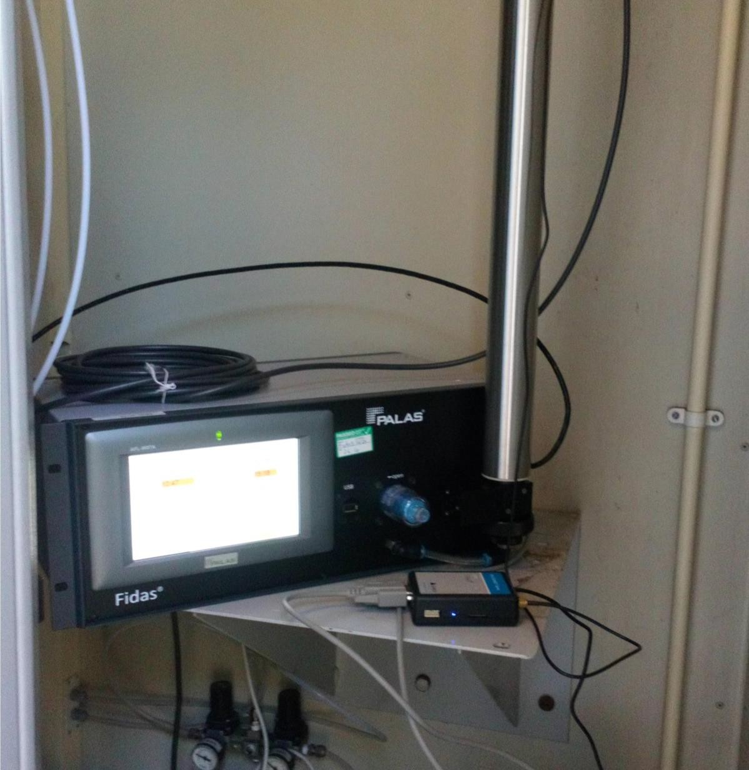

Photo 2 Palas Fidas 200 Combined PM10+2.5 Analyser at the Main Street, Bainsford Site
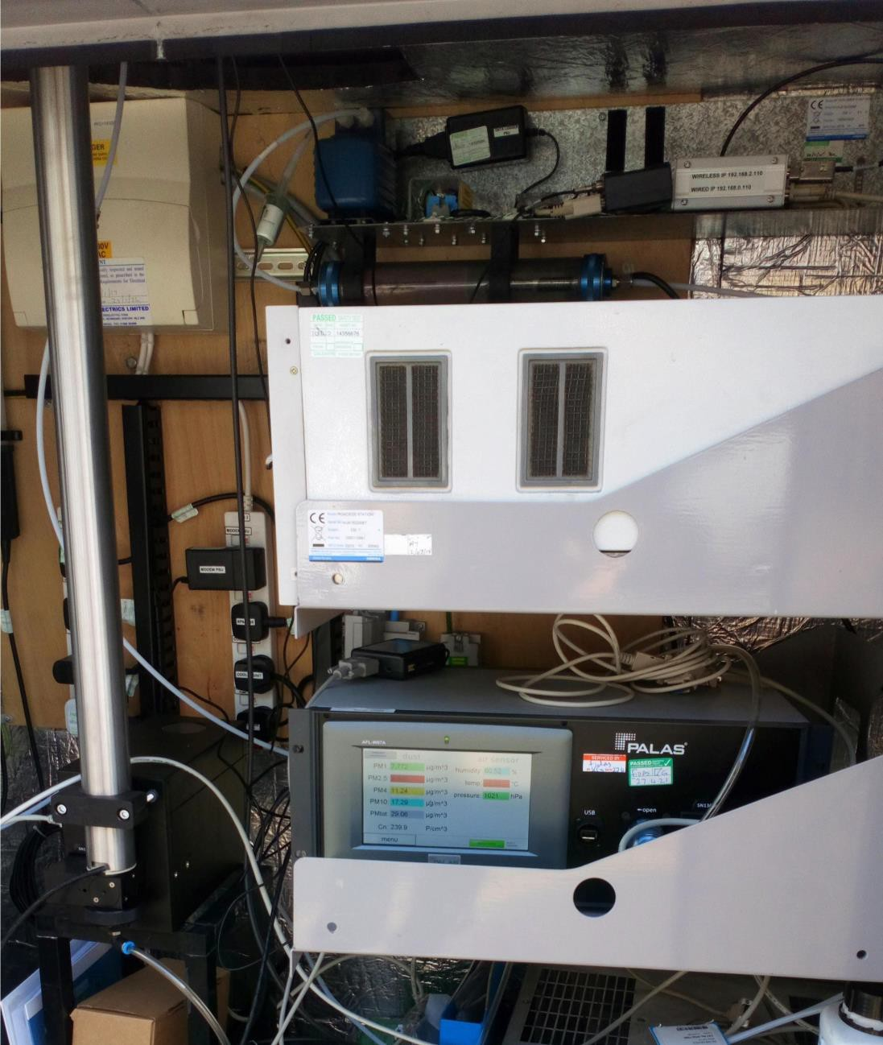

Photo 3 Palas Fidas 200 Combined PM10+2.5 Analyser at the Grangemouth Zetland Park Site
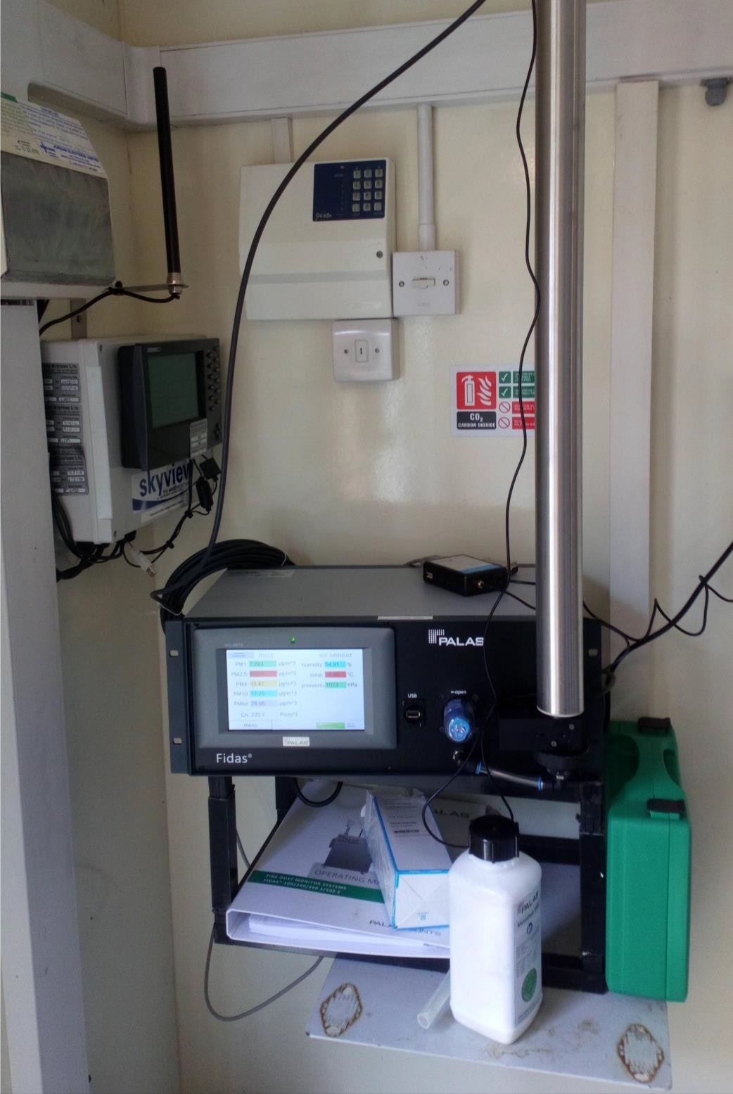

Photo 4 New Air Conditioning Units Installed at the Grangemouth AURN Site
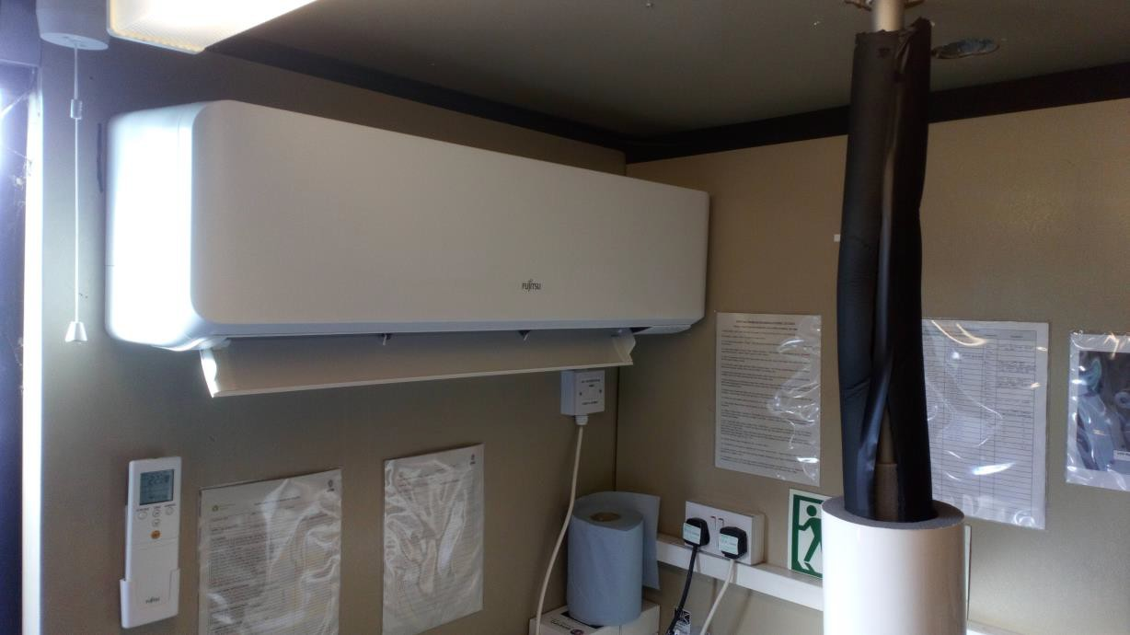
Photo 5 New Air Conditioning Units Installed at the Grangemouth AURN Site
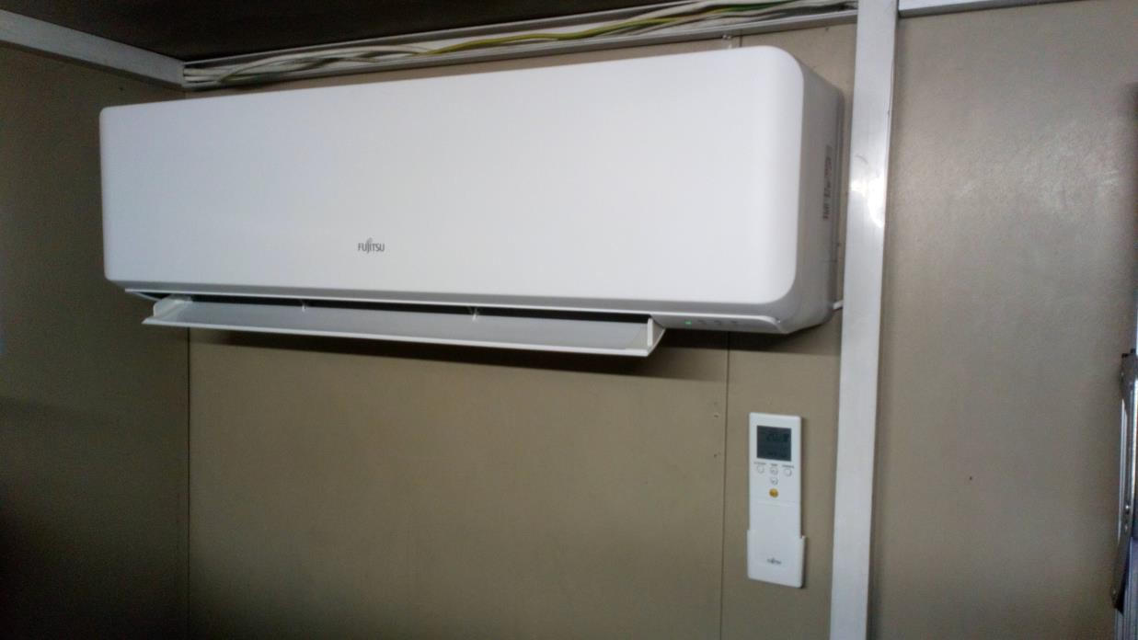

Photo 6 New Zero Air Scrubber Installed at the Bo’ness Site
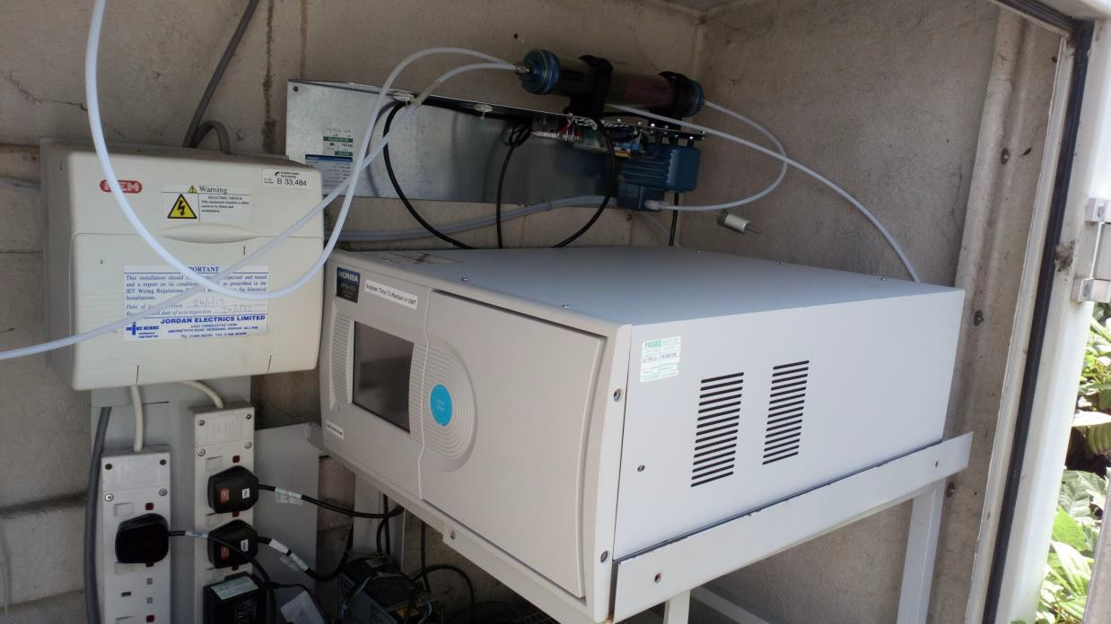

Photo 7 Falkirk Council Environmental Health – Fully Electric Van (Renault Kangoo ZE33)


ECOStars Fleet Recognition Scheme
Throughout 2020/21 Falkirk Council’s ECOStars fleet recognition scheme has grown significantly from 227 to 252 members. Falkirk Council’s ECOStars taxi scheme has a small but engaged membership of 7 members. ECOStars membership consists of vehicle fleet operators located within the Falkirk Council local authority area as well as those whose depots are located out with the Council boundary but operate vehicles within that area; all of these operators have an impact on local air quality. In addition, Falkirk Council has been working closely with fellow members of the East Central Scotland Vehicle Emissions Partnership (ECSVEP Switch Off and Breathe) to work to the objectives set out in the Scottish Government’s Cleaner Air for Scotland (CAFS, 2015) strategy. Air Quality Action Plan (AQAP) funding has been provided to continue the operation of the Falkirk ECOStars scheme (for fleet operators and taxis) during 2020/21.
Falkirk Council also continues to work closely with its partner organisations to manage local air quality issues. The Council works regularly with organisations such as SEPA, INEOS and Petroineos to help reduce exceedances of the SO2 NAQS objectives within the Grangemouth AQMA.

Local Priorities and Challenges

Education and Awareness of Air Quality Issues
In 2021 Falkirk Council will be developing our engagement with local schools through promotion of air quality education resources such as the ‘Learn About Air’ teaching package, promoting the Clean Air Day in Scotland and working closer with the Falkirk Council Transport Planning department on promoting alternative and sustainable local transport solutions.
Low Emission Zones

Low Emission Zones (LEZ) are currently being planned and operated in the four major Scottish cities: Glasgow, Edinburgh, Aberdeen and Dundee over the next few years. There are no current plans for any form of LEZ in the Falkirk Council area. Falkirk Council has undertaken the ‘Stage 1 Screening Exercise (clause 2.2.25)’ assessment in the 2020 APR in accordance with the Scottish Government’s National Low Emissions Framework to inform this process.

How to Get Involved
To obtain further information on air quality within the Falkirk Council area, please visit our air quality policy webpage:
http://www.falkirk.gov.uk/services/environment/environmental-policy/air-quality/

There are ten automatic air quality monitoring sites across the Falkirk Council area. The air quality data from all the monitoring sites (excluding Banknock 2 station) can be viewed on the Scottish Air Quality website at:
http://www.scottishairquality.co.uk/latest/summary?view=la

To learn more about the ECOStars Fleet Recognition Scheme and for details of how to join if you are a commercial fleet operator please visit:
https://www.ecostars-uk.com/eco-stars-schemes/

Table of Contents
Executive Summary: Air Quality in Our Area Error! Bookmark not defined.
- Air Quality in Falkirk Council Error! Bookmark not defined.

- Actions to Improve Air Quality iv
- Local Priorities and Challenges xi
- How to Get Involved xii
- Local Air Quality Management ...........................Error! Bookmark not defined.1
- Actions to Improve Air Quality 2
- 2.1 Air Quality Management Areas 2
- 2.2 Cleaner Air for Scotland 5
    - Transport – Avoiding travel – T1 5
    - Climate Change – Effective co-ordination of climate change and air quality policies to deliver co-benefits – CC2 6
- Progress and Impact of Measures to address Air Quality in Falkirk Council 6
- Air Quality Monitoring Data and Comparison with Air Quality Objectives 19
- 3.1 Summary of Monitoring Undertaken 19
    - Automatic Monitoring Sites 19
    - Non-Automatic Monitoring Sites 19
- 3.2 Individual pollutants 20
    - Nitrogen Dioxide (NO2) 20
    - Particulate Matter (PM10) 22
    - Particulate Matter (PM2.5) 23
    - Sulphur Dioxide (SO2) 25
    - Carbon Monoxide, Lead, 1,3-Butadiene and Benzene 26
- New Local Developments 27
- 4.1 Road Traffic Sources 27
    - Narrow Congested Streets 27
    - Busy Streets 27
    - Roads with High Flow or Buses and / or HGVs 27
    - Junctions 27
    - New Roads Constructed or Proposed 28
    - Roads with Significantly Changes Traffic Flows 28
    - Bus or Coach Stations 28
- 4.2 Other Transport Sources 28
    - Airports 28
    - Stationary Trains 29
    - Railways (Diesel and Steam Trains) 29
    - Ports for Shipping 29
- 4.3 Industrial Sources 30
- 4.4 Commercial and Domestic Sources 32
    - Biomass Combustion Plants 32
    - Biomass Combustion Plants - Combined Sources 32
    - Domestic Solid Fuel Burning 32
    - Combined Heat and Power (CHP) Plant… 33
- 4.5 New Developments with Fugitive or Uncontrolled Sources 33
- Planning Applications 34
- Impact of COVID-19 upon LAQM… 45
- Conclusions and Proposed Actions 47
- 6.1 Conclusions from New Monitoring Data 47
- 6.2 Conclusions relating to New Local Developments 51
- 6.3 Proposed Actions 61
Appendix A: Monitoring Results 63
Appendix B: Full Monthly Diffusion Tube Results for 2019 115
Appendix C: Supporting Technical Information / Air Quality Monitoring Data QA/QC 120
Glossary of Terms 298
References 300

List of Tables
Table 1.1 – Summary of Air Quality Objectives in Scotland 1
Table 2.1 – Declared Air Quality Management Areas 4
Table 2.2 – Progress on Measures to Improve Air Quality 8

Table A.1 – Details of Automatic Monitoring Sites 63
Table A.2 – Details of Non-Automatic Monitoring Sites 66
Table A.3 – Annual Mean NO2 Monitoring Results 71
Table A.4 – 1-Hour Mean NO2 Monitoring Results 75
Table A.5 – Annual Mean PM10 Monitoring Results 83
Table A.6 – 24-Hour Mean PM10 Monitoring Results 84
Table A.7 – Annual Mean PM2.5 Monitoring Results 91
Table A.8 – SO2 Monitoring Results 94
Table A.9 - 1,3 Butadiene Annual Mean Diffusion Tube Results… 105
Table A.10 - Benzene Annual Mean Diffusion Tube Results… 106
Table A.11 - Pumped Benzene Annual Mean Results… 107
Table A.12 - Estimated Annual Mean PM2.5 Results… 108
Table B.1 – NO2 Monthly Diffusion Tube Results for 2020 115
Table B.2 - 1,3 Butadiene Monthly Diffusion Tube Results… 118
Table B.3 - Benzene Monthly Diffusion Tube Results… 119
Table C.1 - Bias Adjustment Factor… 286
Table C.2 – Comparison of Local vs National Bias Adjustment Factor Summary… 287
Table C.3 – Details of the QA / QC at the Automatic Monitoring Stations… 291
Table C.4 – Locally Derived PM2.5/PM10 Correction Ratio 294
Table C.5 – Annualisation Summary… 295

Table C.6 – Annualisation Summary… 296
Table C.7 – Local Bias Adjustment Calculations… 297
List of Figures
Figure 1 - A4 Falkirk Haggs Long Term NO2 Concentrations… 75
Figure 2 - A5 Falkirk Hope St Long Term NO2 Concentrations… 76
Figure 3 – A7 Falkirk West Bridge St Long Term NO2 Concentrations… 77
Figure 4 - A8 Grangemouth AURN Long Term NO2 Concentrations… 78
Figure 5 - A9 Grangemouth Moray Long Term NO2 Concentrations… 79
Figure 6 - A10 Grangemouth Municipal Chambers Long Term NO2 Concentrations.80 Figure 7 - A15 Main St, Bainsford Long Term NO2 Concentrations… 81
Figure 8 - A4 Haggs Long Term PM10 (24-hour mean) Concentrations… 84
Figure 9 - A5 Falkirk Hope St Long Term PM10 (24-hour mean) Concentrations… 85
Figure 10 - A7 Falkirk West Bridge St Long Term PM10 (24-hour mean) Concentrations… 86
Figure 11 - A8 Grangemouth AURN Long Term PM10 (24-hour mean) Concentrations… 87
Figure 12 - A10 Grangemouth Municipal Chambers Long Term PM10 (24-hour mean) Concentrations… 88
Figure 13 - A15 Main St, Bainsford Long Term PM10 (24-hour mean) Concentrations… 89
Figure 15 - A7 Falkirk West Bridge St Long Term PM2.5 Concentrations… 91
Figure 16 - A8 Grangemouth AURN Long Term PM2.5 Concentrations… 92
Figure 17 - A3 Bo’ness Long Term SO2 Concentrations… 94
Figure 18 – A5 Falkirk Hope St Long Term SO2 Concentrations… 95
Figure 19 - A8 Grangemouth AURN Long Term SO2 Concentrations 96
Figure 20 - A9 Grangemouth Moray Long Term SO2 Concentrations 97
Figure 21 – A10 Grangemouth Municipal Chambers Long Term SO2 Concentrations… 98
Figure 22 – A11 Grangemouth Zetland Park Long Term SO2 Concentrations… 99
Figure 23 – Polar Plots of Average SO2 Concentrations Recorded at the Grangemouth Sites… 100
Figure 24 – Exceedances of the 15 Minute SO2 NAQS Objective Concentration at the Grangemouth Sites 2016 – 2020 103

Figure 25 – Maps of the AQMA Boundaries in the Falkirk Council Area 108
Figure 26 - Maps Showing Automatic Monitoring Locations… 111
Figure 27 - NO2 Locally Derived Bias Adjustment Factor Spreadsheets… 287
List of Photos
Photo 1 - Palas Fidas 200 Combined PM10+2.5 Analyser at the Falkirk Hope Street Site
… vi
Photo 2 - Palas Fidas 200 Combined PM10+2.5 Analyser at the Main Street, Bainsford Site vii
Photo 3 - Palas Fidas 200 Combined PM10+2.5 Analyser at the Grangemouth Zetland Park Site viii
Photo 4 - New Air Conditioning Units Installed at the Grangemouth AURN Site ix
Photo 5 - New Air Conditioning Units Installed at the Grangemouth AURN Site ix
Photo 6 - New Zero Air Scrubber Installed at the Bo’ness Site x
Photo 7 Falkirk Council Environmental Health – Fully Electric Van (Renault Kangoo ZE33)… x

Local Air Quality Management

This report provides an overview of air quality in Falkirk Council during 2020. It fulfils the requirements of Local Air Quality Management (LAQM) as set out in Part IV of the Environment Act (1995) and the relevant Policy and Technical Guidance documents.
The LAQM process places an obligation on all local authorities to regularly review and assess air quality in their areas, and to determine whether the air quality objectives are likely to be achieved. Where an exceedance is considered likely the local authority must declare an Air Quality Management Area (AQMA) and prepare an Air Quality Action Plan (AQAP) setting out the measures it intends to put in place in pursuit of the objectives. This Annual Progress Report (APR) summarises the work being undertaken by Falkirk Council to improve air quality and any progress that has been made.

Table 1.1 – Summary of Air Quality Objectives in Scotland

Pollutant | Air Quality Objective Concentration | Air Quality Objective Measured as | Date to be Achieved by
Nitrogen  dioxide (NO2) | 200 µg/m3 not to be exceeded more than 18 times a year | 1-hour mean | 31.12.2005
Nitrogen  dioxide (NO2) | 40 µg/m3 | Annual mean | 31.12.2005
Particulate  Matter (PM10) | 50 µg/m3, not to be exceeded more than 7 times a year | 24-hour mean | 31.12.2010
Particulate  Matter (PM10) | 18 µg/m3 | Annual mean | 31.12.2010
Particulate  Matter (PM2.5) | 10 µg/m3 | Annual mean | 31.12.2020
Sulphur  dioxide (SO2) | 350 µg/m3, not to be exceeded more than 24 times a year | 1-hour mean | 31.12.2004
Sulphur  dioxide (SO2) | 125 µg/m3, not to be exceeded more than 3 times a year | 24-hour mean | 31.12.2004
Sulphur  dioxide (SO2) | 266 µg/m3, not to be exceeded more than 35 times a year | 15-minute mean | 31.12.2005
Benzene | 3.25 µg/m3 | Running annual mean | 31.12.2010
1,3 Butadiene | 2.25 µg/m3 | Running annual mean | 31.12.2003
Carbon Monoxide | 10.0 mg/m3 | Running 8-Hour mean | 31.12.2003

Actions to Improve Air Quality

Air Quality Management Areas
Air Quality Management Areas (AQMAs) are declared when there is an exceedance or likely exceedance of an air quality objective. After declaration, the authority must prepare an Air Quality Action Plan (AQAP) within 12 months, setting out measures it intends to put in place in pursuit of the objectives.
Further information related to declared or revoked AQMAs, including maps of AQMA boundaries are available online at https://uk-air.defra.gov.uk/aqma/local- authorities?la_id=371 – see full list at https://uk-air.defra.gov.uk/aqma/list.
Falkirk Town Centre AQMA

The Falkirk town centre AQMA for NO2 (annual mean) remains justified as although there were no exceedances of the NO2 (annual mean) NAQS objective recorded in 2020 there have been consecutive diffusion tube exceedances (such as NA27 Falkirk West Bridge Street location) in previous years which haven’t been affected by Coronavirus (COVID-19) Scottish Government travel restrictionsRef1. One diffusion tube (NA27 Falkirk West Bridge Street) was close to the NAQS annual limit (40µg/m3) with the highest concentration of 35µg/m3 recorded in 2020.
There have been over five years where PM10 (24-hr and annual mean) results at both Falkirk Town Centre AQMA automatic monitoring locations (Falkirk Hope Street and Falkirk West Bridge Street) have complied with the PM10 NAQS objective. It is anticipated that the PM10 element (24-hr and annual mean) of the Falkirk Town Centre AQMA will be assessed for revocation eligibility during 2021.
Haggs AQMA

The Haggs AQMA was declared on the 18th March 2010 following NAQS exceedances for NO2 (annual mean). Since the AQMA was declared, measured concentrations (using automatic and non-automatic monitoring methods) of NO2 have complied with the NAQS objectives consistently over the past six years (since 2015). It is anticipated that the Haggs AQMA will be revoked in 2021. The ‘Falkirk Council Proposal for Revocation of Haggs

AQMA’ can be shown in Appendix C: ‘Supporting Technical Information / Air Quality Monitoring Data QA/QC’.
Grangemouth AQMA

Although the SO2 NAQS objectives have been achieved within the Grangemouth AQMA for seven consecutive years, Falkirk Council considers the AQMA remains justified based upon continual exceedances of the 15min SO2 NAQS objective concentration recorded at the A8 Grangemouth AURN, A9 Grangemouth Moray and A10 Grangemouth Municipal Chambers sites for the past five consecutive years. The Grangemouth Emission Study (which includes a review of the Grangemouth AQMA) has been completed by Sweco consultants and can be shown in Appendix C ‘Additional Air Quality Works Undertaken by Falkirk Council During 2020’.

Table 2.1 – Declared Air Quality Management Areas

AQMA Name | Pollutants and Air Quality Objectives | City / Town | Description | Action Plan
Falkirk Town Centre | NO2 annual mean  PM10 24-hour mean and annual mean | Falkirk | An area encompassing an area of Falkirk Town Centre | Air Quality Action Management Plan (Falkirk Town Centre and Haggs) 2015  Air Quality Management Action Plan (Falkirk Town Centre and Haggs) June 2015
Haggs | NO2 annual mean | Haggs | An area that connects Banknock and Haggs around the road junction of the A803 and M80 | Air Quality Management Plan (Falkirk Town Centre and Haggs) 2015  Air Quality Management Action Plan (Falkirk Town  Centre and Haggs) June 2015
Grangemouth | SO2 15-min mean | Grangemouth | An area encompassing the Grangemouth industry areas, shipping port and adjacent residential  areas | Air Quality Action Plan Update (Grangemouth) 2009  Available on request

Cleaner Air for Scotland
‘Cleaner Air for Scotland – The Road to a Healthier Future (CAFS)’ is a national cross- government strategy that sets out how the Scottish Government and its partner organisations propose to reduce air pollution further to protect human health and fulfil Scotland’s legal responsibilities as soon as possible. A series of actions across a range of policy areas are outlined, a summary of which is available on the Scottish Government’s website. Progress by Falkirk Council against relevant actions within this strategy is demonstrated below.

Transport – Avoiding Travel – T1
All local authorities should ensure that they have a corporate travel plan (within a carbon management plan or similar) which is consistent with any local air quality action plan.
Falkirk Council has a local transport strategy published in 2014 entitled Falkirk Council Local Transport Strategy. This strategy sets out the Council’s overall transport vision. This includes objectives directly related to providing sustainable transport options such as encouraging more travel by foot, bicycle, rail, and ensuring new transport infrastructure is delivered to support future sustainable travel choices. The Council also has a Road Safety Plan which is associated with the above strategy, it can be accessed here: Road Safety Plan.
Falkirk Council has an active travel scheme which promotes alternative transport methods to car. Projects completed with local communities in 2020 include:
- Take the Right Route: utilising online marketing campaigns, extensive local bus / newspaper / business advertising and social media presence incorporating market research feedback.
- Green Travel Map: The map covers the main built up areas and highlights many routes which are suitable for both walkers and cyclists. They include cycle paths, shared use paths and canal towpaths, amongst others.
- Town Centre First: Bus Promotion Initiative: Partnership between Falkirk Council, Falkirk Delivers (Town Centre Management team) and First Bus. The aim of the project is to encourage bus travel and for the community to think 'shop local first'. Both bus use and local shopping has rapidly declined nationwide over the last

decade. The Coronavirus (COVID-19) pandemicRef 1 has accelerated this decline. The ‘Town Centre First’ project aims to assist in overcoming this decline and encourage support for both bus use and localised shopping habits.
- School engagement: Promote the National bi-annual Walk to School campaign (May and October) to all primary schools in the Falkirk Council area. Falkirk Council have been promoting the ‘Walk to School Campaign’ since 2004. In 2020, Falkirk Council achieved 100% school engagement. We will continue to sustain this high level of engagement with working towards the primary outcome of more people choosing to walk or cycle for short, local journeys.
- Walk to School campaigns delivered to fifty primary schools in the Falkirk Council area in 2020.
- Falkirk Active Travel Hub (Forth Environment Link) is in Falkirk town centre (203 High Street, Falkirk, FK1 1DU) and is open to the public to increase awareness of active travel throughout the region.

Climate Change – Effective co-ordination of climate change and air quality policies to deliver co-benefits – CC2
Scottish Government expects any Scottish local authority which has or is currently developing a Sustainable Energy Action Plan to ensure that air quality considerations are covered. Falkirk Council has a dedicated Climate Change and Sustainability team and associated webpage which outlines what the Council has completed and what they are committed to achieving. The webpage also provides links to:
- Sustainable Procurement including a Procurement Strategy 2020 - 2023.
- Sustainable Transport including the Falkirk Area Green Travel Map.
- Sustainable Falkirk including the Sustainable Falkirk Map.
The webpage also provides a link to the Council’s Carbon Management Plan 2015 - 2021.

Progress and Impacts of Measures to address Air Quality in Falkirk Council
Falkirk Council has taken forward several measures during the current reporting year of 2020 in pursuit of improving local air quality. Details of all measures completed, in progress or planned are set out in Table 2.2. More details on these measures can be found in the AQAP relating to each AQMA. Key completed measures are:

- Measure 4: Monitoring network requirements reviewed and upgraded where necessary such as upgrading three R&P TEOM PM10 particulate analysers to combined (PM10+2.5) Palas Fidas 200 analysers at the following sites: Falkirk Hope Street, Main Street, Bainsford and Grangemouth Zetland Park.
- Measure 5: New Environmental Health fully electric van (Renault Kangoo ZE33) now in use for all air quality site work within the Falkirk Council area.
- Measure 16: Continuation and increased members of the ECOStars Fleet Recognition scheme.
Falkirk Council expects the following measures to be completed over the course of the next reporting year:
- Review of Falkirk Town Centre (PM10) AQMA with potential revocation (reduction of Falkirk Council AQMAs from three to two).
- Dedicated and tailored air quality data collection system with secure webpage log-in for data security and back-up which can be used on multiple devices.
- Replacement of older (NOX and SO2) analysers with new models (providing increased accuracy, availability of spares, less breakdowns and expensive maintenance visits etc.).
- Continuation of ECOStars Fleet Recognition Scheme with new members added (Increased fleet efficiency measures / knowledge) – Scottish Government AQAP funding dependant.

Table 2.2 – Progress on Measures to Improve Air Quality

Meas. No. | Measure | Category | Focus | Lead Authority | Planning Phase | Impleme- ntation Phase | Key Performance Indicator | Target Pollution Reduction in the AQMA | Progress to Date | Estimated Completion Date | Comments
1 | Improving SO2 data access | Public Information | Supplying SO2 monitoring data to SEPA, Petroineos, INEOS and other interested organisations. | Falkirk Council | 2013 | 2013 | AQ Objectives met during 2016-2020. | Anticipated reduction in SO2 concentration/ breaches of NAQS  objectives. | Data sent after Grangemouth SO2  exceedances- monthly summary reports sent with ongoing totals. | Completed, and monthly reports ongoing.
2 | Grangemouth Working Group | Policy Guidance and Developmen t Control | Bringing together: Petroineos, INEOS, S. Gov, SEPA  and Falkirk Council. | Falkirk Council | 2013 | 2013 | AQ Objectives met in during 2016-2020. | Reduction in SO2 due to cooperative working and agreement of priorities. | Completed.  TGU fully commissioned in August 2013, meeting held in November 2013. Further meeting only if breach of objective occurs. | Completed.

3 | Text Alert System | Public Information | Real-time notification of exceedances by SMS and Email. | Falkirk Council | 2013 | 2013 | Text alerts received by Falkirk Council, SEPA,  Petroineos and INEOS when an NAQS objective exceedance occurs within the Grangemouth AQMA. | Anticipated reduction in SO2 NAQS objective exceedances due to real time alerts of exceedances supplied to SEPA,  Petroineos and INEOS so action to rectify any plant emission / process issues can be addressed. | Completed and on-going. | Completed in 2013 / Upgraded in 2018 | Rather than a text alert system linked to individual analysers this system has been upgraded in 2018 to incorporate the Council’s data collection system and can be used for any measured pollutant.
4 | Review Monitoring Network | Public Information | Grangemouth Moray SO2 in Scottish Air Quality Network (SAQN). | Falkirk Council | Falkirk Park St ceased operation in April 2014. | 2014 and  2015 | All Grangemouth automatic monitoring sites are affiliated with the SAQN. | Affiliation with the SAQN increases data capture allowing better comparison to the NAQS objectives. | Completed.  In addition, the Bo’ness, Falkirk Graham’s Rd, and Main St, Bainsford stations were | Completed.

 |  |  | Monitoring conducted in Grangemouth Zetland Park. |  | Zetland Park commen ced operation April 2015. |  |  |  | affiliated to the SAQN in 2016.
5 | Electric Vehicles and Plug-ins | Promoting Low Emission Transport | Cars / Fleet | Falkirk Council | 2012 | 2012 and on-going | Charging points at Falkirk Council depots | Anticipated reduction in NOX and PM emissions due to increased use of electric vehicles. | In 2020, the EV charging point bays increased to 39. These are located at depots and public places across the Falkirk Council area. There are 63 being planned in coming year.  Falkirk Council increased its electric vehicle fleet to 42 available for use by Council staff. | Completed and on-going | The air quality team within the Env. Health Department at Falkirk Council have received a new fully electric (Renault Kangoo ZE33) van in June 2019 – further details provided in Section ‘Actions to  Improve Air

 |  |  |  |  |  |  |  |  |  |  | Quality’, page v
6 | Eco-advanced Driver Training | Promoting Low Emission Transport | All types of vehicle, fuel use and emissions | Falkirk Council | 2014 | 2015 | Offered to Council services by fleet | Anticipated reduction in NOX and PM emissions due to promotion of efficient driving practices. | Offered to Council services by fleet. | Completed and on-going training offered.
7 | Review of School Bus Contracts with View to Raising EURO Engine  Standards | Vehicle Fleet Efficiency | Buses | Falkirk Council | 2017 | 2021 | n/a | Anticipated reduction in NOX and PM emissions from buses operating within the Falkirk Council area. | Meetings to be arranged in 2021/22 with Public Transport Co-ordinator and Procurement Services to discuss the feasibility of raising the EURO  standards for local and school bus contracts from 2021 onwards. | 2021

8 | Improvements of Traffic Lights at Bankside | Transport Planning and Infrastructur e | Congestion | Falkirk Council | 2013 | 2014 | n/a | Anticipated reduction in NOX and PM emissions due to traffic queue reduction at Bankside traffic lights. | Completed. | Completed.
9 | Feasibility Study of Haggs Infrastructure Changes | Transport Planning and Infrastructur e | Congestion | Falkirk Council | Depende nt on develope r contributi ons and planning applicatio ns. | Dependent on developer contributio ns and planning application s. | n/a. | Anticipated reduction in NOX and PM emissions. | Dependent on developer contributions and planning applications. | Dependent on developer contributions and planning applications. Future action.
10 | Feasibility study of West Bridge St and Town Centre Traffic Management Changes (speed limits, TROs etc.) | Transport Planning and Infrastructur e | Congestion | Falkirk Council | n/a | n/a | n/a | Anticipated reduction in NOX and PM emissions. | This measure was linked to a planning application to build new council offices at Falkirk Town Centre Municipal  Buildings. | Completed

 |  |  |  |  |  |  |  |  | However, this project is still being decided upon. However, traffic signals along West Bridge St have been altered to improve traffic flows.
11 | Take the Right Route / Walk to School & School Travel Plan Pack | Promote Travel Alternatives | Car travel | Falkirk Council | 2009 | 2013 and ongoing | Scheme in place and publicly advertised on Falkirk Council website. | Anticipated reduction in NOX and PM emissions due to an increase in green travel such as walking and cycling. | In 2020 Take the Right Route continually promoted across the Falkirk Council area with on street interviews, online campaigns, bus and newspaper advertising and leaflets distributed. | Completed and on- going.
12 | Bike Hire Scheme | Promote Travel Alternatives | Mode transfer | Falkirk Council | 2016 | 2018 | Unknown | Anticipated reduction in NOX and PM  emissions due | Forth Bike (in conjunction with Forth  Environment | Completed. Forth Bike scheme  established

 |  |  |  |  |  |  |  | to an increase in green travel alternatives. | Link) operates an electric bike hire scheme within the Falkirk and Stirling area The Forth Bike system currently includes over one hundred electric pedal assist (Pedelec) bikes spread between their four local stations: the Falkirk Wheel, the Helix, Forth Valley Royal Hospital, and University of Stirling. | and running in 2020.  Expansion of the scheme expected in future years.
13 | Soft Measures  e.g. travel planning (larger employers, schools), journey  sharing, | Promote Travel Alternatives | Variety | Falkirk Council | 2006 | 2014 | Development of Travel Plans | Anticipated reduction in NOX and PM emissions due to promotion of travel alternatives. | Increased fuel efficient and electric pool car vehicles for staff use as part of Council’s travel plan | On-going

 | changes to mileage, home and mobile working. |  |  |  |  |  |  |  | Operational car sharing database for Falkirk Council area.
14 | Consideration of Air Quality in Local Development Plan | Policy Guidance and Developmen t Control | Development | Falkirk Council | 2015 | 2015 | Air quality policy statement in local development plan | Air Quality Assessment required for developments within AQMAs. | Air quality policy statement in plan. | Completed
15 | Appropriate Air Quality Monitoring in AQMAs. | Public Information | Improving data capture. | Falkirk Council | 2005 | 2005 | Good data capture (90%) in AQMAs | Good data capture will allow strict comparison of PM10, PM2.5, SO2, NOX  concentrations against the NAQS  objectives. | Monitoring maintained in AQMAs.  Equipment upgrades completed during 2020. | Completed and on-going
16 | Promotion of ECO Stars | Vehicle Fleet Efficiency | Commercial vehicles, taxis and private hire cars. | Falkirk Council | 2013 | 2013 and on-going | The latest Falkirk Eco Stars report shows that  recruitment in | Anticipated reduction in NOX and PM emissions due  to promotion of | During 2020, reference to EcoStars is now included in the  tender | On-going

 |  |  |  |  |  |  | Falkirk has 227 members. | efficient driving practices. | specification for Falkirk Council Adult and Children’s Service passenger transport.  Member meetings were held regularly during 2020.
17 | Review of Park and Ride Facilities | Transport Planning and Infrastructur e | Cars | Falkirk Council | 2017 | 2018 | Ongoing. | Anticipated reduction in NOX and PM emissions. | There is currently no progress in taking forward any new bus park and ride facilities.  However, additional parking has been created at Falkirk High and Larbert train stations to help improve park and ride facilities. | Completed and on-going

18 | Taxi Licensing | Vehicle Fleet Efficiency | Taxis | Falkirk Council | 2013 | 2015 | Increase in taxi services signed up to Eco Stars Scheme. | Anticipated reduction in NOX and PM emissions due to promotion of efficient driving and vehicles. | Changes to licensing in May 2013 and Eco Stars extended to taxis and private hire cars. | On-going
19 | Vehicle Emissions Partnership (testing and idling) - enforcement and fines rather than raising awareness. | Promoting Low Emission Transport | Cars | Falkirk and other neighbouri ng authorities. | 2012 | 2012 and on-going | Maintain membership of the partnership. | Anticipated reduction in NOX and PM emissions through anti- idling enforcement. | The ESVEP  continues to assist in promoting anti idling in the Falkirk Council area.  Improvements of the associated ‘Switch Off and Breathe’ website have taken place. | On-going subject to annual funding allocation.
20 | Introduce Quality Bus Corridors | Transport Planning and Infrastructur e | Buses | Falkirk Council | 2017 | On-going depending on funding to complete the scheme. | Unknown | Anticipated reduction in NOX and PM emissions through improved public transport. | The Council has secured areas of land along the A803 Glasgow Road corridor in Camelon. In addition to this | 2030

the Council has updated the traffic signals on the B902 Grahams Road corridor
to “intelligent” traffic signals which better manage the flows of traffic increasing green time along the main corridor, the knock on effect of this improves bus journey times into the town centre.

Air Quality Monitoring Data and Comparison with Air Quality Objectives

Summary of Monitoring Undertaken

Automatic Monitoring Sites

This section sets out what monitoring has taken place and how local concentrations of the main air pollutants compare with the NAQS objectives.
Falkirk Council undertook automatic (continuous) monitoring at ten sites during 2020. Table A.1 in Appendix A shows the details of the sites. National monitoring results are available at http://www.scottishairquality.scot/.
Maps showing the location of the monitoring sites are provided in Appendix A, Figure 25
A) to F). Further details on how the monitors are calibrated and how the data has been adjusted are included in Appendix C ‘Supporting Technical Information / Air Quality Monitoring Data QA/QC’.

Non-Automatic Monitoring Sites

Falkirk Council undertook non-automatic (passive) monitoring of NO2 at sixty-one sites during 2020. Table A.2 in Appendix A shows the details of the sites.
Falkirk Council also undertook non-automatic (passive) monitoring of 1, 3 butadiene at three sites during 2020. Table A.9 in Appendix A shows the details of the 1, 3 butadiene sites.
In addition, Falkirk Council also undertook non-automatic (passive) monitoring of benzene at sixteen sites during 2020. Table A.10 in Appendix A shows the details of the benzene sites.
Maps showing the location of the monitoring sites are provided in Appendix A, Figure 26
A) to C). Further details on Quality Assurance/Quality Control (QA/QC) and bias adjustment for the diffusion tubes are included in Appendix C ‘Supporting Technical Information / Air Quality Monitoring Data QA/QC’.

LAQM Annual Progress Report 2021

Individual Pollutants
The air quality monitoring results presented in this section are, where relevant, adjusted for annualisation and bias. Further details on adjustments are provided in Appendix C ‘Supporting Technical Information / Air Quality Monitoring Data QA/QC’.

Nitrogen Dioxide (NO2)

Table A.3 in Appendix A compares the ratified and adjusted monitored NO2 (annual mean) concentrations for the past five years with the NAQS objective limit of 40 µg/m3.
For diffusion tubes, the full 2020 dataset of monthly mean values is provided in Appendix B ‘Full Monthly Diffusion Tube Results for 2020’.
Table A.4 in Appendix A compares the ratified continuous monitored NO2 hourly mean concentrations for the past five years with the air quality objective of 200µg/m3, not to be exceeded more than 18 times per year.
NO2 Automatic Analyser Results
The 2020 monitoring results (as displayed in Appendix A Tables A.3 and A.4) show that all seven automatic NO2 analysers in the Falkirk Council’s air monitoring network met both NO2 NAQS objectives (1hr and annual mean). The highest NO2 annual mean result in 2020 was recorded at the Falkirk West Bridge Street site (27µg/m3) - this result has decreased (11 µg/m3) from 2019’s result (38µg/m3). The lowest result was recorded at the Grangemouth AURN (11µg/m³) site. The Grangemouth AURN NO2 annual mean result has decreased from 15µg/m³ in 2019. Overall, all fixed automatic site’s NO2 concentrations have decreased significantly from 2019’s results however, this is most likley to be attributed to the Coronavirus (COVID-19) travel restrictionsRef1 which commenced in late March 2020 and continued into 2021. This resulted in less daily vehicle trips due to the ‘Stay at Home’ Scottish Government advice. The last exceedance in relation to NO2 annual mean concentrations was recorded in 2014 at the Falkirk West Bridge Street site (41µg/m3).
Over a five year period (from 2016 to 2020), all seven monitoring sites have recorded annual mean NO2 concentration reductions. There have been minor fluctuations in results during this period but all remain within the NO2 NAQS (1hr and annual mean) objecvtives.
Long term NO2 trend graphs are shown in Appendix A, Figures 1 to 7. There is an overall downward trend in NO2 (annual mean) concentrations at the following monitoring sites: A4

Haggs (Figure 1), A5 Falkirk Hope Street (Figure 2), A10 Grangemouth Municipal Chambers (Figure 6) and A15 Main Street Bainsford (Figure 7). A8 Grangemouth AURN (Figure 4) trend has largely remained at the same concentration. The A7 Falkirk West Bridge Street (Figure 3) site shows flucuations upwards and downwards over this time period.
Likely contributing factors to the reduction in NO2 concentrations at the above sites include the Coronavirus (COVID-19) pandemicRef 1 in March 2020 to 2021 (resulting in less road traffic), traffic-light timing amendments (on Falkirk West Bridge Street) to minimise congestion and prevent excessive idling (within the Falkirk town centre area), road upgrades (M80 at Haggs) and speed limit enforcement measures (30mph on the A803).
Increased ownership of hybrid and electric vehicles may also have contributed to the overall NO2 reduction.
Annual NO2 Diffusion Tube Results
The 2020 annual NO2 diffusion tube monitoring results (as displayed in Appendix A Table A.3) shows that no (non-automatic) NO2 tubes exceeded the NAQS (annual mean) objective limit of 40µg/m³. All sixty-one tubes in Falkirk Council’s network met the NO2 NAQS (annual mean) objective.
One diffusion tube was close to the 40µg/m3 annual limit with the highest concentration recorded at the NA27 Falkirk West Bridge Street (35µg/m3) site. This tube is located within the Falkirk Town Centre AQMA at a roadside location.
Diffusion tube NA27 is co-located with the Falkirk West Bridge Street fixed automatic monitoring station. This site contains a NO2 reference method (Chemiluminescence) analyser (API Teledyne T200) which has recorded an annual NO2 concentration of 27µg/m3 during 2020. The reference analyser result is significantly lower than the diffusion tube for 2020.
Historically, diffusion tube NA27 Falkirk West Bridge Street records a higher concentration than the automatic analyser despite the close proximity to one another. The most likely reason for a higher concentration at this location is that the automatic site is located at a further distance from the road than the NA27 tube location and is therefore less exposed to traffic emissions. The NA27 Falkirk West Bridge Street diffusion tube concentrations regularly exceeds the NAQS objective for NO2 - this is the second occasion over a five year period that the result has complied with the NAQS objective for NO2.

The lowest NO2 annual mean diffusion tube concentrations in 2020 were recorded at the following locations: NA105 West of Shieldhill (Rural, 6µg/m3) and NA64 New Hallglen Road, Falkirk (Urban Background 11µg/m3).
In addition, the diffusion tubes are affected by several sources of interference which can cause substantial under or overestimation (often referred to as “bias”) compared to the automatic NO2 (chemiluminescence) reference analyser (as defined within the EU as the reference method)^{Ref} ². Due to this, NO2 concentrations recorded using diffusion tubes are typically of lower accuracy than that recorded by the reference method using automatic (chemiluminescence) NO2 analysers.

Particulate Matter (PM10)

Table A.5 in Appendix A compares the ratified and adjusted monitored PM10 annual mean concentrations for the past five years with the PM10 NAQS (annual mean) objective of 18µg/m3.
Table A.6 in Appendix A compares the ratified continuous monitored PM10 daily mean concentrations for the past five years with the PM10 NAQS (24-hr mean) objective of 50µg/m3, not to be exceeded more than seven times per year.
Falkirk Council measured PM10 concentrations at seven locations during 2020. The relevant Scottish NAQS objectives for PM10 were met at all seven locations.
The sites with the highest recorded annual mean PM10 concentrations in 2020 (but within the Scottish NAQS PM10 objective) were: A4 Falkirk Haggs (10µg/m³) and A15 Main Street, Bainsford (11µg/m3). Overall annual data capture was good for two of these sites (A5 Falkirk Hope Street: 87% and A8 Grangemouth AURN: 97%) . The Falkirk West Bridge Street site recorded low PM10 annual data capture of 38%, this was due to a significant communications fault between the Palas Fidas 200 analyser and the onsite datalogger with the Fidas being removed from site for a prolonged period for workshop investigation in May 2020. Lower than average annual data capture was recorded for Falkirk Haggs (56%), Grangemouth Municipal Chambers (63%) and Main Street, Bainsford (80%), this was due to the transition from removing R&P TEOM PM10 analysers to installing the upgraded Palas Fidas 200 analysers in late 2020. Low annual data capture was also recorded at Banknock 3 (63%) - this was due to an overdue service/data clearing issue with the Turnkey Osiris analyser as Falkirk Council were unable to enter residential premises due to Coronavirus (COVID-19) restrictionsRef 1.

The two sites with the lowest PM10 (annual mean) concentrations were: A14 Banknock 3 (7.8µg/m3) and A7 Falkirk West Bridge Street (8.4µg/m3). Data capture rates were poor for both sites at 63% and 38% respectively.
Over a five year period (from 2016 to 2020), five sites have recorded PM10 (annual mean) concentration reductions, these were: A4 Falkirk Haggs, A5 Falkirk Hope Street, A7 Falkirk West Bridge Street, A8 Grangemouth AURN and A10 Grangemouth Municipal Chambers. Two sites have recorded concentration increases, these were: A14 Banknock 3 and A15 Main Street, Bainsford.
In 2020, the A14 Banknock 3 monitoring site recorded the greatest number of daily exceedances (one) which remains the same exceedance count from 2019’s result. This result is within the NAQS PM10 24-hr objective (50µg/m³ not to be exceeded more than seven times per year). The full results are shown in Appendix A, Table A.6.
Over a five year period (from 2016 to 2020), one site (A14 Banknock 3) has recorded a PM10 (24-hr mean) concentration reduction. The remaining six sites have remained at the same number of PM10 24-hour mean exceedances (zero): A4 Falkirk Haggs, A5 Falkirk Hope Street, A7 Falkirk West Bridge Street, A8 Grangemouth AURN, A10 Grangemouth Municipal Chambers and A15 Main Street, Bainsford.

Particulate Matter (PM2.5)

Table A.7 in Appendix A compares the ratified and adjusted monitored PM2.5 (annual mean) concentrations for the past five years with the PM2.5 NAQS (annual mean) objective limit of 10µg/m3.
PM2.5 is measured at five locations within the Falkirk Council area, these are: A4 Haggs, A7 Falkirk West Bridge Street, A8 Grangemouth AURN, A10 Grangemouth Municipal Chambers and A14 Banknock 3. Two sites: A5 Falkirk Hope Street and A15 Main Street, Bainsford have PM10-only monitoring data available for 2020 so a locally derived correction ratio was used to calculate PM2.5 results for these sites – further information on estimating PM2.5 from PM10 measurements can be shown in Appendix C, ‘Supporting Technical Information / Air Quality Monitoring Data QA/QC’, ‘QA/QC of Automatic Monitoring’,
During 2020 there were no exceedances of the PM2.5 Scottish NAQS (annual mean) objective limit (10µg/m3) at any of the monitoring sites.

The sites with the highest recorded PM2.5 (annual mean) concentrations in 2020 (within the Scottish NAQS PM10 annual mean objective) were: A15 Main Street, Bainsford (6.2µg/m³), A8 Grangemouth AURN (6µg/m3) and A4 Haggs (6µg/m3). Annual data capture was reasonable for A15 Main Street, Bainsford (80%), good for A8 Grangemouth AURN (94%) but very poor for A4 Haggs (29%).
The two sites with the lowest PM2.5 (annual mean) concentrations were: A14 Banknock 3 (3.6µg/m3) and A7 Falkirk West Bridge Street (4.4µg/m3) / A10 Grangemouth Municipal Chambers (4.4µg/m3). Data capture rates were poor for all sites at 63% and 38% / 63% respectively.
Over a five year period (from 2016 to 2020) one site (A7 Falkirk West Bridge Street) has recorded a PM2.5 (annual mean) concentration reduction. One monitoring site (Banknock 3) has recorded a slight concentration increase. Five sites: A4 Haggs, A5 Falkirk Hope Street, A8 Grangemouth AURN, A10 Grangemouth Municipal Chambers and A15 Main Steet, Bainsford have remained at the same concentrations over this period.
The PM2.5 concentrations at the Grangemouth AURN site have, in general, remained at the same level of 6µg/m3. 2019 saw a marginal concentration increase to 8µg/m3 however, this concentration remains reasonably low and within the Scottish PM2.5 NAQS (annual mean) objective. This reduction may be may be attributed to the commissioning of the Tail Gas Treatment (TGT) unit at the INEOS Grangemouth complex in 2013. Since the commissioning of the TGT unit, SO2 concentrations have reduced within the Grangemouth AQMA. As sulphate species are known to contribute towards the formation of secondary PM2.5, a reduction in SO2 could also impact local PM2.5 concentrations.
Long-term trend analysis has been completed on two sites for PM2.5 (data availability dependant) and can be shown in Appendix A, Figures 15 and 16. In general terms, there has been a long-term reduction in PM2.5 concentrations at the A7 Falkirk West Bridge Street and A8 Grangemouth AURN site and since 2016.
To appraise compliance with the PM2.5 NAQS (annual mean) objective at locations that currently do not monitor PM2.5 concentrations, Falkirk Council has previously applied locally derived correction factors of 0.5 (non-urban roadside), 0.57 (urban roadside) and
0.67 (urban background / industrial) following LAQM TG(16)Ref 2 guidance. This methodology provides an estimation of PM2.5 results derived from PM10 data where only one of the two metrics were available. For urban roadside sites the correction factor was derived using PM data from the A7 Falkirk West Bridge Street site, for the background / industrial sites the factor was derived using PM data from the A8 Grangemouth AURN site

and for non-urban roadside sites the correction factor was derived using PM data from the A13 Banknock 2 site. For further details of these factors see Appendix C, ‘Table C.1’.
During 2020, the PM2.5 concentration estimations indicate that the two sites (A5 Falkirk Hope Street and A15 Main Street, Bainsford) where the correction factor was applied complied with the PM2.5 NAQS (annual mean) objective. See Appendix A ‘Table A.12’ for a full comparison of estimated PM2.5 annual mean concentrations against the PM2.5 NAQS (annual mean) objective.

Sulphur Dioxide (SO2)

Table A.8 in Appendix A compares the ratified continuous monitored SO2 concentrations for year 2020 with the NAQS (15-min, 1-hr and 24-hr) objectives for SO2.
In 2020, Falkirk Council monitored SO2 at six locations. Four of the sites are located within the Grangemouth (15-minute NAQS objective) AQMA and two of the sites are located outwith this AQMA.
There were no exceedances of the SO2 objectives (15-minute, hourly or daily) recorded at any of the Falkirk Council monitoring locations during 2020.
The site recording the only exceedance of the 15-minute NAQS objective during 2020 was Grangemouth AURN (six). No other SO2 exceedances were recorded at any of the other sites during 2020.
This is the seventh consecutive year that no breaches of the SO2 NAQS objectives (15- minute, hourly or daily) have been recorded at any site in the Grangemouth AQMA. It is important to stress that although there were exceedances of the 15-minute and 1-hour NAQS objectives, the number of exceedances were below the maximum permitted.
Polar roses displaying average SO2 concentrations for the Grangemouth sites are shown in Appendix A ‘Figure 24, A) to F)’.
The Grangemouth Emission Study has now been completed by Sweco consultants and can be shown in Appendix C, ‘Supporting Technical Information / Air Quality Monitoring Data QA/QC’, ‘Additional Air Quality Works Undertaken by Falkirk Council During 2020’.

Carbon Monoxide, Lead, and 1,3-Butadiene

Carbon Monoxide

No monitoring undertaken.

Lead

No monitoring undertaken.

1, 3-Butadiene

In 2020, Falkirk Council monitored 1, 3-butadiene at three locations using passive diffusion tubes. All the results were within the NAQS objective and are shown in Appendix A, ‘Table A.9’. No changes have occurred since the submission of the previous APR.
Benzene

In 2020, Falkirk Council monitored benzene at sixteen locations using passive diffusion tubes. In addition, at the A8 Grangemouth AURN site, a pumped diffusion tube operates as part of the AURN network. The results from the passive diffusion tubes are shown in Appendix A Table A.10 with the pumped diffusion tube results shown in Appendix A Table A.11.
All the benzene concentrations recorded by the passive diffusion tubes were within the NAQS objectives. None of the sixteen benzene diffusion tubes achieved 100% data capture due to the ‘Stay at Home’ Scottish Government Coronavirus (COVID-19) adviceRef 1 which affected the April 2020 diffusion tube collection only. Twelve tubes achieved 91% annual data capture (NA3, NA21, NA27, NA37, NA42, NA55, NA77, NA80, NA81, NA94, NA116
and NA117) and four tubes achieving 83% (NA38, NA41, NA44 and NA105).

In 2020, the pumped diffusion tube at the A8 Grangemouth AURN site recorded an annual average concentration of 0.53µg/m3. The concentration recorded continues to be within the relevant annual mean NAQS objective (of 3.25µg/m3) and is a slight decrease (of 0.25µg/m3) compared to 2019’s result (0.78µg/m3).

New Local Developments

Road Traffic Sources
    - Narrow Congested Streets
There have been no significant changes from last year’s APR. There are no new locations that are likely to be considered as congested residential streets that have not been assessed in previous APRs or are not already in AQMAs.
    - Busy Streets
Falkirk Council has not identified any streets where pedestrians may spend one hour or more in close proximity to road traffic.
For information: the Falkirk Council automatic air monitoring network recorded no exceedances of the NO2 NAQS (1hr mean) and the NO2 non-automatic diffusion tube NAQS objectives in 2020.
    - Roads with a High Flow or Buses and / or HGVs
Since the closure of the Falkirk town centre bus station in August 2018, additional buses are using Upper Newmarket Street. As this road has witnessed an increase in bus traffic, Falkirk Council have kept the additional NO2 (diffusion tube) monitoring location on Glebe Street active.
The number of buses would be less than 2019 and there was a reduced timetable and service provision due the Coronavirus (COVID-19)Ref1 Scottish Government travel restrictions and drop in overall passenger numbers.
HGVs may have been reduced as the restrictions impacted on non-essential retail and non-essential activities that would be dependent on delivery vehicles.
    - Junctions
There were no new road junctions constructed during 2020 within the Falkirk Council area. There were however, two junction improvements completed in 2020, these were:
      - Barnego Road / Stirling Street, Dunipace
      - Quarry Brae North / Main Street, Brightons

LAQM Annual Progress Report 2021

    - New Roads Constructed or Proposed

Falkirk Council received an air quality impact assessment (AQIA) report in November 2020 for a proposed upgrade to a section of main roads and associated junctions. These upgrades are proposed to take place between Earlsgate and the Forth Valley College on the A904 and alongside the Helix and Falkirk Football Club along the A9 road. Further details of this proposed development and the AQIA can be found in Section 5 ‘Planning Applications’.
    - Roads with Significantly Changed Traffic Flows

All roads in Falkirk will have experienced significant changes in traffic flows as a result of Coronavirus (COVID-19) Ref 1 and the travel restrictions introduced by the Scottish Government with less traffic movements than previous years.
In addition, Falkirk Council carried out less traffic-related data collection during 2020 as a result of the Coronavirus (COVID-19) restrictionsRef 1 and the Scottish Government advice on the need to travel.
    - Bus or Coach Stations
The Falkirk town centre bus station was located adjacent to Meadow Street as indicated using this weblink, the station closed in August 2018 after many years of operation. Bus routes have subsequently been diverted via the Upper Newmarket Street hub since the closure of the main town centre bus station. There are no new bus or coach stations constructed or planned for the foreseeable future within the Falkirk Council area.

Other Transport Sources
    - Airports
The nearest major airport to the Falkirk Council area is Edinburgh. Airport passenger movements were 1,301,197 in 2020Ref 3 - this is a decrease of 1721 from 2019 (1,302,918) This airport does not need considering further as it is greater than 1km from the Falkirk Council boundary.
Falkirk Council is not aware of any significant changes to Cumbernauld airport. This is a small airport situated near to the Falkirk Council boundary.
No other new airports are constructed or planned for the foreseeable future.

    - Stationary trains
Falkirk Council has not identified any new locations where locomotives or trains are stationary for more than 15-minutes that would not have been assessed in previous APRs.
    - Railways (diesel and steam trains)
Falkirk Council confirms that there are no new locations with a large number of movements of diesel trains, and potential long-term relevant exposure within 30m.
    - Ports for Shipping
Falkirk Council confirms that there are no ports or shipping that requires further consideration. The Grangemouth Port is the nearest major port within Falkirk Council area and this has been operating for many years.

Industrial Sources
Industrial Installations – New / Proposed Installations
Proposed Pharmaceuticals Manufacturing Facility Expansion – Piramal, Grangemouth
During September 2020, Falkirk Council received a pre-scoping opinion for a proposed development to expand the Piramal pharmaceutical site to include a multi-suite facility (approximately 4.7 acres) of brownfield site on their existing site in Roseland Hall, Grangemouth.
The proposed development contained details to expand manufacturing capability to include a new dedicated facility.
The development proposals comprise the following:
- Construction of a new facility containing four bulk manufacturing suites, with associated buffer preparation, storage, and support utilities.
- In addition, the new facility will include laboratory support, warehousing, offices and associated support infrastructure.
- Vehicular access to be gained from the existing road at Roseland Hall with two access points - one for staff and one for service vehicles.
- Limited landscaping around access and carparking routes with appropriate surface water drainage and discharge.
- The site will be secured with a 2m (min) perimeter fence
An Environmental Impact Assessment (EIA) for the development was produced by Ironside Farrar (report ref: 50447/September 2020) which considered the air quality impacts of the proposed development. Specifically, within section 2.6, considered:
- The impacts of the construction of the proposed development on dust soiling and concentrations of PM10 during the construction period.
- The impacts of emissions from road traffic generated by the development on concentrations of nitrogen dioxide, PM10 and PM2.5 at sensitive locations along the local road network.
- The impacts of nitrogen oxides emissions from the gas-fired energy plant within the development on local air quality conditions; and
- Whether any additional mitigation measures will be required to address any significant air quality effects.

The production process is a closed system, with no direct emissions to air. Therefore, there no further assessment of odours or other emissions from the process itself is required.
Construction Dust Assessment
Given the size of the development, it is anticipated that a construction dust assessment will be required as part of the air quality chapter of the environmental statement. The assessment methodology will follow that set out in the Institute of Air Quality Management’s (IAQM) guidance on the ‘Assessment of Dust from Demolition and Construction’Ref 4. It will identify the potential for dust to be generated and the sensitivity of the surrounding area and will combine these to determine the risk of dust impacts without appropriate mitigation. This information will then be used to determine the appropriate level of mitigation required to ensure that there are no significant effects.
Road Traffic Emissions Assessment
The development and its traffic generation will initially be screened against the criteria set out in the Environmental Protection UK (EPUK) and IAQM guidance document on ‘Planning for Air Quality’Ref 5. Due to the scale of the development, it is likely that the changes in traffic on roads near to sensitive receptors will fall below the relevant criteria. However, if necessary, roadside pollutant concentrations, and the impacts of the development-generated traffic, will be predicted using the ADMS-Roads dispersion model. The model will be verified against local monitoring data.
The Ironside Farrar EIA (report ref: 50447/September 2020) was reviewed by Falkirk Council Environmental Health and was deemed satisfactory and in accordance with current and correct dust management guidance such as the stated IAQM and EPUK. The AQIA is still to be produced and will be assessed when received by Falkirk Council.

Commercial and Domestic Sources
    - Biomass Combustion Plants

Falkirk Council did not receive any applications in 2020 for any proposed biomass combustion plants.
    - Biomass Combustion Plants – Combined Sources
Falkirk Council has received no significant number of complaints about particular areas in relation to or changes to the following:
      - Complaints about nuisance dust or odour relating to burning from domestic biomass appliances.
      - Visual signs of chimney smoke being emitted from several properties in close proximity to each other.
      - Significant odours of burning biomass fuel.
      - Known high levels of sales of biomass or other fuels via home delivery or local outlets.
      - Areas known to have limited or no access to mains gas.
    - Domestic Solid Fuel Burning
In 2020, Falkirk Council has received a large volume of complaints in relation to smoke and odour from domestic biomass sources such as wood burning stoves and open garden bonfires. These complaints were investigated thoroughly and advice was provided on smoke control area rules, Department for Environment Food and Rural Affairs (DEFRA) approval of stoves including using authorised fuels, guidance on efficient stove use and recommended regular maintenance measures. Relevant and current guidance is now provided by Falkirk Council Environmental Health within the initial planning phase of new residential and commercial developments in relation to installing new combustion appliances such as wood burning stoves. This guidance includes adhering to local smoke control area rules, DEFRA approval of stoves, using authorised fuels and providing information on flue height and termination to allow effective smoke dispersal to minimise local smoke / odour nuisance.
A map of the smoke control areas in the Falkirk Council area is available to view via Falkirk Council website at: http://www.falkirk.gov.uk/services/environment/environmental- policy/air-quality/smoke-control-areas.aspx

    - Combined Heat and Power (CHP) Plant

Falkirk Council did not receive any applications in 2020 for any CHP plant.

  - New Developments with Fugitive or Uncontrolled Sources

Falkirk Council did not receive any applications in 2020 for any new developments with fugitive or uncontrolled sources.
Landfill sites are regulated by SEPA licences and no changes with respect to the pollutants covered in this report have been indicated by SEPA.

Planning Applications
Proposed Flood Prevention Scheme – Grangemouth – Environmental Impact Assessment – January 2020
Falkirk Council received an Environmental Impact Assessment (EIA) for a proposed large- scale flood prevention scheme in Grangemouth in January 2020. The Grangemouth Flood Protection Scheme is the largest flood defence project in Scotland and one of the biggest in the United Kingdom, protecting communities in areas such as Grangemouth, Wholeflats, Glensburgh, Langlees, Carron, Carronshore and Stirling Road, Camelon. The scheme was identified as the highest priority given the potentially huge costs if an extreme flood event were to occur. Whilst other parts of Scotland have been significantly affected by flooding over the last five years, Grangemouth has fortunately avoided significant flooding.
An EIA for the development was produced by Jacobs which considered the air quality and climate change impacts of the proposed development. Specifically, within section 12 considered:
The potential emission sources of air pollutants and dust associated with the Scheme considered within this chapter include:
- Dust emissions generated by the earthworks and construction related activities during the construction phase.
- Construction emissions of pollutants to air from on-road vehicles travelling on the local road network and off-road machinery.
- Greenhouse gas (GHG) emissions (expressed as carbon dioxide equivalent: CO2e) from the construction phase (e.g. carbon embodied in the materials used to construct the Scheme and emissions from construction activities and the transport of materials and waste to and from the construction areas); and
- GHG emissions resulting from the operation of the Scheme. Although the Scheme is a passive scheme and there would be no direct carbon emissions from operation, there would be emissions from activities associated with maintenance, repair, refurbishment, or replacement of the various elements of the Scheme during its operational lifetime.

LAQM Annual Progress Report 2021

The EIA has considered the potential impacts to local air quality during the construction phase including construction dust, emissions from construction related road traffic and machinery and effects on climate (Greenhouse Gas Emissions). The pollutants assessed within this EIA were particulate matter (PM10 and PM2.5), nitrogen dioxide (NO2) and carbon dioxide (CO2).
Falkirk Council reviewed the EIA for air quality on 22/01/2020 and made the following comments:
    - It is noted that there is no assessment of the demolition phase of the scheme as it is anticipated that the proposed engineered measures are to be maintained for over 100 years with future extensions or improvement being developed as required.
    - The scope of pollutants assessed is satisfactory, the report focusses on nitrogen dioxide (NO2) and particulate matter (PM10+2.5) from vehicle use and larger dust particles released from the construction phase. Although the Grangemouth AQMA is declared for SO2, the report states this pollutant is not anticipated to be emitted as a result of the construction or operation of the proposed scheme so is not included in this assessment.
    - All stated International and national legislation with associated NAQS objectives are current and correct. The stated local policy statement which references Falkirk Council policy ‘RW07 Air Quality’ is current and correct.
    - The construction dust for the various proposed work sections have been assessed using the IAQM methodology and the emissions from ‘Construction Related Road Traffic’ have been assessed using Design Manual for Roads and Bridges (DMRB) which is recommended / acceptable;
    - All stated info related to LAQM / AQMAs with regards to baseline conditions are correct.
    - It is noted that the dust risk assessed at each section is classed as negligible to medium risk with proposed mitigation measures in accordance with IAQM guidance set out in Section 12.6.1. As stated, the Grangemouth Flood Prevention (GFP) scheme represents a relatively large construction site with mitigation methods already available that have been successfully applied on other, similar sized schemes.
    - Monitoring measures are stated in the EIA ‘Table 12-12’ with each category covered, it is stated that the site will have to develop a Dust Management Plan (DMP) and adhere to and implement mitigation measures as described.

Overall, a reasonably detailed assessment of air quality for the proposed scheme, it has to be noted that If any air emission / dust complaints are received during the duration of planned works, Falkirk Council have an obligation to investigate and ensure the stated mitigation measures (as included in the DMP) are being adhered to.
Proposed Residential Development – Wilson Avenue, Polmont - Air Quality Impact Assessment – January 2020
Falkirk Council received an AQIA for a proposed residential development at Wilson Avenue, Polmont in January 2020. The proposed development is for the erection of twenty-eight residential dwellings (seven houses and twenty-one flats). The AQIA report was completed by ITP Energised for Falkirk Council (report ref: 2830).
The AQIA report was requested to identify the potential impact to local air quality as a result of increased traffic on the local road network due to the proposed development. The pollutants that were assessed within this air quality assessment were nitrogen dioxide (NO2) and particulate matter (PM10 and PM2.5).
Increased road traffic from the planned residential development has been fully assessed in Section 3.5.7 ‘Operational Phase: Road Traffic Emissions’ with impacts at nearest human receptors being stated as “significantly below relevant Air Quality Standards”.
It is unlikely that air quality / dust issues should arise if the mitigation measures outlined in the AQIA’s Appendix C ‘Construction Dust Risk Assessment’ are fully implemented with regards to the construction phase of the development. All legislation, policies and guidance referenced within the report are current, applicable and correct.
The ITP Energised (report ref: 2830) AQIA report for the proposed residential development at Wilson Avenue, Polmont proposed development was deemed satisfactory by Falkirk Council.
Proposed Residential Development – Loch View, Stirling Road, Larbert - Air Quality Impact Assessment – February 2020
Falkirk Council received an AQIA for a proposed residential development at Loch View, Stirling Road, Larbert in February 2020. The proposed development is for the erection of sixty residential dwellings. The AQIA report was completed by The Airshed for Avant Homes (report ref: Project AS 0712).
The AQIA report was requested to identify the potential impact to local air quality as a result of increased traffic on the local road network due to the proposed development.

Although traffic generated NO2 levels are considered within this report, PM10 levels (from road traffic) have not been reported upon.
Increased road traffic flows from the planned residential development have been displayed in Table 1 ‘Predicted Baseline and Scheme Flows 2021’. The report states that ‘The latest air quality review and assessment report issued by Falkirk Council indicates that “air pollution is not an issue in Larbert. The results from air quality monitoring in Larbert summarised in Table 2 below indicate that levels are well below the relevant Air Quality Objectives for NO2”.
It is unlikely that air quality / dust issues should arise if the mitigation measures outlined in Appendix 2 ‘Dust Control Measures During Construction’ are fully implemented with regards to the construction phase of the development. All legislation, policies and guidance referenced within the report are current, applicable and correct.
The Airshed (report ref: Project AS 0712) AQIA report for the proposed residential development at Loch View, Stirling Road, Larbert proposed development was deemed satisfactory by Falkirk Council.
Proposed Residential Development – 35 Main Street, Bonnybridge - Air Quality Impact Assessment – February 2020
Falkirk Council received an AQIA for a proposed residential development at 35 Main Street, Bonnybridge in February 2020. The proposed development is seeking to build twenty-two residential dwellings. The AQIA report was completed by ITP Energised for Falkirk Council (report ref: 2962).
The AQIA report was requested to identify the potential impact to local air quality as a result of increased traffic on the local road network due to the proposed development. The pollutants that were assessed within this air quality assessment were nitrogen dioxide (NO2) and particulate matter (PM10 and PM2.5).
Increased road traffic from the planned residential development has been fully assessed in Section 3.5.2 ‘Operational Phase: Road Traffic Emissions’ with impacts at nearest human receptors being stated as “significantly below relevant Air Quality Standards”.
It is unlikely that air quality / dust issues should arise if the mitigation measures outlined in Appendix 3 ‘Construction Dust Risk Assessment’ are fully implemented with regards to the construction phase of the development. All legislation, policies and guidance referenced within the report are current, applicable and correct.

The ITP Energised (report ref: 2962) AQIA report for the proposed residential development at 35 Main Street, Bonnybridge proposed development was deemed satisfactory by Falkirk Council.
Proposed Residential Development – Graham Terrace, Airth - Air Quality Assessment – March 2020
Falkirk Council received an AQIA for a proposed residential development at Graham Terrace in March 2020. The proposed development is for the erection of one hundred and eight dwellings, in a variety of house sizes. The air quality assessment report was completed by ITP Energised for Lochay Homes Ltd (report ref: 3130).
The air quality assessment report was requested to identify the potential impact to local air quality as a result of increased traffic on the local road network due to the proposed development. The pollutants that were assessed within this air quality assessment were nitrogen dioxide (NO2) and particulate matter (PM10 and PM2.5).
Increased road traffic from the planned residential development has been fully assessed in Section 5 ‘Assessment Results’ with impacts at nearest human receptors being fully assessed. The report states in Section 7 ‘Conclusions’ that:
“No exceedances of the AQSs for NO2, PM10 and PM2.5 are predicted at any of the sensitive human receptors within the study area as a result of the Proposed Development.
The change in NO2, PM10 and PM2.5 annual mean concentrations between the future without Proposed Development and future with Proposed Development scenarios shows that the Proposed Development is predicted to have a negligible impact at all human receptors within the study area. The predicted short-term mean concentrations for NO2 and PM10 which are relevant for the short-term exposure of members of public, comply with the relevant AQSs for NO2 and PM10 at all human receptors.
There are no exceedances of the AQS for NOx predicted at the nearby sensitive ecological receptor as a result of the Proposed Development.
In summary, the significance of effect on local air quality of the Proposed Development is assessed as not significant.
There are also no exceedances of the AQSs for NO2, PM10 and PM2.5 predicted at any of the propose residential receptors within the Proposed Development.”
All legislation, policies and guidance referenced within the report are current, applicable and correct.

Falkirk Council reviewed the ITP Energised air quality impact assessment (report ref: 3130 v2) for Lochay Homes Limited ‘Graham Terrace, Airth’ proposed development as satisfactory.
Proposed Residential Development – Kilsyth Road, Banknock - Air Quality Assessment – March 2020
Falkirk Council received an AQIA for a proposed residential development at Kilsyth Road, Banknock in March 2020. The proposed development is for the erection of one-hundred and five residential dwellings (eighty-one houses and twenty-four flats). The AQIA report was completed by ITP Energised for Falkirk Council (report ref: 2876).
The AQIA report was requested to identify the potential impact to local air quality as a result of increased traffic on the local road network due to the proposed development. The pollutants that were assessed within this air quality assessment were nitrogen dioxide (NO2) and particulate matter (PM10 and PM2.5).
Increased road traffic from the planned residential development has been fully assessed in Section 3.5.2 ‘Operational Phase: Road Traffic Emissions’ with impacts at nearest human receptors being stated as “significantly below relevant Air Quality Standards for NO2, PM10 and PM2.5”.
It is unlikely that air quality / dust issues should arise if the mitigation measures outlined in Appendix 6 ‘Construction Dust Risk Assessment’ are fully implemented with regards to the construction phase of the development. All legislation, policies and guidance referenced within the report are current, applicable and correct.
The ITP Energised (report ref: 2876) AQIA report for the proposed residential development at Kilsyth Road, Banknock proposed development was deemed satisfactory by Falkirk Council.
Proposed Residential Development – The Drum, Phase 5, Bo’ness - Air Quality Assessment – March 2020
Falkirk Council received an AQIA for a proposed residential development at The Drum, Phase 5, Bo’ness in March 2020. The proposed development is for the erection of sixty- four dwellings, in a variety of house sizes. The air quality assessment report was completed by Ensafe for Ogilvie Homes (report ref: AQ108930).
The air quality assessment report was requested to identify the potential impact to local air quality as a result of increased traffic on the local road network due to the proposed

development. The pollutants that were assessed within this air quality assessment were nitrogen dioxide (NO2) and particulate matter (PM10 and PM2.5). Additionally, given the proximity of the development site to the A993 and A904, recognised sources of road vehicle exhaust emissions, there is potential to expose future site users to elevated pollutant concentrations.
Increased road traffic from the planned residential development has been fully assessed in Section 5.2 ‘Operational Phase Assessment’ and Appendix 2 ‘Assessment Inputs’ with impacts at nearest human receptors being fully assessed. The report states in Section 7 ‘Conclusions’ that:
“During the construction phase of the development there is the potential for air quality impacts as a result of fugitive dust emissions from the site. These were assessed in accordance with the IAQM methodology. Assuming good practice dust control measures are implemented, the residual potential air quality impacts from dust generated by construction, earthworks and track out activities was predicted to be not significant.
Potential impacts during the operational phase of the development may occur due to road traffic exhaust emissions associated with vehicles travelling to and from the site. An assessment was therefore undertaken using the EPUK and IAQM screening criteria to determine the potential for vehicle trips generated by the development to affect local air quality. This indicated that impacts are likely to be not significant throughout the operational phase.”
Falkirk Council reviewed the Ensafe air quality impact assessment (AQ108930) for Ogilvie Homes Ltd ‘The Drum, Phase 5, Bo’ness’ and made the following comments:
- Please note that Falkirk Council has four AQMAs active rather than five as stated in section 4.1.
- Please note that the DEFRA Technical Guidance (TG16)Ref 2 has been updated in Feb 2018 rather than 2016 as stated – so please refer to this guidance in future.
- All other air quality legislation, policies, standards and guidance referenced within the report are current, applicable and correct.
A second version of the AQIA was produced which addressed the above comments which was then deemed satisfactory by Falkirk Council.

Proposed Mixed-Use Development – Gilston Park, Bo’ness – Updated Air Quality Assessment – October 2020
Falkirk Council received an updated AQIA for a proposed mixed-use development at Gilston Park, Bo’ness in October 2020. The proposed development is seeking permission to build up to a capacity of five hundred residential units including housing, businesses, neighbourhood centre and greenspace at Gilston Park, East of Polmont. The site will connect to a new roundabout on the A803 to facilitate development of this area. The AQIA report was completed by ITP Energised for Hansteen Land Ltd (report ref: 3257).
The previous ITP Energised AQIA in relation to this development has been updated to reflect:
- Change in future receptor locations.
- Change to proposed development generated traffic based on the updated mix of uses and proposed housing numbers.
- Change to the predicted future year of completion (from 2032 to 2029).
- Update of dispersion models versions including new software capabilities and availability of built-in vehicle emissions factors (DEFRA, 2019).
- Updated concentration maps for baseline year of 2020.
- Proposed changes in odour / dust emissions from the neighbouring Avondale landfill site
ITP Energised have used ADMS Roads 5 – latest version of this emission modelling software which is satisfactory.
The pollutants assessed within the report are nitrogen dioxide (NO2) and fine particulate matter (PM10+2.5).
Increased road traffic from the planned development has been fully assessed in section
3.5.2 ‘Operational Phase’ with relevant traffic displayed in Tables 4A-E with impacts at nearest human receptors being stated in Section 7. ‘Conclusion’ as “negligible”. It is unlikely that air quality / dust issues should arise if the mitigation measures outlined in Appendix 5 ‘Construction Dust Risk Assessment’ are fully implemented with regards to the construction phase of the development. All legislation, policies and guidance referenced within the report are current, applicable, and correct.

The ITP Energised (report ref: 3257) air quality assessment for the proposed mixed-use development at Gilston Park, Polmont proposed development was deemed satisfactory by Falkirk Council.
Proposed Mixed-Use Development – Gilston Park, Bo’ness – Updated Odour and Dust Risk Assessment – November 2020
Falkirk Council received an updated Odour and Dust Risk Assessment Report for a proposed mixed-use development at Gilston Park, Bo’ness in November 2020. The proposed development is seeking permission to build up to a capacity of five hundred residential units including housing, businesses, neighbourhood centre and greenspace at Gilston Park, East of Polmont. The site will connect to a new roundabout on the A803 road to facilitate development of this area. The updated Odour and Dust Risk Assessment Report was completed by ITP Energised for Hansteen Land Ltd (report ref: 3257 v2).
The previous ITP Odour and Dust Risk Assessment (2017) in relation to this development has been updated to reflect:
- The updated draft masterplan as shown in ‘Drawing 1’.
- A review of updated operational procedures at Avondale facilities.
- A review of complaints received by SEPA from members of the public from 2018- 2020; and
- A review of SEPA inspection reports of Avondale facilities 2018-2020.
Odour Assessment
ITP Energised have used five years of Met Office derived wind data from Edinburgh Gogarbank and completed a qualitative odour assessment in accordance with the IAQM method including reference to FIDOL factors. A review of SEPA odour complaints has been completed in section 4.2.3 as stated. A review of SEPA inspection reports 2018- 2020 has been completed in section 4.2.4 as stated.
The odour assessment results conclude in section 5.1: “The likely effect of odour emitted from the Avondale installations upon future on-site receptors at the Proposed Development has been assessed as ‘negligible to slight’. The significance of the effect of odour emitted from the Avondale installations upon future on-site receptors at the Proposed Development has been assessed as ‘not significant’.”

Dust Assessment
ITP Energised have used the IAQM Assessment of Mineral Dust Impacts for Planning (12) guidance document which is satisfactory. The dust assessment results conclude in section
5.1: “The likely effect of dust emitted from the Avondale installations upon future on-site receptors at the Proposed Development has been assessed as ‘negligible’. ‘The significance of the effect of dust emitted from the Avondale installations upon future on-site receptors at the Proposed Development has been assessed as ‘not significant’”.
Please note the stated mitigation measures stated in Section 6 are in relation to building design stage features to help minimise odour and dust risk at all proposed future receptors within the proposed development. This area has had historical odour issues associated with it.
All stated guidance and policy documents appear to be current, applicable and correct.

Falkirk Council reviewed the ITP Energised (report ref: 3257 v2) Odour and Dust Risk Assessment for the mixed-use development at Gilston Park, Polmont proposed development which appears to be satisfactory.
Proposed Road Improvement Development – A9 A904 – Air Quality Assessment – November 2020
Falkirk Council received an AQIA report for a proposed upgrade to a section of road and associated junctions. These upgrades are proposed to take place between Earlsgate and the Forth Valley College on the A904 road and alongside the Helix and Falkirk Football Club along the A9 road. The proposed development is seeking permission to undertake these upgrades as part of the Falkirk Gateway Masterplan. An initial design has been submitted that involves road widening and general improvements, three new roundabouts, improvement of the existing A9/A904 roundabout, and an iconic pedestrian crossing structure over the existing A9/A904 roundabout. The AQIA was completed by WSP on behalf of Falkirk Council (report ref: WSP-9750-0000-R-007).
After assessing the WSP Air Quality Assessment ‘A9-A904 Improvement Scheme’ Ref: WSP-9750-0000-R-007 it is noted within ‘Executive Summary’, p6 and Section 5.2 ‘Operational Phase’, 5.2.10 ‘Annual Mean PM2.5 Concentrations’, p27’ that:
“For PM2.5 (during the Operational Phase), exceedances of the annual mean objective are predicted at three receptors with and without the Proposed Scheme in place.” It is noted

that there are no predicted exceedances for PM10 and NO2 from the Proposed Scheme on local receptors.
An objection was submitted on air quality-related grounds for the predicted exceedances (during the operational phase of the Proposed Scheme) of the particulate matter (PM2.5) national air quality strategy objective at the three local receptors.
If additional mitigation measures (within the ‘Do Something’ scenario) were considered to reduce these PM2.5 exceedances to within the National Air Quality Strategy Objective at the three receptors, then this can be further assessed and commented upon.
All stated legislation, policy, scope and methodology of the WSP air quality impact report appear to be current and correct.

Impact of COVID-19 upon LAQM

Falkirk Council endeavoured to minimise disruption from Coronavirus (COVID-19)Ref 1 restrictions on LAQM duties during 2020. In line with Scottish Government national adviceRef 1, staff were instructed to work from home (where possible) and minimise unnecessary travel. Due to the key role LAQM has on human health, LAQM duties were considered ‘essential’ in understanding how local air quality was affected by irregular daily travel patterns and other Coronavirus (COVID-19) restrictions.
‘Did your local authority maintain diffusion tube monitoring networks as normal (exposure and analysis in line with diffusion tube calendar) during 2020, including over the lockdown period?’
Falkirk Council completed the majority of its diffusion tube exposure and analysis in line with the DEFRA 2020 Diffusion Tube Calendar. The only month that was missed during 2020 was April – all diffusion tube results including annual data capture rates can be shown in ‘Appendix A: Monitoring Results’, ‘Table A.3 Annual Mean NO2 Monitoring Results (µg/m3)’. The planned diffusion tube change in April 2020 was missed due to several factors such as organising relevant sample media to be delivered to staff’s homes, uncertainty over travel advice and rearranging sample media logistics.
‘Did your local authority maintain automatic air quality monitoring sites as normal (LSO visits, etc.) during 2020, including over the lockdown period?’
Falkirk Council maintained all nine automatic monitoring stations during 2020 without any significant periods of non-operation of these sites. Fortnightly routine LSO calibration visits to sites were reduced to one monthly visits from April 2020 until November 2020.
Normal fortnightly LSO calibration visit resumed as normal from November 2020 onwards.

‘Did your local authority carry out any low-cost monitoring during 2020, including over the lockdown period?’
No additional low-cost monitoring was carried out in 2020 by Falkirk Council.

LAQM Annual Progress Report 2021

Falkirk Council are now operating a normal LSO service of all automatic and non- automatic monitoring with no anticipated major disruption to its air quality monitoring services going forward.

Conclusions and Proposed Actions

Conclusions from New Monitoring Data
Falkirk Council has assessed its automatic and non-automatic 2020 air quality monitoring data and results.
The 2020 monitoring results (as displayed in Appendix A Tables A.3 and A.4) show that all seven automatic NO2 analysers in Falkirk Council’s air monitoring network met both NO2 NAQS (1-hr and annual mean) objectives. The highest NO2 annual mean result in 2020 was recorded at Falkirk West Bridge Street site (27µg/m3) - this has decreased (11 µg/m3) from 2019’s result (38µg/m3). The lowest result was recorded at the Grangemouth AURN (11µg/m³) site. The Grangemouth AURN NO2 annual mean result has decreased from 15µg/m³ in 2019. Overall, all fixed automatic site’s NO2 concentrations have decreased significantly from 2019’s results however, this is most likley to be attributed to the Coronavirus (COVID-19) restrictionsRef 1 which commenced in late March 2020 and lasted into 2021. These restrictions resulted in less daily vehicle trips due to the ‘Stay at Home’ Scottish Government advice. The last exceedance in relation to NO2 annual mean concentrations was recorded in 2014 at the Falkirk West Bridge Street site (41µg/m3).
Over a five year period (from 2016 to 2020), all seven monitoring sites have recorded annual mean NO2 concentration reductions. There have been minor fluctuations in results during this period but all remain within the NAQS (annual mean) objective.
The 2020 annual NO2 diffusion tube monitoring results (as displayed in Appendix A, ‘Table A.3’) shows that no (non-automatic) NO2 tubes exceeded the NAQS (annual mean) objective of 40µg/m3. All sixty-one tubes in Falkirk Council’s network met the NAQS objective.
One diffusion tube was close to the 40µg/m3 NAQS annual limit with the highest concentration recorded at the NA27 Falkirk West Bridge Street (35µg/m3) site. This tube is located at a roadside location and is within the Falkirk Town Centre AQMA.
Historically, diffusion tube NA27 Falkirk West Bridge Street records a higher concentration than the automatic analyser despite the close proximity to one another. The most likely reason for a higher concentration at this location is that the automatic site is located further from the road than the NA27 tube location and is therefore less exposed to traffic
LAQM Annual Progress Report 2021

emissions. The NA27 Falkirk West Bridge Street diffusion tube concentrations regularly exceeds the NAQS objective for NO2, This is the second occasion over a five year period that the result has complied with the NAQS objective for NO2.
The lowest NO2 annual mean diffusion tube concentrations in 2020 were recorded at the following locations: NA105 West of Shieldhill (6µg/m3) and NA64 New Hallglen Road, Falkirk (11µg/m3).
Falkirk Council measured PM10 concentrations at seven locations during 2020. The Scottish NAQS (annual mean) objective for PM10 were met at all seven monitoring locations. The sites with the highest recorded PM10 (annual mean) concentrations in 2020 (but within the Scottish NAQS PM10 annual mean objective) were: A4 Falkirk Haggs (10µg/m3) and A15 Main Street, Bainsford (11µg/m3).
During 2020 there were no exceedances of the PM2.5 Scottish NAQS (annual mean) objective (10µg/m3) at any of the monitoring sites.
The sites with the highest recorded PM2.5 (annual mean) concentrations in 2020 (within the Scottish NAQS PM10 objective) were: A15 Main Street, Bainsford (6.2µg/m³), A8 Grangemouth AURN (6µg/m3) and A4 Haggs (6µg/m3). Annual data capture was reasonable for A15 Main Street, Bainsford (80%), good for A8 Grangemouth AURN (94%) but very poor for A4 Haggs (29%).
The two sites with the lowest PM2.5 (annual mean) concentrations were: A14 Banknock 3 (3.6µg/m3) and A7 Falkirk West Bridge Street (4.4µg/m3) / A10 Grangemouth Municipal Chambers (4.4µg/m3). Data capture rates were poor for all sites at 63% and 38% / 63% respectively.
Over a five year period (from 2016 to 2020) one site, A7 Falkirk West Bridge Street has recorded a PM2.5 (annual mean) concentration reduction. One monitoring site (Banknock 3) has recorded a slight concentration increase. Five sites: A4 Haggs, A5 Falkirk Hope Street, A8 Grangemouth AURN, A10 Grangemouth Municipal Chambers and A15 Main Steet, Bainsford have remained at the same concentrations over this period.
There were no exceedances of the SO2 objectives (15-minute, hourly or daily) recorded at any of the Falkirk Council monitoring locations during 2020.
The site recording the only exceedances of the 15-minute NAQS objective during 2020 was Grangemouth AURN (six). No other SO2 exceedances were recorded at any of the other sites during 2020.

This is the seventh consecutive year that no breaches of the SO2 NAQS objectives (15- minute, hourly or daily) have been recorded at any site in the Grangemouth AQMA. It is important to stress that although there were exceedances of the 15-minute and 1-hour NAQS objectives, the number of exceedances were below the maximum permitted.
In 2020, Falkirk Council monitored 1, 3-butadiene at three locations using passive diffusion tubes. All the results were within the NAQS objective. Falkirk Council monitored benzene at sixteen locations using passive diffusion tubes. All the benzene concentrations recorded by the passive diffusion tubes were within the NAQS objectives. None of the sixteen benzene diffusion tubes achieved 100% data capture due to the ‘Stay at Home’ Scottish Government Coronavirus (COVID-19) restrictionsRef 1 which affected the April 2020 diffusion tube collection. In 2020, the pumped diffusion tube at the A8 Grangemouth AURN site recorded an annual average concentration of 0.53µg/m3. The concentration recorded continues to be within the relevant annual mean NAQS objective (of 3.25µg/m3) and is a slight decrease (of 0.25µg/m3) compared to 2019’s result (0.78µg/m3).
Local Air Quality Policy PG (S) 16Ref 2 states that “There are no set criteria on which a revocation decision will be based, and the Scottish Government considers each request on a case by case basis. A minimum requirement however will normally be at least three consecutive years where the objectives of concern are being achieved.”
Although SO2 NAQS objectives have been achieved within the Grangemouth AQMA for seven consecutive years; Falkirk Council considers the AQMA remains justified based upon continual exceedances of the 15min SO2 NAQS objective concentration recorded at the A8 Grangemouth AURN, A9 Grangemouth Moray and A10 Grangemouth Municipal Chambers sites for the past five consecutive years. The Grangemouth Emission Study (which includes a review of the Grangemouth AQMA) has been completed by Sweco consultants and can be shown in Appendix C ‘Additional Air Quality Works Undertaken by Falkirk Council During 2020’.
The Falkirk town centre AQMA for NO2 (annual mean) remains justified as although there were no exceedances of the NO2 NAQS (annual mean) objective recorded in 2020 there have been consecutive diffusion tube (such as NA27 Falkirk West Bridge Street) exceedances in previous years which haven’t been affected by the Coronavirus (COVID- 19) Scottish Government travel restrictionsRef1 which has affected 2020 and 2021 air quality data. One diffusion tube was close to the 40µg/m3 NAQS annual limit with the highest concentration recorded at the NA27 Falkirk West Bridge Street (35µg/m3) site.

There have been over five years where PM10 results at both Falkirk Town Centre AQMA automatic monitoring locations (Falkirk Hope Street and Falkirk West Bridge Street) have complied with the PM10 NAQS objective. It is anticipated that the PM10 element of the Falkirk Town Centre AQMA will be assessed for revocation eligibility during 2021.
The Haggs AQMA was declared on the 18th March 2010 following NAQS exceedances for NO2 (annual mean). Since the AQMA was declared, measured concentrations (using automatic and non-automatic monitoring methods) of NO2 have complied with the NAQS objectives consistently over the past six years (since 2015). It is anticipated that the Haggs AQMA will be revoked in 2021. The ‘Falkirk Council Proposal for Revocation of Haggs AQMA’ can be shown in Appendix C ‘Supporting Technical Information / Air Quality Monitoring Data QA/QC’,
Site A15 Main St, Bainsford met all NAQS objectives for NO2 and PM10 in 2020. There was a PM2.5 (annualised estimation) NAQS (annual mean) exceedance (12µg/m³) recorded at this site in 2018. Falkirk Council undertook a Detailed Assessment (DA) of NO2, PM10 and PM2.5 in Main St, Bainsford in 2016 (DA report contained within the 2016 APR). There is no further requirement to update the Detailed Assessment until NAQS objective breaches are recorded at the roadside automatic site.

Conclusions relating to New Local Developments
Falkirk Council received an Environmental Impact Assessment (EIA) for a proposed large- scale flood prevention scheme in Grangemouth in January 2020. The Grangemouth Flood Protection Scheme is the largest flood defence project in Scotland and one of the biggest in the United Kingdom, protecting communities in areas such as Grangemouth, Wholeflats, Glensburgh, Langlees, Carron, Carronshore and Stirling Road, Camelon. The scheme was identified as the highest priority given the potentially huge costs if an extreme flood event were to occur. Whilst other parts of Scotland have been significantly affected by flooding over the last five years, Grangemouth has fortunately avoided significant flooding.
An EIA for the development was produced by Jacobs which considered the air quality and climate change impacts of the proposed development. Specifically, within section 12 considered:
The potential emission sources of air pollutants and dust associated with the Scheme considered within this chapter include:
- Dust emissions generated by the earthworks and construction related activities during the construction phase.
- Construction emissions of pollutants to air from on-road vehicles travelling on the local road network and off-road machinery.
- Greenhouse gas (GHG) emissions (expressed as carbon dioxide equivalent: CO2e) from the construction phase (e.g. carbon embodied in the materials used to construct the Scheme and emissions from construction activities and the transport of materials and waste to and from the construction areas); and
- GHG emissions resulting from the operation of the Scheme. Although the Scheme is a passive scheme and there would be no direct carbon emissions from operation, there would be emissions from activities associated with maintenance, repair, refurbishment, or replacement of the various elements of the Scheme during its operational lifetime.
The EIA has considered the potential impacts to local air quality during the construction phase including construction dust, emissions from construction related road traffic and machinery and effects on climate (Greenhouse Gas Emissions). The pollutants assessed within this EIA were particulate matter (PM10 and PM2.5), nitrogen dioxide (NO2) and carbon dioxide (CO2).

Falkirk Council reviewed the EIA for air quality on 22/01/2020 and made the following comments:
- It is noted that there is no assessment of the demolition phase of the scheme as it is anticipated that the proposed engineered measures are to be maintained for over 100 years with future extensions or improvement being developed as required.
- The scope of pollutants assessed is satisfactory, the report focusses on nitrogen dioxide (NO2) and particulate matter (PM10+2.5) from vehicle use and larger dust particles released from the construction phase. Although the Grangemouth AQMA is declared for SO2, the report states this pollutant is not anticipated to be emitted as a result of the construction or operation of the proposed scheme so is not included in this assessment.
- All stated International and national legislation with associated NAQS objectives are current and correct. The stated local policy statement which references Falkirk Council policy ‘RW07 Air Quality’ is current and correct.
- The construction dust for the various proposed work sections have been assessed using the IAQM methodology and the emissions from ‘Construction Related Road Traffic’ have been assessed using Design Manual for Roads and Bridges (DMRB) which is recommended / acceptable;
- All stated info related to LAQM / AQMAs with regards to baseline conditions are correct.
- It is noted that the dust risk assessed at each section is classed as negligible to medium risk with proposed mitigation measures in accordance with IAQM guidance set out in Section 12.6.1. As stated, the Grangemouth Flood Prevention (GFP) scheme represents a relatively large construction site with mitigation methods already available that have been successfully applied on other, similar sized schemes.
- Monitoring measures are stated in the EIA ‘Table 12-12’ with each category covered, it is stated that the site will have to develop a Dust Management Plan (DMP) and adhere to and implement mitigation measures as described.
Overall, a reasonably detailed assessment of air quality for the proposed scheme, it has to be noted that If any air emission / dust complaints are received during the duration of planned works, Falkirk Council have an obligation to investigate and ensure the stated mitigation measures (as included in the DMP) are being adhered to.
Falkirk Council received an AQIA for a proposed residential development at Wilson Avenue, Polmont in January 2020. The proposed development is for the erection of

twenty-eight residential dwellings (seven houses and twenty-one flats). The AQIA report was completed by ITP Energised for Falkirk Council (report ref: 2830).
The AQIA report was requested to identify the potential impact to local air quality as a result of increased traffic on the local road network due to the proposed development. The pollutants that were assessed within this air quality assessment were nitrogen dioxide (NO2) and particulate matter (PM10 and PM2.5).
Increased road traffic from the planned residential development has been fully assessed in Section 3.5.7 ‘Operational Phase: Road Traffic Emissions’ with impacts at nearest human receptors being stated as “significantly below relevant Air Quality Standards”.
It is unlikely that air quality / dust issues should arise if the mitigation measures outlined in the AQIA’s Appendix C ‘Construction Dust Risk Assessment’ are fully implemented with regards to the construction phase of the development. All legislation, policies and guidance referenced within the report are current, applicable and correct.
The ITP Energised (report ref: 2830) AQIA report for the proposed residential development at Wilson Avenue, Polmont proposed development was deemed satisfactory by Falkirk Council.
Falkirk Council received an AQIA for a proposed residential development at Loch View, Stirling Road, Larbert in February 2020. The proposed development is for the erection of sixty residential dwellings. The AQIA report was completed by The Airshed for Avant Homes (report ref: Project AS 0712).
The AQIA report was requested to identify the potential impact to local air quality as a result of increased traffic on the local road network due to the proposed development. Although traffic generated NO2 levels are considered within this report, PM10 levels (from road traffic) have not been reported upon.
Increased road traffic flows from the planned residential development have been displayed in Table 1 ‘Predicted Baseline and Scheme Flows 2021’. The report states that ‘The latest air quality review and assessment report issued by Falkirk Council indicates that “air pollution is not an issue in Larbert. The results from air quality monitoring in Larbert summarised in Table 2 below indicate that levels are well below the relevant Air Quality Objectives for NO2”.
It is unlikely that air quality / dust issues should arise if the mitigation measures outlined in Appendix 2 ‘Dust Control Measures During Construction’ are fully implemented with

regards to the construction phase of the development. All legislation, policies and guidance referenced within the report are current, applicable and correct.
The Airshed (report ref: Project AS 0712) AQIA report for the proposed residential development at Loch View, Stirling Road, Larbert proposed development was deemed satisfactory by Falkirk Council.
Falkirk Council received an AQIA for a proposed residential development at 35 Main Street, Bonnybridge in February 2020. The proposed development is seeking to build twenty-two residential dwellings. The AQIA report was completed by ITP Energised for Falkirk Council (report ref: 2962).
The AQIA report was requested to identify the potential impact to local air quality as a result of increased traffic on the local road network due to the proposed development. The pollutants that were assessed within this air quality assessment were nitrogen dioxide (NO2) and particulate matter (PM10 and PM2.5).
Increased road traffic from the planned residential development has been fully assessed in Section 3.5.2 ‘Operational Phase: Road Traffic Emissions’ with impacts at nearest human receptors being stated as “significantly below relevant Air Quality Standards”.
It is unlikely that air quality / dust issues should arise if the mitigation measures outlined in Appendix 3 ‘Construction Dust Risk Assessment’ are fully implemented with regards to the construction phase of the development. All legislation, policies and guidance referenced within the report are current, applicable and correct.
The ITP Energised (report ref: 2962) AQIA report for the proposed residential development at 35 Main Street, Bonnybridge proposed development was deemed satisfactory by Falkirk Council.
Falkirk Council received an AQIA for a proposed residential development at Graham Terrace in March 2020. The proposed development is for the erection of one hundred and eight dwellings, in a variety of house sizes. The air quality assessment report was completed by ITP Energised for Lochay Homes Ltd (report ref: 3130).
The air quality assessment report was requested to identify the potential impact to local air quality as a result of increased traffic on the local road network due to the proposed development. The pollutants that were assessed within this air quality assessment were nitrogen dioxide (NO2) and particulate matter (PM10 and PM2.5).

Increased road traffic from the planned residential development has been fully assessed in Section 5 ‘Assessment Results’ with impacts at nearest human receptors being fully assessed. The report states in Section 7 ‘Conclusions’ that:
“No exceedances of the AQSs for NO2, PM10 and PM2.5 are predicted at any of the sensitive human receptors within the study area as a result of the Proposed Development.
The change in NO2, PM10 and PM2.5 annual mean concentrations between the future without Proposed Development and future with Proposed Development scenarios shows that the Proposed Development is predicted to have a negligible impact at all human receptors within the study area. The predicted short-term mean concentrations for NO2 and PM10 which are relevant for the short-term exposure of members of public, comply with the relevant AQSs for NO2 and PM10 at all human receptors.
There are no exceedances of the AQS for NOx predicted at the nearby sensitive ecological receptor as a result of the Proposed Development.
In summary, the significance of effect on local air quality of the Proposed Development is assessed as not significant.
There are also no exceedances of the AQSs for NO2, PM10 and PM2.5 predicted at any of the propose residential receptors within the Proposed Development.”
All legislation, policies and guidance referenced within the report are current, applicable and correct.
Falkirk Council reviewed the ITP Energised air quality impact assessment (report ref: 3130 v2) for Lochay Homes Limited ‘Graham Terrace, Airth’ proposed development as satisfactory.
Falkirk Council received an AQIA for a proposed residential development at Kilsyth Road, Banknock in March 2020. The proposed development is for the erection of one-hundred and five residential dwellings (eighty-one houses and twenty-four flats). The AQIA report was completed by ITP Energised for Falkirk Council (report ref: 2876).
The AQIA report was requested to identify the potential impact to local air quality as a result of increased traffic on the local road network due to the proposed development. The pollutants that were assessed within this air quality assessment were nitrogen dioxide (NO2) and particulate matter (PM10 and PM2.5).
Increased road traffic from the planned residential development has been fully assessed in Section 3.5.2 ‘Operational Phase: Road Traffic Emissions’ with impacts at nearest human

receptors being stated as “significantly below relevant Air Quality Standards for NO2, PM10 and PM2.5”.
It is unlikely that air quality / dust issues should arise if the mitigation measures outlined in Appendix 6 ‘Construction Dust Risk Assessment’ are fully implemented with regards to the construction phase of the development. All legislation, policies and guidance referenced within the report are current, applicable and correct.
The ITP Energised (report ref: 2876) AQIA report for the proposed residential development at Kilsyth Road, Banknock proposed development was deemed satisfactory by Falkirk Council.
Falkirk Council received an AQIA for a proposed residential development at The Drum, Phase 5, Bo’ness in March 2020. The proposed development is for the erection of sixty- four dwellings, in a variety of house sizes. The air quality assessment report was completed by Ensafe for Ogilvie Homes (Ref: AQ108930).
The air quality assessment report was requested to identify the potential impact to local air quality as a result of increased traffic on the local road network due to the proposed development. The pollutants that were assessed within this air quality assessment were nitrogen dioxide (NO2) and particulate matter (PM10 and PM2.5). Additionally, given the proximity of the development site to the A993 and A904, recognised sources of road vehicle exhaust emissions, there is potential to expose future site users to elevated pollutant concentrations.
Increased road traffic from the planned residential development has been fully assessed in Section 5.2 ‘Operational Phase Assessment’ and Appendix 2 ‘Assessment Inputs’ with impacts at nearest human receptors being fully assessed. The report states in Section 7 ‘Conclusions’ that:
“During the construction phase of the development there is the potential for air quality impacts as a result of fugitive dust emissions from the site. These were assessed in accordance with the IAQM methodology. Assuming good practice dust control measures are implemented, the residual potential air quality impacts from dust generated by construction, earthworks and track out activities was predicted to be not significant.
Potential impacts during the operational phase of the development may occur due to road traffic exhaust emissions associated with vehicles travelling to and from the site. An assessment was therefore undertaken using the EPUK and IAQM screening criteria to determine the potential for vehicle trips generated by the development to affect local air

quality. This indicated that impacts are likely to be not significant throughout the operational phase.”
Falkirk Council reviewed the Ensafe air quality impact assessment (AQ108930) for Ogilvie Homes Ltd ‘The Drum, Phase 5, Bo’ness’ and made the following comments:
- Please note that Falkirk Council has four AQMAs active rather than five as stated in section 4.1.
- Please note that the DEFRA Technical Guidance (TG16) has been updated in Feb 2018 rather than 2016 as stated – so please refer to this guidance in future.
- All other air quality legislation, policies, standards and guidance referenced within the report are current, applicable and correct.
A second version of the AQIA was produced which addressed the above comments which was then deemed satisfactory by Falkirk Council.
Falkirk Council received an updated AQIA for a proposed mixed-use development at Gilston Park, Bo’ness in October 2020. The proposed development is seeking permission to build up to a capacity of five hundred residential units including housing, businesses, neighbourhood centre and greenspace at Gilston Park, East of Polmont. The site will connect to a new roundabout on the A803 to facilitate development of this area. The AQIA report was completed by ITP Energised for Hansteen Land Ltd (report ref: 3257).
The previous ITP Energised AQIA in relation to this development has been updated to reflect:
  - Change in future receptor locations.
  - Change to proposed development generated traffic based on the updated mix of uses and proposed housing numbers.
  - Change to the predicted future year of completion (from 2032 to 2029).
  - Update of dispersion models versions including new software capabilities and availability of built-in vehicle emissions factors (DEFRA, 2019).
  - Updated concentration maps for baseline year of 2020.
  - Proposed changes in odour / dust emissions from the neighbouring Avondale landfill site
ITP Energised have used ADMS Roads 5 – latest version of this emission modelling software which is satisfactory.

The pollutants assessed within the report are nitrogen dioxide (NO2) and fine particulate matter (PM10+2.5).
Increased road traffic from the planned development has been fully assessed in section
3.5.2 ‘Operational Phase’ with relevant traffic displayed in Tables 4A-E with impacts at nearest human receptors being stated in Section 7. ‘Conclusion’ as “negligible”. It is unlikely that air quality / dust issues should arise if the mitigation measures outlined in Appendix 5 ‘Construction Dust Risk Assessment’ are fully implemented with regards to the construction phase of the development. All legislation, policies and guidance referenced within the report are current, applicable, and correct.
The ITP Energised (report ref: 3257) air quality assessment for the proposed mixed-use development at Gilston Park, Polmont proposed development was deemed satisfactory by Falkirk Council.
Falkirk Council received an updated Odour and Dust Risk Assessment Report for a proposed mixed-use development at Gilston Park, Bo’ness in November 2020. The proposed development is seeking permission to build up to a capacity of five hundred residential units including housing, businesses, neighbourhood centre and greenspace at Gilston Park, East of Polmont. The site will connect to a new roundabout on the A803 road to facilitate development of this area. The updated Odour and Dust Risk Assessment Report was completed by ITP Energised for Hansteen Land Ltd (report ref: 3257 v2).
The previous ITP Odour and Dust Risk Assessment (2017) in relation to this development has been updated to reflect:
- The updated draft masterplan as shown in ‘Drawing 1’.
- A review of updated operational procedures at Avondale facilities.
- A review of complaints received by SEPA from members of the public from 2018- 2020; and
- A review of SEPA inspection reports of Avondale facilities 2018-2020.
Odour Assessment
ITP Energised have used five years of Met Office derived wind data from Edinburgh Gogarbank and completed a qualitative odour assessment in accordance with the IAQM method including reference to FIDOL factors. A review of SEPA odour complaints has been completed in section 4.2.3 as stated. A review of SEPA inspection reports 2018- 2020 has been completed in section 4.2.4 as stated.

The odour assessment results conclude in section 5.1: “The likely effect of odour emitted from the Avondale installations upon future on-site receptors at the Proposed Development has been assessed as ‘negligible to slight’. The significance of the effect of odour emitted from the Avondale installations upon future on-site receptors at the Proposed Development has been assessed as ‘not significant’.”
Dust Assessment
ITP Energised have used the IAQM Assessment of Mineral Dust Impacts for Planning (12) guidance document which is satisfactory. The dust assessment results conclude in section
5.1: “The likely effect of dust emitted from the Avondale installations upon future on-site receptors at the Proposed Development has been assessed as ‘negligible’. ‘The significance of the effect of dust emitted from the Avondale installations upon future on-site receptors at the Proposed Development has been assessed as ‘not significant’”.
Please note the stated mitigation measures stated in Section 6 are in relation to building design stage features to help minimise odour and dust risk at all proposed future receptors within the proposed development. This area has had historical odour issues associated with it.
All stated guidance and policy documents appear to be current, applicable and correct.

Falkirk Council reviewed the ITP Energised (report ref: 3257 v2) Odour and Dust Risk Assessment for the mixed-use development at Gilston Park, Polmont proposed development which appears to be satisfactory.
Falkirk Council received an AQIA report for a proposed upgrade to a section of road and associated junctions. These upgrades are proposed to take place between Earlsgate and the Forth Valley College on the A904 road and alongside the Helix and Falkirk Football Club along the A9 road. The proposed development is seeking permission to undertake these upgrades as part of the Falkirk Gateway Masterplan. An initial design has been submitted that involves road widening and general improvements, three new roundabouts, improvement of the existing A9/A904 roundabout, and an iconic pedestrian crossing structure over the existing A9/A904 roundabout. The AQIA was completed by WSP on behalf of Falkirk Council (report ref: WSP-9750-0000-R-007).
After assessing the WSP Air Quality Assessment ‘A9-A904 Improvement Scheme’ Ref: WSP-9750-0000-R-007 it is noted within ‘Executive Summary’, p6 and Section 5.2 ‘Operational Phase’, 5.2.10 ‘Annual Mean PM2.5 Concentrations’, p27’ that:

“For PM2.5 (during the Operational Phase), exceedances of the annual mean objective are predicted at three receptors with and without the Proposed Scheme in place.” It is noted that there are no predicted exceedances for PM10 and NO2 from the Proposed Scheme on local receptors.
An objection was submitted on air quality-related grounds for the predicted exceedances (during the operational phase of the Proposed Scheme) of the particulate matter (PM2.5) national air quality strategy objective at the three local receptors.
If additional mitigation measures (within the ‘Do Something’ scenario) were considered to reduce these PM2.5 exceedances to within the National Air Quality Strategy Objective at the three receptors, then this can be further assessed and commented upon.
All stated legislation, policy, scope and methodology of the WSP air quality impact report appear to be current and correct.

Proposed Actions
Although SO2 NAQS objectives have been achieved within the Grangemouth AQMA for seven consecutive years, Falkirk Council considers the AQMA remains justified based upon continual exceedances of the SO2 NAQS (15 min) objective concentration recorded at the A8 Grangemouth AURN, A9 Grangemouth Moray and A10 Grangemouth Municipal Chambers sites for the past five consecutive years. The Grangemouth Emission Study (which includes a review of the Grangemouth AQMA) has been completed by Sweco consultants and can be shown in Appendix C ‘Additional Air Quality Works Undertaken by Falkirk Council During 2020’.
The Falkirk town centre AQMA for NO2 (annual mean) remains justified as although there were no exceedances of the NO2 (annual mean) NAQS objective recorded in 2020 there have been consecutive diffusion tube (such as NA27 Falkirk West Bridge Street) exceedances in previous years which haven’t been affected by the Coronavirus (COVID- 19) Scottish Government travel restrictionsRef1 which has affected 2020/21 air quality data. One diffusion tube was close to the 40µg/m3 annual limit with the highest concentration recorded at the NA27 Falkirk West Bridge Street (35µg/m3) site.
There have been over five years where PM10 results at both Falkirk Town Centre AQMA automatic monitoring locations (Falkirk Hope Street and Falkirk West Bridge Street) have complied with the PM10 NAQS objective. It is anticipated that the PM10 element of the Falkirk Town Centre AQMA will be assessed for revocation eligibility during 2021.
The Haggs AQMA was declared on the 18th March 2010 following NAQS exceedances for NO2 (annual mean). Since the AQMA was declared, measured concentrations (using automatic and non-automatic monitoring methods) of NO2 have complied with the NAQS objectives consistently over the past six years (since 2015). It is anticipated that the Haggs AQMA will be revoked in 2021. The ‘Falkirk Council Proposal for Revocation of Haggs AQMA’ can be shown in Appendix C: Supporting Technical Information / Air Quality Monitoring Data QA/QC.
Site A15 Main St, Bainsford met all NAQS objectives for NO2 and PM10 in 2020. There was a PM2.5 (annualised estimation) NAQS (annual mean) exceedance (12 µg/m3) recorded at this site in 2018. Falkirk Council undertook a Detailed Assessment (DA) of NO2, PM10 and PM2.5 in Main St, Bainsford in 2016 (DA report contained within the 2016 APR). There is no further requirement to update the Detailed Assessment until NAQS objective breaches are recorded at the roadside automatic site.

The Air Quality Progress Report (APR) as required by the Scottish Government shall be submitted in June 2022.

Appendix A: Monitoring Results

Table A.1 – Details of Automatic Monitoring Sites

Site ID | Site Name | Site Type | X OS  Grid Ref | Y OS  Grid Ref | Pollutants Monitored | In AQMA? | Monitoring Technique | Distance to Relevant Exposure  (m) (1) | Distance to kerb of nearest road (m)  (2) | Inlet Height (m)
A3 | Bo’ness | Urban  Background / Industrial | 299815 | 681481 | SO2 | N | SO2: Horiba, APSA 370,  UV Fluorescence. | 5 | 22 | 1.2
A4 | Falkirk Haggs | Roadside | 278977 | 679271 | NO2, PM10, PM2.5 | Y (NO2) | NO2: API Teledyne T200, Chemiluminescence. PM10+2.5: Palas Fidas 200  (Optical). | 5 | 2 | 1.2
A5 | Falkirk Hope Street | Roadside | 288688 | 680218 | SO2, NO2, PM10, PM2.5 | Y (NO2  and PM10) | SO2: Horiba APSA 360,  UV Fluorescence.  NO2: Horiba APNA 360,  Chemiluminescence.  PM10+2.5: Palas Fidas 200 (Optical). | 1 | 5 | 1.5
A7 | Falkirk West Bridge Street | Roadside | 288457 | 680064 | NO2, PM10, PM2.5 | Y (NO2  and PM10) | NO2: API Teledyne T200, Chemiluminescence. PM10+2.5: Palas Fidas 200  (Optical). | 1 | 2 | 1.2

Site ID | Site Name | Site Type | X OS  Grid Ref | Y OS  Grid Ref | Pollutants Monitored | In AQMA? | Monitoring Technique | Distance to Relevant Exposure  (m) (1) | Distance to kerb of nearest road (m)  (2) | Inlet Height (m)
A8 | Grangemouth Automatic Urban and Rural Network (AURN) | Urban Background / Industrial | 293830 | 681022 | Benzene, SO2, NO2,  PM10 and PM2.5 | Y (SO2) | Benzene: Pumped  absorption tube.  SO2: Ecotech Serinus 50, UV Fluorescence.  NO2: API Teledyne T200, Chemiluminescence.  PM10: Met One 1020 Beta Attenuation Monitor (BAM).  PM2.5: Met One 1020 Beta Attenuation Monitor  (BAM). | 5 | 20 | 3.5
A9 | Grangemouth Moray | Urban Background / Industrial | 293469 | 681321 | SO2, NO2 | Y (SO2) | SO2: Horiba APSA 370,  UV Fluorescence.  NO2: API Teledyne T200, Chemiluminescence. | 1 | 25 | 3.5
A10 | Grangemouth Municipal Chambers | Urban Background / Industrial | 292816 | 682009 | SO2, NO2, PM10, PM2.5 | Y (SO2) | SO2: Horiba APSA 370,  UV Fluorescence.  NO2: Horiba APNA 360,  Chemiluminescence.  PM10+2.5: Palas Fidas 200 (Optical). | 1 | 40 | 3.5
A11 | Grangemouth Zetland Park | Urban Background / Industrial | 292969 | 681106 | SO2, PM10, PM2.5 | Y (SO2) | SO2: Horiba APSA 360,  UV Fluorescence.  PM10+2.5: Palas Fidas 200 (Optical). | 1 | 135 | 3.5
A13 | Banknock 2  (AQMA  Revoked in Jan 2021) | Roadside | 277247 | 679027 | PM10 | N (PM10) | Palas Fidas 200 (Optical). (Analyser transferred to nearby Haggs on 23/07/2020 – site to be decommissioned in 2021) | 7 | 3 | 1.2
A14 | Banknock 3 | Urban Background | 277168 | 679254 | PM10, PM2.5 | N (PM10) | Turnkey Osiris (Optical) | 19 | 17 | 1.3

Site ID | Site Name | Site Type | X OS  Grid Ref | Y OS  Grid Ref | Pollutants Monitored | In AQMA? | Monitoring Technique | Distance to Relevant Exposure  (m) (1) | Distance to kerb of nearest road (m)  (2) | Inlet Height (m)
A15 | Main St, Bainsford | Roadside | 288566 | 681508 | NO2, PM10 | N | NO2: Horiba APNA 360,  Chemiluminescence.  PM10+2.5: Palas Fidas 200 (Optical). | 1 | 2 | 1.2
Notes:
- 0m if the monitoring site is at a location of exposure (e.g. installed on the façade of a residential property).
- N/A if not applicable.

Table A.2 – Details of Non-Automatic Monitoring Sites

Site ID | Site Name | Site Type | X OS  Grid Ref | Y OS  Grid Ref | Pollutants Monitored | In AQMA?  Which AQMA? | Distance to Relevant Exposure  (m) (1) | Distance to kerb of nearest road  (m) (2) | Tube collocated with a Continuous  Analyser? | Tube Height (m)
NA3 | Tinto Drive, Grangemouth | Urban Background | 293427 | 680386 | Benzene,  NO2 | N | <5 | 2.6 | N | 3
NA5 | Copper Top pub, Camelon | Roadside | 287332 | 680333 | NO2 | N | <2 | 0.6 (Traffic Island) | N | 2.3
NA7 | Irving Parish Church, Camelon | Urban Background | 287324 | 680442 | NO2 | N | <5 | 1.4 | N | 2.6
NA9 | Bellsdyke Rd, Larbert | Roadside | 286048 | 683542 | NO2 | N | <2 | 0.7 | N | 2.5
NA19 | Kilsyth Rd, Banknock | Roadside | 278779 | 679301 | NO2 | Y, Haggs | <2 | 2.2 | N | 1.9
NA20 | Garngrew Rd, Haggs | Urban Background | 278957 | 679172 | NO2 | N | <5 | 1.5 | N | 2.5
NA21 | Grangemouth Rd, Falkirk College | Roadside | 290112 | 680500 | Benzene, NO2 | N | <2 | 1.8 | N | 2.5
NA24 | Kerse Lane, Falkirk | Roadside | 289189 | 680018 | NO2 | Y, FTC AQMA | <2 | 3 | N | 2.5
NA26 | Weir St, Falkirk | Urban Background | 289207 | 680123 | NO2 | Y, FTC AQMA | <5 | 1.7 | N | 2.5
NA27 | West Bridge St, Falkirk | Roadside | 288490 | 680055 | Benzene,  NO2 | Y, FTC AQMA | <2 | 0.5 | Y | 2.2
NA29 | Wellside Place, Falkirk | Urban Background | 288467 | 680220 | NO2 | N | <5 | 1.6 | N | 2.4
NA36 | Kerr Crescent, Haggs | Roadside | 278985 | 679273 | NO2 | Y, Haggs AQMA | <5 | 2.1 | N | 2.5
NA37 | Denny Town House | Urban Centre | 281226 | 682526 | Benzene,  NO2 | N | <5 | 8.9 | N | 2.5
NA38 | Larbert Village Primary School | Urban Background | 285937 | 682309 | Benzene,  NO2 | N | <5 | 2.3 | N | 2.4
NA41 | Seaview Place, Bo’ness | Roadside | 299722 | 681594 | Benzene, 1,3 | N | <2 | 0.1 | N | 2.5

Site ID | Site Name | Site Type | X OS  Grid Ref | Y OS  Grid Ref | Pollutants Monitored | In AQMA?  Which AQMA? | Distance to Relevant Exposure  (m) (1) | Distance to kerb of nearest road  (m) (2) | Tube collocated with a Continuous Analyser? | Tube Height (m)
Butadiene,
NO2
NA42 | Municipal Chambers, Grangemouth | Urban Centre / Industrial | 292817 | 682000 | Benzene, NO2 | N | <5 | 37.5 | Y | 3
NA44 | Harvey Avenue, Polmont | Urban Background | 293720 | 678911 | Benzene, NO2 | N | <5 | 1.6 | N | 2.4
NA48 | Hayfield, Falkirk | Urban Background | 289197 | 681564 | NO2 | N | <5 | 3.1 | N | 2.5
NA50 | Upper  Newmarket St, Falkirk | Urban Background | 288671 | 680047 | NO2 | Y, FTC AQMA | <5 | 9 | N | 2.3
NA51 | Mary St, Laurieston | Roadside | 290965 | 679490 | NO2 | N | 1 | 4.5 | N | 2.4
NA52 | Main St, Larbert | Roadside | 285866 | 682356 | NO2 | N | <2 | 4.4 | N | 2.6
NA53 | Denny Cross | Roadside | 281211 | 682727 | NO2 | N | <2 | 0.8 | N | 2.9
NA58 | Callendar Rd, Falkirk | Roadside | 290194 | 679624 | NO2 | N | <2 | 0.5 | N | 2.5
NA59 | Carron Rd, Bainsford | Roadside | 288392 | 681931 | NO2 | N | <2 | 1.2 | N | 2.4
NA60 | Ronades Rd, Carron | Roadside | 288133 | 681587 | NO2 | N | <2 | 1.6 | N | 2.3
NA61 | Canal Rd, Falkirk | Roadside | 287976 | 680656 | NO2 | N | <2 | 1.5 | N | 2.3
NA62 | Arnot St, Falkirk | Roadside | 289125 | 679705 | NO2 | Y, FTC AQMA | <2 | 1.2 | N | 2.1
NA63 | Camelon Rd, Falkirk | Urban Background | 288055 | 680134 | NO2 | On FTC AQMA  boundary | <5 | 1.4 | N | 2.3
NA64 | New Hallglen Rd, Falkirk | Roadside | 288807 | 678422 | NO2 | N | <2 | 1.7 | N | 2.7
NA65 | Redding Rd, Redding | Roadside | 291356 | 678644 | NO2 | N | <2 | 0.6 | N | 2.4

Site ID | Site Name | Site Type | X OS  Grid Ref | Y OS  Grid Ref | Pollutants Monitored | In AQMA?  Which AQMA? | Distance to Relevant Exposure  (m) (1) | Distance to kerb of nearest road  (m) (2) | Tube collocated with a Continuous Analyser? | Tube Height (m)
NA67 | Queen St, Falkirk | Urban Background | 289430 | 680433 | NO2 | N | <5 | 1.8 | N | 2.9
NA69 | Kerse Lane, Falkirk | Roadside | 289025 | 679991 | NO2 | Y, FTC AQMA | <2 | 2.3 | N | 2.7
NA71 | Park St, Falkirk | Roadside | 288910 | 680112 | NO2 | Y, FTC AQMA | <2 | 1.5 | N | 2.1
NA72 | Vicar St, Falkirk | Roadside | 288824 | 680120 | NO2 | Y, FTC AQMA | <2 | 1.5 | N | 2.5
NA73 | West Bridge St RHS, Falkirk | Roadside | 288467 | 680048 | NO2 | Y, FTC AQMA | <2 | 0.3 | N | 2.5
NA76 | Tryst Rd, Stenhousemuir | Roadside | 286851 | 683229 | NO2 | N | <2 | 1.8 | N | 2.4
NA77 | Kinnaird Village | Roadside | 286490 | 683775 | Benzene,  NO2 | N | <2 | 3.9 | N | 2.5
NA78 | Glen Brae, Falkirk | Roadside | 288525 | 678991 | NO2 | N | <2 | 2.6 | N | 2.2
NA80 | Cow Wynd, Falkirk | Roadside | 288765 | 679456 | Benzene,  NO2 | N | <2 | 1.8 | N | 2.5
NA81 | Grahams Rd, Falkirk | Roadside | 288817 | 680911 | Benzene,  NO2 | N | <2 | 0.5 | N | 2.3
NA82 | Castings Av, Falkirk | Roadside | 288858 | 681036 | NO2 | N | <2 | 1 | N | 2.5
NA83 | Main St, Bainsford | Roadside | 288614 | 681415 | NO2 | N | <2 | 0.5 | N | 2.6
NA85 | Auchincloch Dr, Banknock | Roadside | 278752 | 679049 | NO2 | Y, Haggs AQMA | <2 | 0.8 | N | 2.5
NA86 | Wolfe Rd, Falkirk | Urban Background | 289667 | 679871 | NO2 | N | <2 | 2 | N | 2.5
NA87 | M80 Slip South, Haggs | Roadside | 279017 | 679305 | NO2 | Y, Haggs AQMA | <2 | 1.6 | N | 1.8
NA88 | Ure Crescent, Bonnybridge | Roadside | 282444 | 681074 | NO2 | N | <2 | 1.7 (16 to M876) | N | 2.5
NA89 | Grahams Rd / Meeks Rd, Falkirk | Roadside | 288856 | 680336 | NO2 | Y, FTC AQMA | <2 | 2.2 | N | 2.3

Site ID | Site Name | Site Type | X OS  Grid Ref | Y OS  Grid Ref | Pollutants Monitored | In AQMA?  Which AQMA? | Distance to Relevant Exposure  (m) (1) | Distance to kerb of nearest road  (m) (2) | Tube collocated with a Continuous Analyser? | Tube Height (m)
NA94 | A905  (Glensburgh Road),  Grangemouth | Roadside | 291213 | 681074 | NO2 | N | 7 | 5.4 | N | 2.4
NA98 | Arnothill, Falkirk | Urban Background | 288080 | 680073 | NO2 | N | 23 | 1.6 | N | 2.2
NA99 | St Crispins Pl, Falkirk | Roadside | 288924 | 679675 | NO2 | Y, FTC AQMA | 7.6 | 2.7 | N | 2
NA101 | Glensburgh Rd (2), Grangemouth | Roadside | 291127 | 682007 | NO2 | N | 7 | 0.9 | N | 2.2
NA105 | West of Shieldhill | Rural | 288279 | 676875 | Benzene,  NO2 | N | Background Rural Site | 1.7 | N | 1.6
NA107 | Main St (East), Bainsford | Roadside | 288640 | 681396 | NO2 | N | 4 | 0.5 | N | 2.3
NA110 | Banknock 2 Air Quality Station | Roadside | 277247 | 679027 | NO2 | N | 5.2 | 2.6 | N | 1.8
NA111 | Falkirk West Bridge St, Air Quality Station | Urban Centre | 288457 | 680064 | NO2 | Y, FTC AQMA | 4.3 | 2.3 | Y | 1.8
NA114 | Glasgow Rd, Camelon | Roadside | 286624 | 680577 | NO2 | N | 2 | 0.5 | N | 2.6
NA115 | Brown St, Camelon | Urban Background | 286761 | 680413 | NO2 | N | 2 | 1.5 | N | 2.1
NA116 | Kersiebank Avenue, Grangemouth | Urban Background  / Industrial | 293671 | 680347 | Benzene, NO2 | N | 2 | 2.75 | N | 2.27
NA117 | Oswald Avenue (East), Grangemouth | Urban Background  / Industrial | 294101 | 681532 | Benzene, NO2 | Y, GM AQMA | 2.5 | 2.2 | N | 2.27
NA118 | Glebe Street, Falkirk | Roadside | 288726 | 680096 | NO2 | Y, FTC AQMA | 2.5 | 1.6 | N | 2.27
NA119 | Hendry Street, Falkirk | Urban Background | 288728 | 681383 | NO2 | N | 3 | 1.3 | N | 2.3

Notes:
- 0m if the monitoring site is at a location of exposure (e.g. installed on/adjacent to the façade of a residential property).
- N/A if not applicable.

Table A.3 – Annual Mean NO2 Monitoring Results (µg/m³)

Site ID | Site Type | Monitoring Type | Valid Data Capture for Monitoring Period (%) (1) | Valid Data Capture 2020  (%) (2) | NO2 Annual Mean Concentration (µg/m³) ⁽³⁾
 |  |  |  |  | 2016 | 2017 | 2018 | 2019 | 2020
A4 | Falkirk Haggs | Automatic | 89 | 89 | 33 | 28 | 28 | 27 | 18
A5 | Falkirk Hope St | Automatic | 83 | 83 | 23 | 19 | 21 | 20 | 14
A7 | Falkirk West Bridge St | Automatic | 88 | 88 | 37 | 36 | 39 | 38 | 27
A8 | Grangemouth AURN | Automatic | 98 | 98 | 16 | 14 | 14 | 15 | 11
A9 | Grangemouth Moray | Automatic | 75 | 75 | 18 | 17 | 17 | 15 | 12
A10 | Grangemouth Municipal Chambers | Automatic | 95 | 95 | 21 | 17 | 18 | 17 | 12
A15 | Main St, Bainsford | Automatic | 65 | 65 | 24 | 23 | 22 | 25 | 20.3
NA3 | Tinto Drive, Grangemouth | Diffusion Tube | 91 | 91 | 19 | 18 | 18 | 19 | 15
NA5 | Copper Top pub, Camelon | Diffusion Tube | 91 | 91 | 25 | 24 | 24 | 27 | 19
NA7 | Irving Parish Church, Camelon | Diffusion Tube | 83 | 83 | 16 | 15 | 17 | 15 | 12
NA9 | Bellsdyke Rd, Larbert | Diffusion Tube | 91 | 91 | 25 | 24 | 22 | 23 | 18
NA19 | Kilsyth Rd, Banknock | Diffusion Tube | 91 | 91 | 33 | 26 | 28 | 27 | 21
NA20 | Garngrew Rd, Haggs | Diffusion Tube | 91 | 91 | 24 | 22 | 22 | 22 | 18
NA21 | Grangemouth Rd, Falkirk College | Diffusion Tube | 83 | 83 | 28 | 28 | 28 | 26 | 21
NA24 | Kerse Lane, Falkirk | Diffusion Tube | 91 | 91 | 35 | 39 | 34 | 33 | 25
NA26 | Weir St, Falkirk | Diffusion Tube | 91 | 91 | 18 | 17 | 20 | 18 | 13
NA27 | West Bridge St, Falkirk | Diffusion Tube | 91 | 91 | 48 | 38 | 44 | 47 | 35
NA29 | Wellside Pl, Falkirk | Diffusion Tube | 91 | 91 | 17 | 17 | 18 | 17 | 13
NA36 | Kerr Crescent, Haggs | Diffusion Tube | 91 | 91 | 38 | 35 | 37 | 35 | 27
NA37 | Denny Town House | Diffusion Tube | 91 | 91 | 17 | 15 | 17 | 17 | 14
16
NA38 | Larbert Village Primary School | Diffusion Tube | 83 | 83 | 17 | 15 | 17 |  | 13
NA41 | Seaview Pl, Bo’ness | Diffusion Tube | 83 | 83 | 21 | 20 | 22 | 23 | 19

Site ID | Site Type | Monitoring Type | Valid Data Capture for Monitoring Period (%) (1) | Valid Data Capture 2020  (%) (2) | NO2 Annual Mean Concentration (µg/m³) ⁽³⁾
 |  |  |  |  | 2016 | 2017 | 2018 | 2019 | 2020
NA42 | Municipal Chambers, Grangemouth | Diffusion Tube | 91 | 91 | 20 | 17 | 19 | 19 | 15
NA44 | Harvey Av, Polmont | Diffusion Tube | 91 | 91 | 12 | 16 | 19 | 18 | 14
NA48 | Hayfield, Falkirk | Diffusion Tube | 91 | 91 | 19 | 16 | 18 | 19 | 15
NA50 | Upper Newmarket St, Falkirk | Diffusion Tube | 91 | 91 | 24 | 20 | 24 | 24 | 18
NA51 | Mary St, Laurieston | Diffusion Tube | 91 | 91 | 25 | 22 | 24 | 24 | 18
NA52 | Main St, Larbert | Diffusion Tube | 91 | 91 | 24 | 21 | 23 | 22 | 20
NA53 | Denny Cross | Diffusion Tube | 83 | 83 | 29 | 23 | 26 | 27 | 21
NA58 | Callendar Rd, Falkirk | Diffusion Tube | 83 | 83 | 23 | 19 | 23 | 21 | 16
NA59 | Carron Rd, Bainsford | Diffusion Tube | 91 | 91 | 26 | 28 | 28 | 29 | 23
NA60 | Ronades Rd, Carron | Diffusion Tube | 91 | 91 | 26 | 23 | 24 | 25 | 21
NA61 | Canal Rd, Falkirk | Diffusion Tube | 91 | 91 | 24 | 20 | 24 | 23 | 19
NA62 | Arnot St, Falkirk | Diffusion Tube | 91 | 91 | 39 | 34 | 34 | 34 | 27
NA63 | Camelon Rd, Falkirk | Diffusion Tube | 83 | 83 | 36 | 33 | 35 | 34 | 27
NA64 | New Hallglen Rd, Falkirk | Diffusion Tube | 91 | 91 | 18 | 14 | 16 | 17 | 11
NA65 | Redding Rd, Redding | Diffusion Tube | 91 | 91 | 26 | 23 | 24 | 24 | 19
NA67 | Queen St, Falkirk | Diffusion Tube | 83 | 83 | 29 | 27 | 27 | 26 | 22
NA69 | Kerse Lane, Falkirk | Diffusion Tube | 91 | 91 | 34 | 30 | 32 | 30 | 23
NA71 | Park St, Falkirk | Diffusion Tube | 91 | 91 | 29 | 30 | 31 | 30 | 25
NA72 | Vicar St, Falkirk | Diffusion Tube | 91 | 91 | 32 | 25 | 26 | 27 | 22
NA73 | West Bridge St RHS, Falkirk | Diffusion Tube | 91 | 91 | 22 | 28 | 31 | 31 | 24
NA76 | Tryst Rd, Stenhousemuir | Diffusion Tube | 91 | 91 | 22 | 19 | 20 | 20 | 16
NA77 | Kinnaird Village | Diffusion Tube | 91 | 91 | 33 | 21 | 22 | 23 | 18
NA78 | Glen Brae, Falkirk | Diffusion Tube | 83 | 83 | 31 | 28 | 30 | 28 | 21
NA80 | Cow Wynd, Falkirk | Diffusion Tube | 83 | 83 | 27 | 29 | 28 | 30 | 25
NA81 | Grahams Rd, Falkirk | Diffusion Tube | 91 | 91 | 19 | 28 | 30 | 32 | 24
NA82 | Castings Av, Falkirk | Diffusion Tube | 91 | 91 | 38 | 17 | 19 | 18 | 15
NA83 | Main St, Bainsford | Diffusion Tube | 91 | 91 | 21 | 31 | 34 | 34 | 25
NA85 | Auchincloch Dr, Banknock | Diffusion Tube | 91 | 91 | 16 | 17 | 19 | 20 | 14
NA86 | Wolfe Rd, Falkirk | Diffusion Tube | 91 | 91 | 32 | 15 | 16 | 16 | 12

Site ID | Site Type | Monitoring Type | Valid Data Capture for Monitoring Period (%) (1) | Valid Data Capture 2020  (%) (2) | NO2 Annual Mean Concentration (µg/m³) ⁽³⁾
 |  |  |  |  | 2016 | 2017 | 2018 | 2019 | 2020
NA87 | M80 Slip South, Haggs | Diffusion Tube | 91 | 91 | 30 | 27 | 28 | 31 | 21
NA88 | Ure Crescent, Bonnybridge | Diffusion Tube | 91 | 91 | 30 | 28 | 27 | 27 | 20
NA89 | Grahams Rd / Meeks Rd, Falkirk | Diffusion Tube | 91 | 91 | 32 | 28 | 30 | 30 | 23
NA94 | A905 (Glensburgh Rd), Grangemouth | Diffusion Tube | 91 | 91 | 21 | 30 | 31 | 30 | 24
NA98 | Arnothill, Falkirk | Diffusion Tube | 91 | 91 | 26 | 19 | 18 | 13 | 16
NA99 | St Crispins Pl, Falkirk | Diffusion Tube | 91 | 91 | 21 | 24 | 25 | 25 | 20
NA101 | Glensburgh Rd (2), Grangemouth | Diffusion Tube | 91 | 91 | 21 | 24 | 23 | 23 | 17
NA105 | West of Shieldhill | Diffusion Tube | 91 | 91 | 8 | 7 | 8 | 8 | 6
NA107 | Main St (East), Bainsford | Diffusion Tube | 83 | 83 | 30 | 26 | 27 | 30 | 23
NA110 | Banknock 2 Air Quality Station | Diffusion Tube | 91 | 91 | 19 | 16 | 16 | 16 | 13
NA111 | Falkirk West Bridge St, Air Quality Station | Diffusion Tube | 91 | 91 | 43 | 36 | 37 | 38 | 31
NA114 | Glasgow Rd, Camelon | Diffusion Tube | 66 | 66 | New Location for 2018 |  | 39 | 41 | 31
NA115 | Brown St, Camelon | Urban Background | 91 | 91 | New Location for 2018 |  | 18 | 19 | 13
NA116 | Kersiebank Avenue, Grangemouth | Urban Background / Industrial | 91 | 91 | New Location for 2019 |  |  | 20 | 15
NA117 | Oswald Avenue (East), Grangemouth | Urban Background / Industrial | 91 | 91 | New Location for 2019 |  |  | 20 | 15
NA118 | Glebe Street, Falkirk | Roadside | 91 | 91 | New Location for 2019 |  |  | 23 | 18
NA119 | Hendry Street, Falkirk | Urban Background | 83 | 83 | New Location for 2019 |  |  | 22 | 18
Notes:
Exceedances of the NO2 annual mean objective of 40µg/m³ are shown in bold.
NO2 annual means exceeding 60µg/m³, indicating a potential exceedance of the NO2 1-hour mean objective are shown in bold and underlined.

Means for diffusion tubes have been corrected for bias. All means have been “annualised” as per LAQM.TG (16) if valid data capture for the full calendar year is less than 75%. See Appendix C for details.
- Data capture for the monitoring period, in cases where monitoring was only carried out for part of the year.
- Data capture for the full calendar year (e.g. if monitoring was carried out for 6 months, the maximum data capture for the full calendar year is 50%).

Table A.4 – 1-Hour Mean NO2 Monitoring Results, Number of 1-Hour Means > 200µg/m³

Site ID | Site Type | Monitoring Type | Valid Data Capture for Monitoring Period (%) ⁽¹⁾ | Valid Data Capture 2020  (%) (2) | 2016 | 2017 | 2018 | 2019 | 2020
A4 Falkirk Haggs | Roadside | Automatic | 89 | 89 | 0 (119) | 0 (107) | 0 | 0 | 0
A5 Falkirk Hope St | Urban Background | Automatic | 83 | 83 | 0 | 0 (82) | 0 | 0 | 0 (81)
A7 Falkirk West Bridge St | Roadside | Automatic | 88 | 88 | 0 (107) | 0 | 0 | 0 | 0
A8 Grangemouth AURN | Urban Background  / Industrial | Automatic | 98 | 98 | 0 | 0 | 0 | 0 | 0
A9 Grangemouth Moray | Urban Background  / Industrial | Automatic | 75 | 75 | 0 | 0 | 0 | 0 | 0 (70)
A10 Grangemouth Municipal Chambers | Urban Background  / Industrial | Automatic | 95 | 95 | 0 (72) | 0 | 0 | 0 | 0
A15 Main St, Bainsford | Roadside | Automatic | 65 | 65 | 0 (94) | 0 | 0 | 0 | 0 (88)
Notes:
Exceedances of the NO2 1-hour mean objective (200 µg/m³ not to be exceeded more than 18 times/year) are shown in bold. If the period of valid data is less than 85%, the 99.8th percentile of 1-hour means is provided in brackets.
- Data capture for the monitoring period, in cases where monitoring was only carried out for part of the year.
- Data capture for the full calendar year (e.g. if monitoring was carried out for 6 months, the maximum data capture for the full calendar year is 50%).

Figure 1 – A4 Falkirk Haggs Long Term NO2 Concentrations
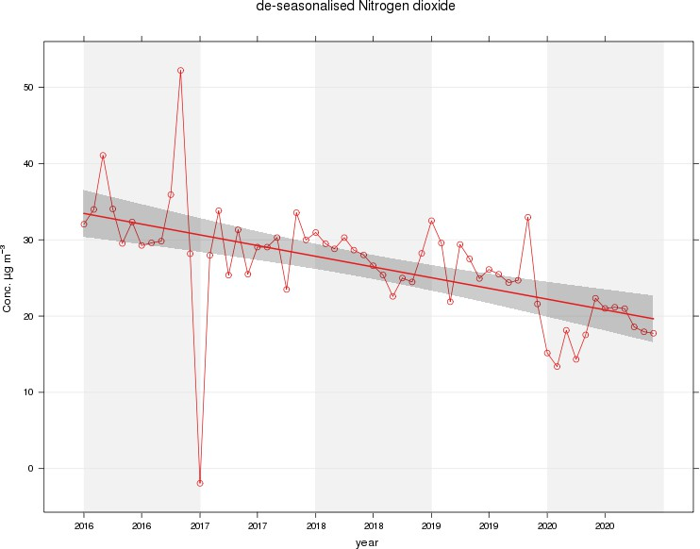

Figure 2 – A5 Falkirk Hope St Long Term NO2 Concentrations
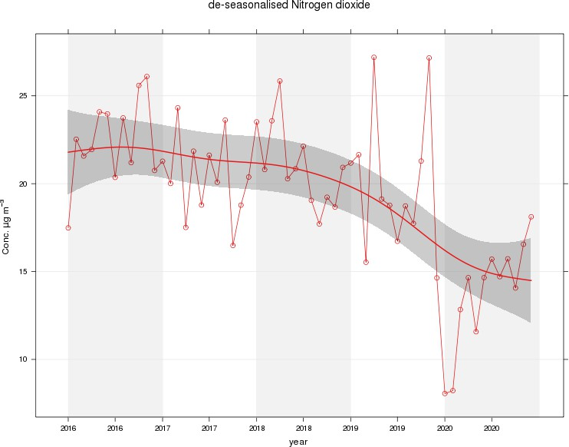

Figure 3 – A7 Falkirk West Bridge St Long Term NO2 Concentrations
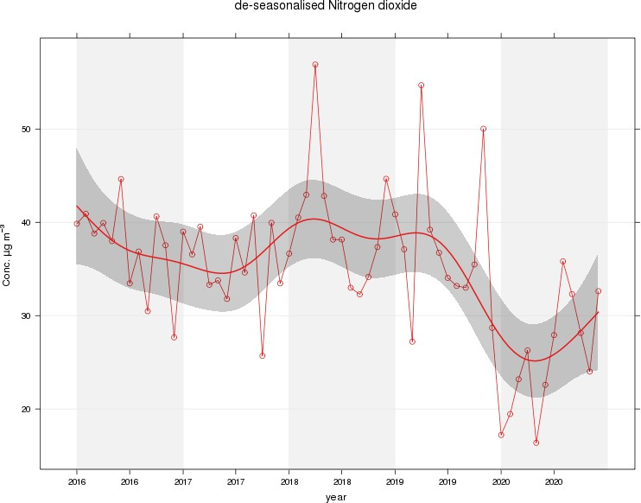

Figure 4 – A8 Grangemouth AURN Long Term NO2 Concentrations
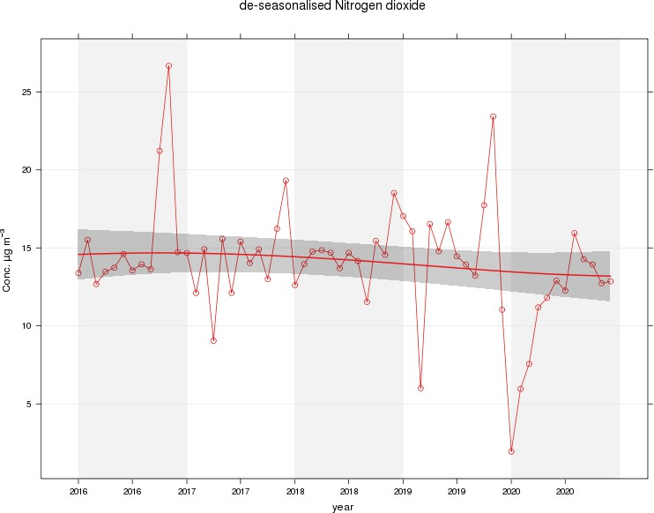

Figure 5 – A9 Grangemouth Moray Long Term NO2 Concentrations
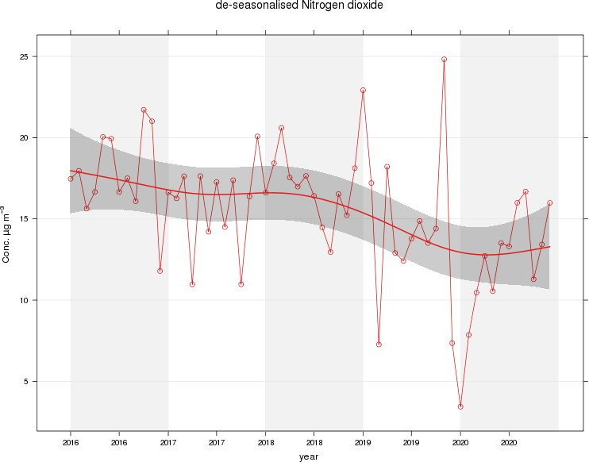

Figure 6 – A10 Grangemouth Municipal Chambers Long Term NO2 Concentrations
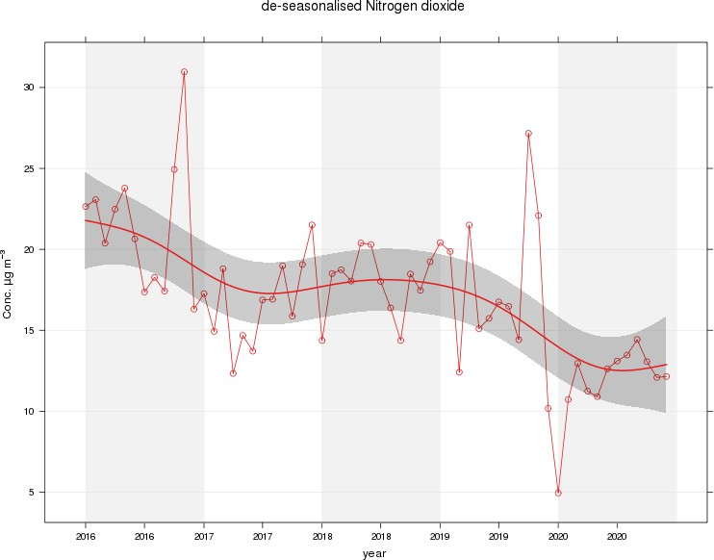

Figure 7 – A15 Main St, Bainsford Long Term NO2 Concentrations
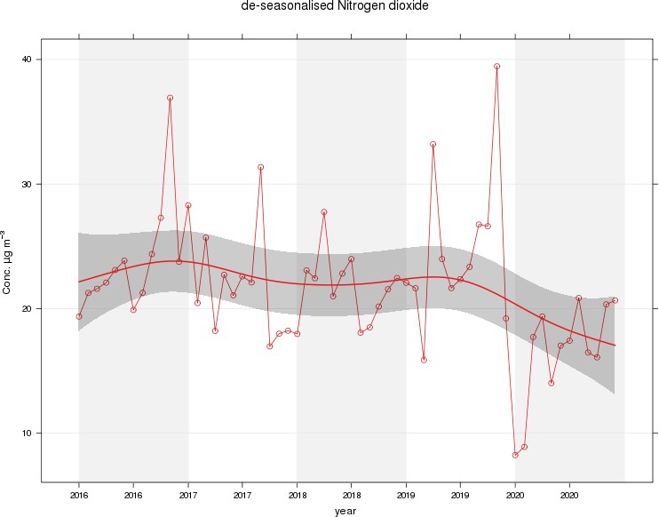

Table A.5 – Annual Mean PM10 Monitoring Results (µg/m³)

Site ID | Site Type | Valid Data Capture for Monitoring Period (%) ⁽¹⁾ | Valid Data Capture 2020 (%)  (2) | 2016 | 2017 | 2018 | 2019 | 2020
A4 | Falkirk Haggs | 56 | 56 | 14 | 12 | 14 | 14 | 10
A5 | Falkirk Hope St | 87 | 87 | PM10 analyser transferred from Falkirk Grahams Rd to Hope St  site on 10/10/2018 |  | 11 | 13 | 9
A7 | Falkirk West Bridge St | 38 | 38 | 15 | 10 | 6 | 11 | 8.4
A8 | Grangemouth AURN | 97 | 97 | 11 | 9 | 12 | 13 | 9
A10 | Grangemouth Municipal Chambers | 63 | 63 | 13 | 12 | 12 | 14 | 9.6
A14 | Banknock 3 | 63 | 63 | n/n | 7 | 6.9 | 7.9 | 7.8
A15 | Main St, Bainsford | 80 | 80 | 10 | 13 | 12 | 14 | 11
Notes:
Exceedances of the PM10 annual mean objective of 18 µg/m³ are shown in bold.
All means have been “annualised” as per LAQM.TG (16), valid data capture for the full calendar year is less than 75%. See Appendix C for details.
- Data capture for the monitoring period, in cases where monitoring was only carried out for part of the year.
- Data capture for the full calendar year (e.g. if monitoring was carried out for 6 months, the maximum data capture for the full calendar year is 50%).

Table A.6 – 24-Hour Mean PM10 Monitoring Results, Number of PM10 24-Hour Means > 50µg/m³

Site ID | Site Type | Valid Data Capture for Monitoring Period (%) ⁽¹⁾ | Valid Data Capture 2020 (%) ⁽²⁾ | 2016 | 2017 | 2018 | 2019 | 2020
A4 | Falkirk Haggs | 56 | 56 | 0 | 0 | 0 | 4 | 0 (21)
A5 | Falkirk Hope St | 87 | 87 | PM10 analyser transferred from Grahams Rd to Hope St  on 10/10/2018 |  | 0 (30) | 1 | 0
A7 | Falkirk West Bridge St | 38 | 38 | 0 | 0 | 0 (47) | 1 | 0 (18)
A8 | Grangemouth AURN | 97 | 97 | 0 | 1 | 0 | 2 | 0
A10 | Grangemouth Municipal Chambers | 63 | 63 | 0 | 0 | 0 | 2 | 0 (17)
A14 | Banknock 3 | 63 | 63 | 3 | 0 | 2 (10) | 1 | 1 (15.6)
A15 | Main St, Bainsford | 80 | 80 | 0 (16) | 0 | 0 (33) | 5 | 0
Notes:
Exceedances of the PM10 24-hour mean objective (50 µg/m³ not to be exceeded more than seven times/year) are shown in bold. If the period of valid data is less than 85%, the 98.1st percentile of 24-hour means is provided in brackets.
- Data capture for the monitoring period, in cases where monitoring was only carried out for part of the year.
- Data capture for the full calendar year (e.g. if monitoring was carried out for 6 months, the maximum data capture for the full calendar year is 50%).

Figure 8 – A4 Haggs Long Term PM10 (24-hour mean) Concentrations

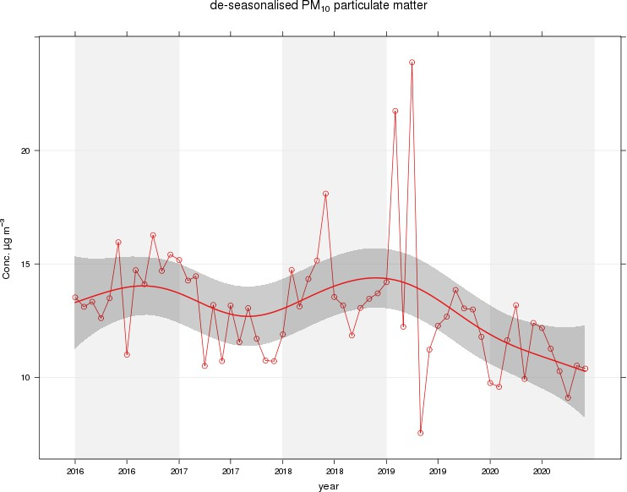

Figure 9 – A5 Falkirk Hope St Long Term PM10 (24-hour mean) Concentrations

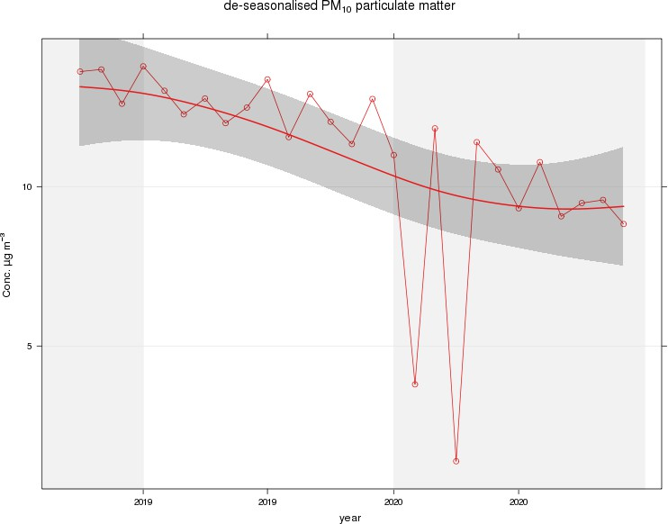

Figure 10 – A7 Falkirk West Bridge St Long Term PM10 (24-hour mean) Concentrations
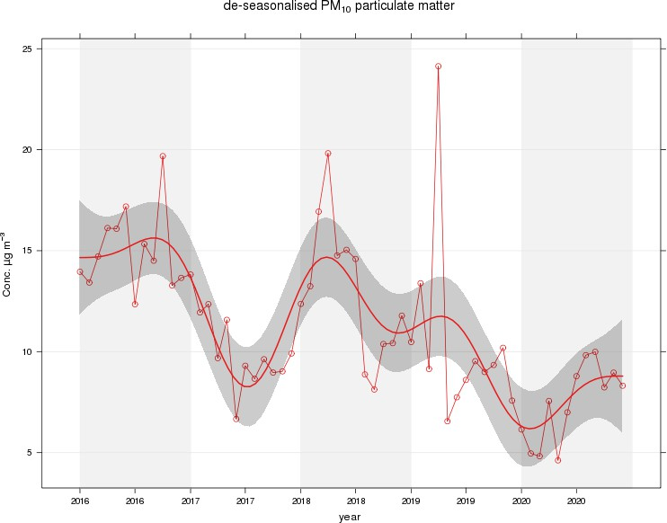

Figure 11 – A8 Grangemouth AURN Long Term PM10 (24-hour mean) Concentrations
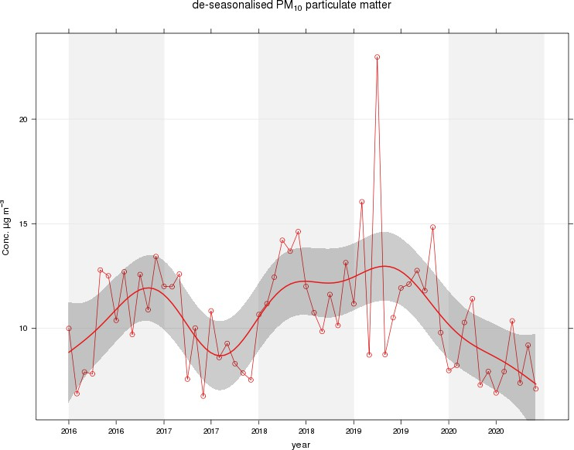

Figure 12 – A10 Grangemouth Municipal Chambers Long Term PM10 (24-hour mean) Concentrations
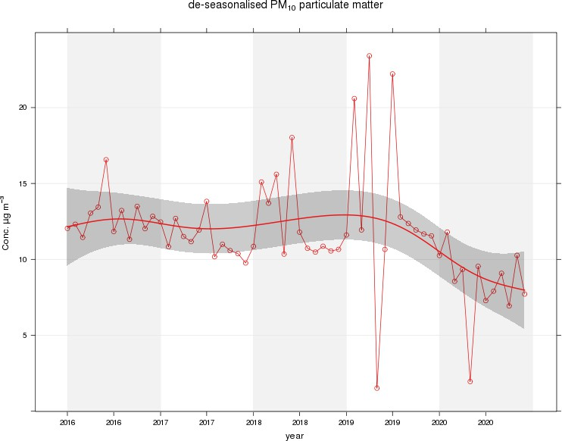

Figure 13 – A15 Main St, Bainsford Long Term PM10 (24-hour mean) Concentrations

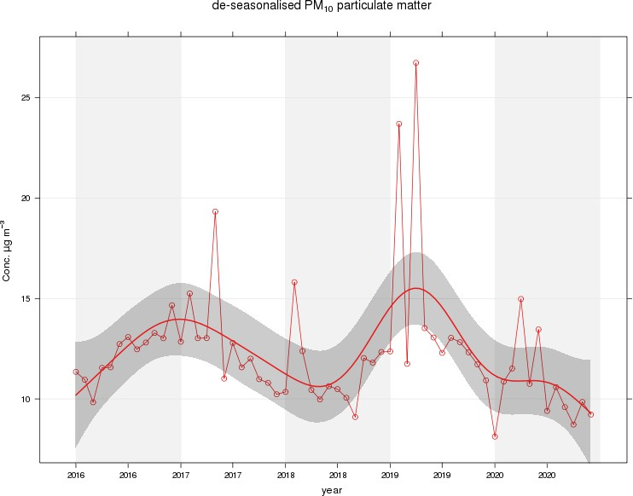

Table A.7 – Annual Mean PM2.5 Monitoring Results (µg/m³)

Site ID | Site Type | Valid Data Capture for Monitoring Period (%) ⁽¹⁾ | Valid Data Capture 2020 (%) ⁽²⁾ | 2016 | 2017 | 2018 | 2019 | 2020
A4 | Falkirk Haggs | 29 | 29 |  |  |  |  | 6
A5 | Falkirk Hope Street | 87 | 87 |  |  |  |  | 5.1
A7 | Falkirk West Bridge St | 38 | 38 | 6 | 6 | 6 | 6 | 4.4
A8 | Grangemouth AURN | 94 | 94 | 6 | 6 | 7 | 8 | 6
A10 | Grangemouth Municipal Chambers | 63 | 63 |  |  |  |  | 4.4
A14 | Banknock 3 | 63 | 63 | n/a | 3 | 4 | 4.6 | 3.6
A15 | Main Street, Bainsford | 80 | 80 |  |  |  |  | 6.2
Notes:
Exceedances of the PM2.5 annual mean objective of 10 µg/m³ are shown in bold.
All means have been “annualised” as per LAQM.TG (16), valid data capture for the full calendar year is less than 75%. See Appendix C for details.
- Data capture for the monitoring period, in cases where monitoring was only carried out for part of the year.
- Data capture for the full calendar year (e.g. if monitoring was carried out for 6 months, the maximum data capture for the full calendar year is 50%).

Figure 15 – A7 Falkirk West Bridge St Long Term PM2.5 Concentrations
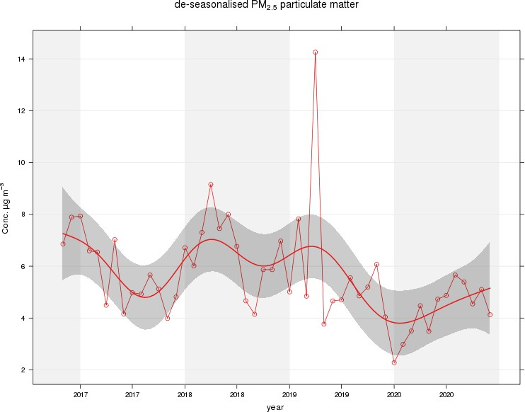

Figure 16 – A8 Grangemouth AURN Long Term PM2.5 Concentrations

Table A.8 – SO2 2020 Monitoring Results, Number of Relevant Instances

Site ID | Site Type | Valid Data Capture for monitoring Period (%) ⁽¹⁾ | Valid Data Capture 2020 (%) ⁽²⁾ | Number of 15-minute Means > 266 µg/m | Number of 1-hour Means > 350 µg/m | Number of 24-hour Means > 125 µg/m
A3 | Bo’ness | 97 | 97 | 0 | 0 | 0
A5 | Falkirk Hope St | 94 | 94 | 0 | 0 | 0
A8 | Grangemouth AURN | 96 | 96 | 6 | 0 | 0
A9 | Grangemouth Moray | 89 | 89 | 0 | 0 | 0
A10 | Grangemouth Municipal Chambers | 96 | 96 | 0 | 0 | 0
A11 | Grangemouth Zetland Park | 95 | 95 | 0 | 0 | 0
Notes:
Exceedances of the SO2 objectives are shown in bold (15-min mean = 35 allowed a year, 1-hour mean = 24 allowed a year, 24-hour mean = 3 allowed a year)
If the period of valid data is less than 85%, the relevant percentiles are provided in brackets (15-Minute means: 99.9th percentile, 1- hour means: 99.7th percentile, 24-hour means: 99.2nd percentile).
- Data capture for the monitoring period, in cases where monitoring was only carried out for part of the year.
- Data capture for the full calendar year (e.g. if monitoring was carried out for 6 months, the maximum data capture for the full calendar year is 50%).

Figure 18 – A3 Bo’ness Long Term SO2 Concentrations
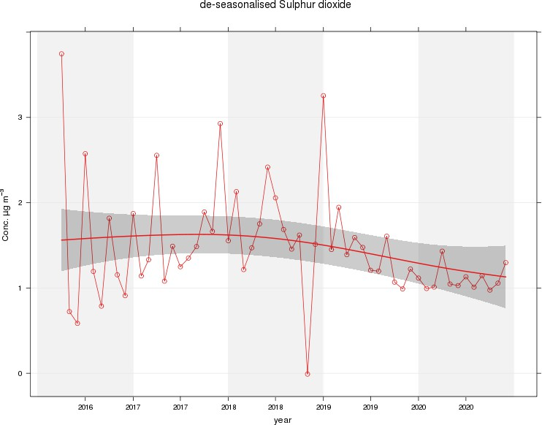

Figure 19 – A5 Falkirk Hope St Long Term SO2 Concentrations
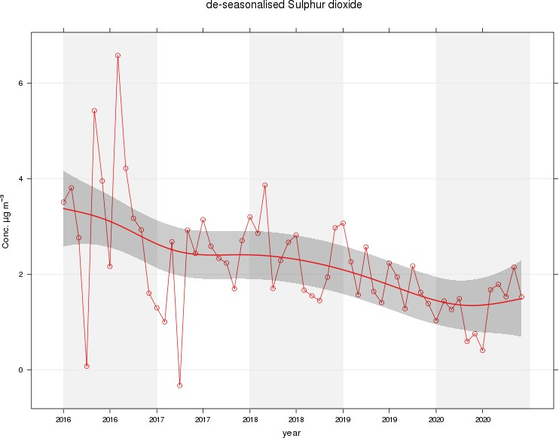

Figure 20 – A8 Grangemouth AURN Long Term SO2 Concentrations
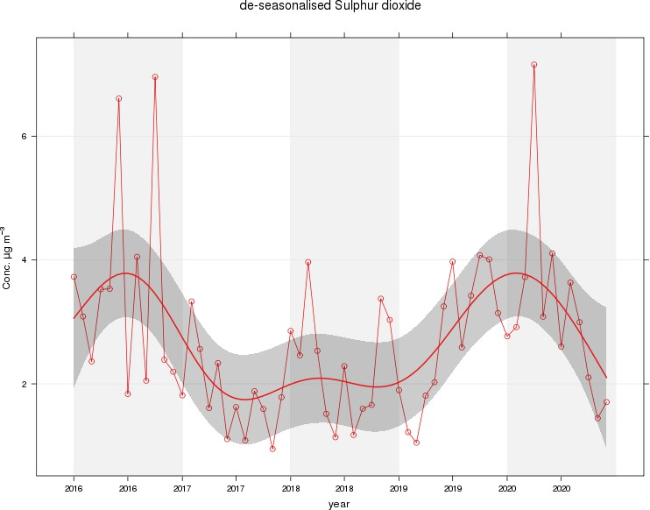

Figure 21 – A9 Grangemouth Moray Long Term SO2 Concentrations
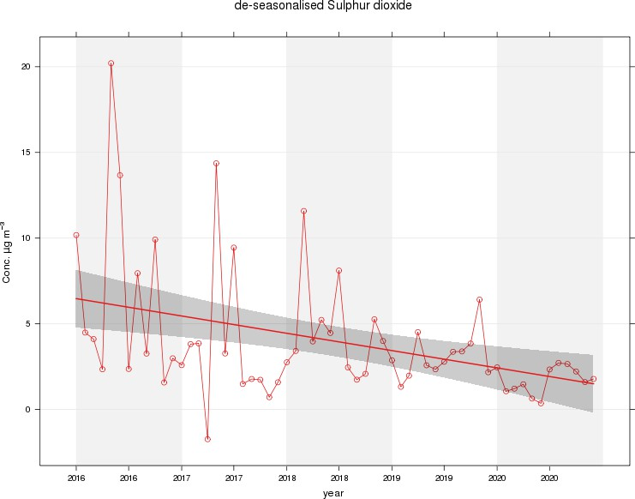

Figure 22 – A10 Grangemouth Municipal Chambers Long Term SO2 Concentrations
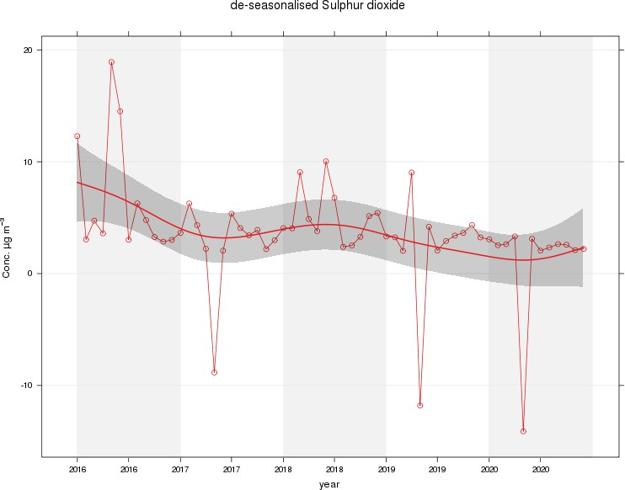

Figure 23 – A11 Grangemouth Zetland Park Long Term SO2 Concentrations
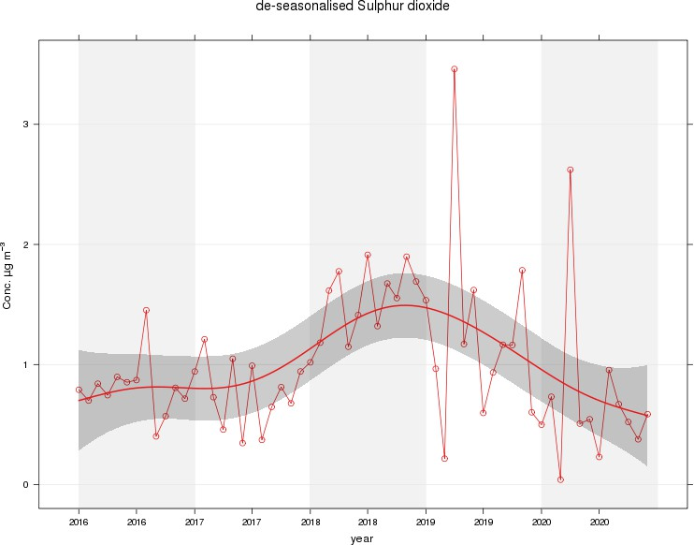

Figure 24 – Polar Plots of Average SO2 Concentrations Recorded at the Grangemouth Sites

A) Grangemouth AURN: 2020 B) Grangemouth AURN: 2016 – 2020
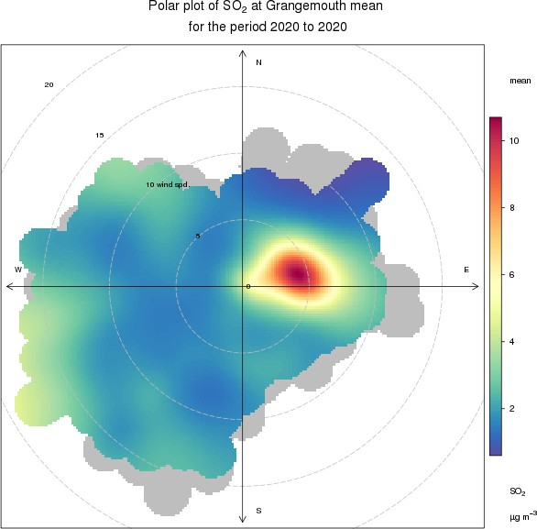
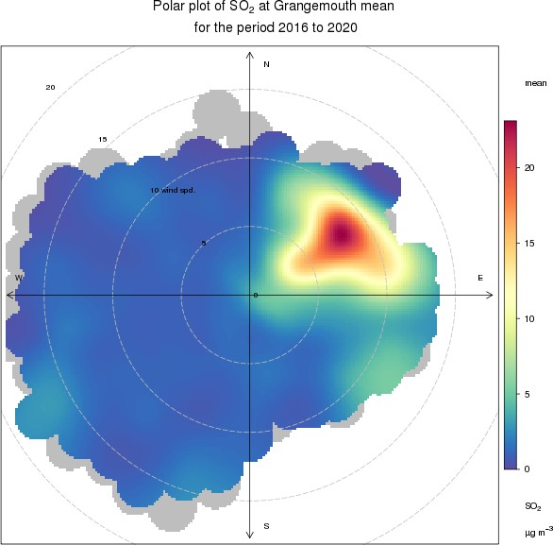

C) Grangemouth Moray: 2020 D) Grangemouth Moray 2016 – 2020

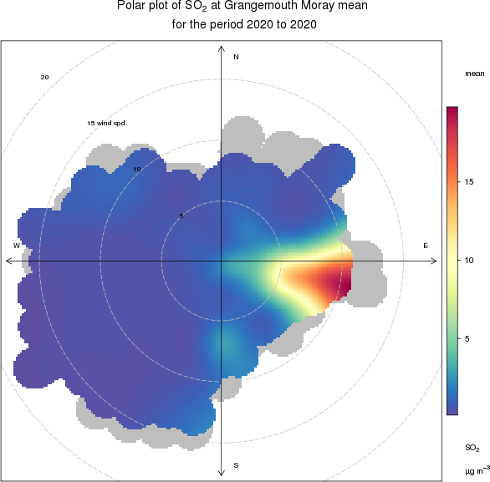
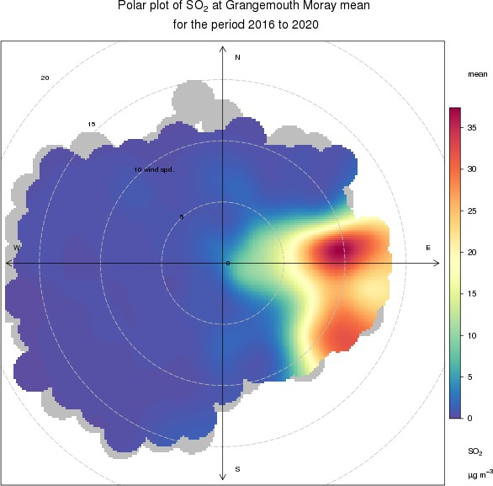

E) Grangemouth Municipal Chambers: 2020 F) Grangemouth Municipal Chambers: 2016 – 2020
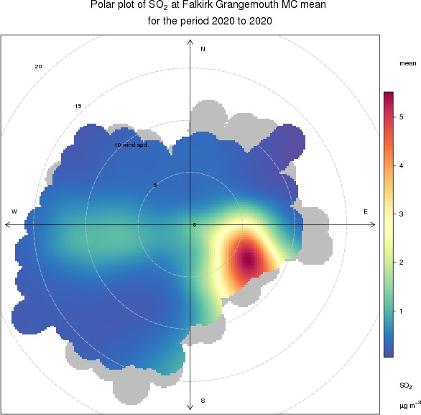
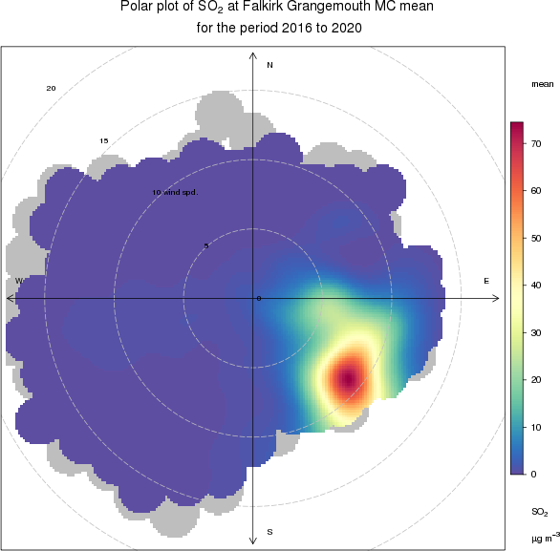

Figure 25 – Exceedances of the 15 Minute SO2 NAQS Objective Concentration at the Grangemouth Sites 2016 – 2020

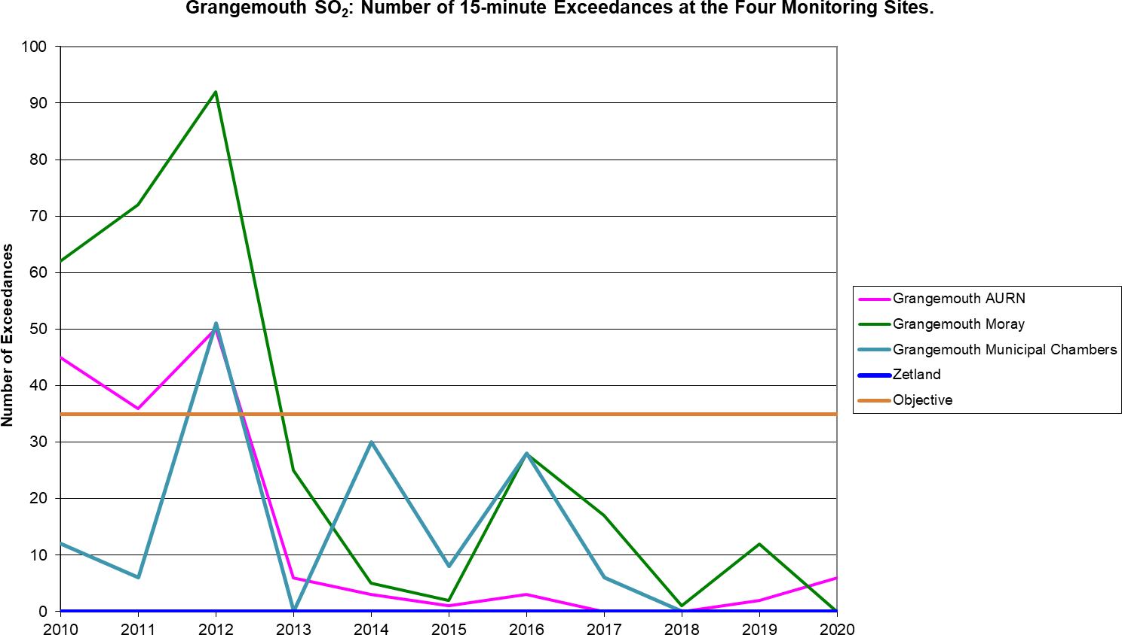

Table A.9 – 1, 3 Butadiene Annual Mean Diffusion Tube Results for 2020

Site ID | Location | Within 1, 3 Butadiene AQMA? | Data Capture in 2020, %. (1) | Annual Mean Concentrations (µg/m³)
 |  |  |  | 2016 | 2017 | 2018 | 2019 | 2020
NA41 | Seaview Place, Bo’ness | N | 100 | 0.10 | 0.1 | 0.06 | 0.05 | 0.05
NA55 | Inchyra Station,  Grangemouth | N | 100 | 0.10 | 0.07 | 0.07 | 0.05 | 0.06
NA104 | Powdrake  Road, Grangemouth | N | 100 | 0.11 | 0.1 | 0.11 | 0.05 | 0.05

Note: Exceedances of the 1, 3 butadiene running annual mean NAQS objective are shown in bold.

Table A.10 – Benzene Annual Mean Diffusion Tube Results for 2020

Site ID | Location | Within AQMA? | Data Capture in 2020, %. (1) | Annual Mean Concentrations (µg/m³)
 |  |  |  | 2016 | 2017 | 2018 | 2019 | 2020
NA3 | Tinto Drive, Grangemouth | N | 91 | 0.51 | 0.58 | 0.66 | 0.8 | 0.48
NA21 | Grangemouth Road, Falkirk College | N | 91 | 0.46 | 0.56 | 0.6 | 0.65 | 0.43
NA27 | West Bridge Street, Falkirk | N | 91 | 0.78 | 0.68 | 0.7 | 1.07 | 0.61
NA37 | Denny Town House | N | 91 | 0.58 | 0.56 | 0.49 | 0.77 | 0.43
NA38 | Larbert Village Primary School | N | 83 | 0.51 | 1.01 | 0.5 | 0.51 | 0.45
NA41 | Seaview Place, Bo’ness | N | 83 | 1.11 | 0.82 | 0.91 | 0.96 | 0.63
NA42 | Municipal Chambers, Grangemouth | N | 91 | 0.79 | 0.47 | 0.63 | 0.78 | 0.45
NA44 | Harvey Avenue, Polmont | N | 83 | 0.48 | 0.39 | 0.52 | 0.67 | 0.38
NA55 | Inchyra AQ Station, Grangemouth | N | 91 | 0.46 | 0.52 | 0.52 | 0.73 | 0.49
NA77 | Kinnaird Village | N | 91 | 0.44 | 0.51 | 0.44 | 0.59 | 0.41
NA80 | Cow Wynd, Falkirk | N | 91 | 0.56 | 0.57 | 0.52 | 0.66 | 0.46
NA81 | Grahams Road, Falkirk | N | 91 | 0.95 | 0.7 | 0.81 | 0.97 | 0.62
NA94 | A905 (Glensburgh Rd), Grangemouth | N | 91 | 0.78 | 0.64 | 0.68 | 0.77 | 0.46
NA105 | West of Shieldhill | N | 83 | 0.19 | 0.69 | 0.3 | 0.4 | 0.25
NA116 | Kersiebank Avenue, Grangemouth | Y | 91 | New site for 2019 |  |  | 0.76 | 0.46
NA117 | Oswald Avenue (East), Grangemouth | Y | 91 | New site for 2019 |  |  | 0.99 | 0.53
Note: Exceedances of the Benzene running annual mean objective of 3.25µg/m3 are shown in bold.

Table A.11 – Pumped Benzene Annual Mean Results for 2020

Site ID | Location | Within AQMA? | Data Capture in 2020, % (1) | Annual Mean Concentrations (µg/m³)
 |  |  |  | 2016 | 2017 | 2018 | 2019 | 2020
A8 | Grangemouth AURN | Y | 100 | 0.64 | 0.65 | 0.74 | 0.78 | 0.53
Note: Exceedances of the Benzene running annual mean objective of 3.25µg/m3 are shown in bold.

Table A.12 – Estimated Annual Mean PM2.5 Results for 2020

Site ID | Site Type | Valid Data Capture for Monitoring Period (%)  (1) | Valid Data Capture in 2020 (%)  (2) | Correction Factor | Estimated PM2.5 Annual Mean Concentration (µg/m³) (3)
 |  |  |  |  | 2016 | 2017 | 2018 | 2019 | 2020
A5 Falkirk Hope St | Roadside (Urban) | 87 | 87 | 0.55 | PM10 analyser not operating at this  site |  | 11 | 7.1 | 5.1
A15 Main St, Bainsford | Roadside (Urban) | 80 | 80 | 0.55 | 6.00 | 7.80 | 12 | 7.7 | 6.2
Note: Exceedences of the PM2.5 annual mean objective of 10µg/m³ are shown in bold.
- Data capture for the monitoring period, in cases where monitoring was only carried out for part of the year.
- Data capture for the full calendar year (e.g. if monitoring was carried out for 6 months, the maximum data capture for the full calendar year is 50%)
- All means have been estimated using a local correction factor as per LAQM.TG (16)¹. See Appendix C for details.

Figure 26 – Maps of the AQMA Boundaries in the Falkirk Council Area
  - Grangemouth AQMA (SO2, 15min mean) with relevant diffusion tube locations, declared November 2005
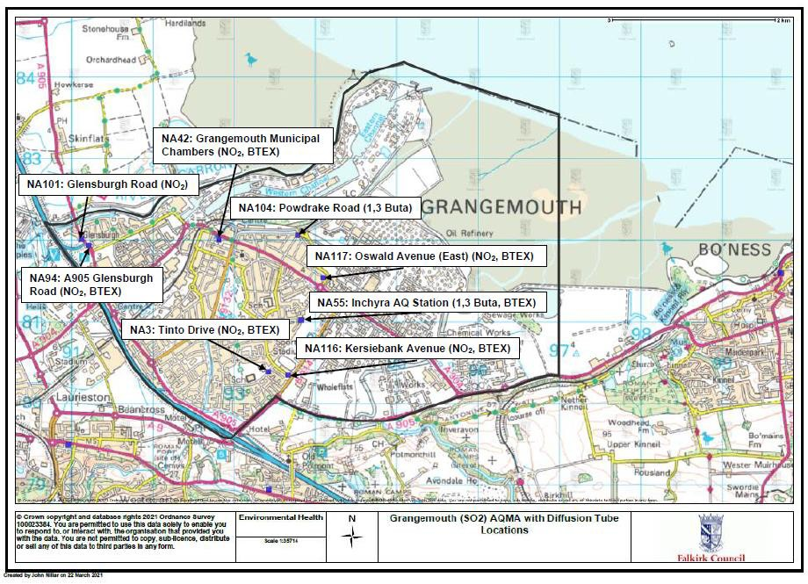

  - Falkirk Town Centre AQMA (NO2 Annual Mean, PM10 annual and 24-hour mean) with relevant diffusion tube locations, declared March 2010
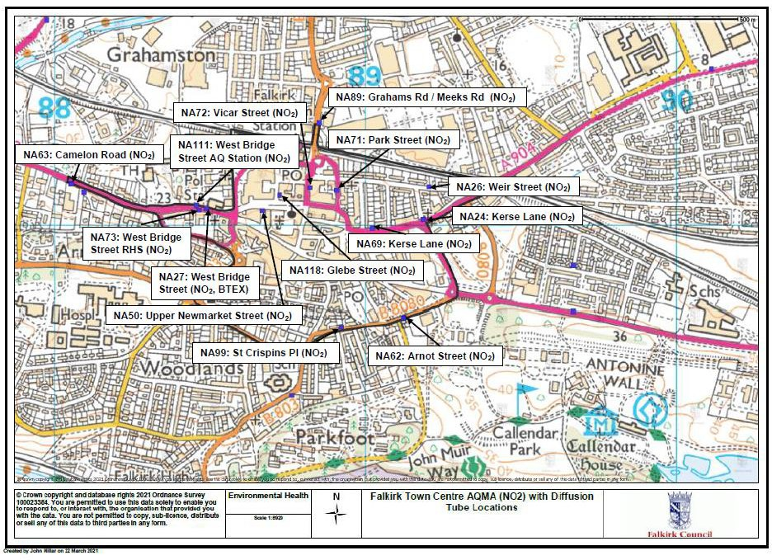

  - Haggs AQMA (NO2 annual mean), with relevant diffusion tube locations declared March 2010
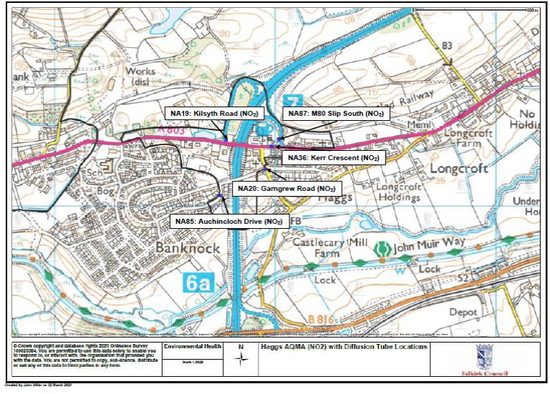

Figure 27 – Maps Showing Automatic Monitoring Locations
    - Grangemouth Air Quality (AQ) Stations
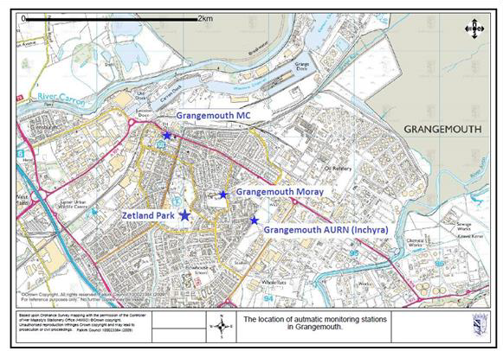

    - Falkirk Hope St AQ Station
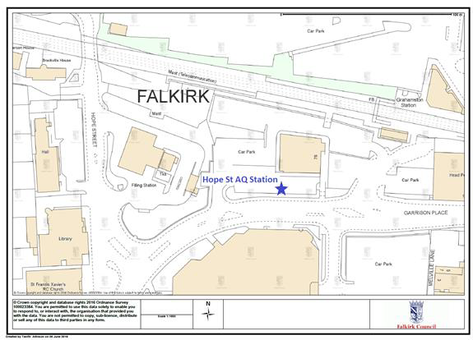

    - Falkirk West Bridge St AQ Station
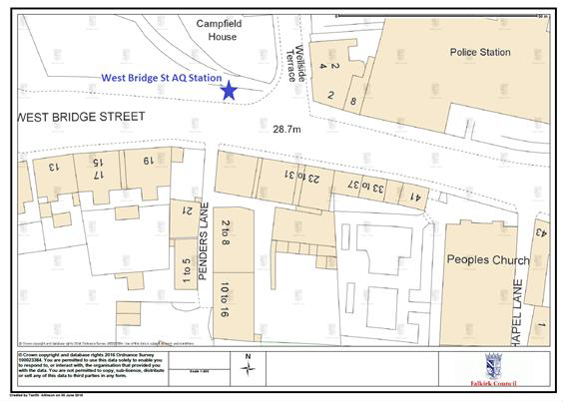

    - Bo’ness AQ Station
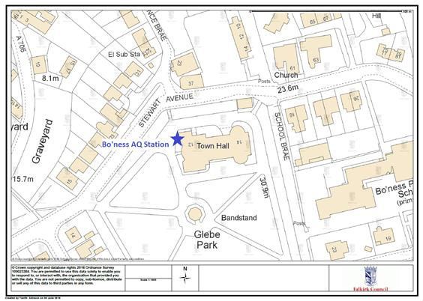

    - Falkirk Haggs AQ Station
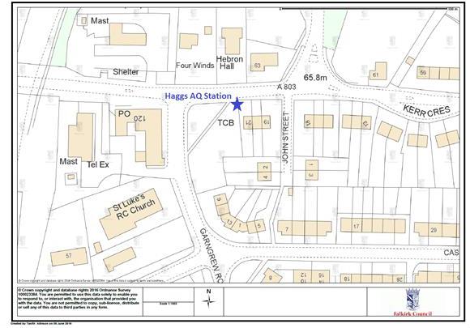

    - Main St, Bainsford, Falkirk AQ Station
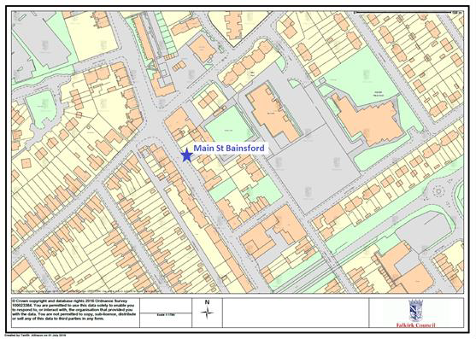

Appendix B: Full Monthly Diffusion Tube Results for 2020

Table B.1 – NO2 2020 Monthly Diffusion Tube Results (µg/m³)

Site ID | Jan | Feb | Mar | Apr (2) | May | Jun | Jul | Aug | Sep | Oct | Nov | Dec | Annual Mean: Raw Data | Annual Mean: Bias Adjusted ⁽¹⁾
NA3 | 19.76 | 16.92 | 12.02 | COVID | 10.51 | 12.22 | 8.74 | 14.32 | 17.28 | 16.91 | 22.62 | 26.85 | 16 | 15
NA5 | 21.85 | 21.88 | 16.89 | COVID | 11.16 | 15.66 | 14.32 | 19.49 | 22.50 | 22.69 | 30.05 | 28.84 | 20 | 19
NA7 | - | 15.28 | 11.63 | COVID | 8.68 | 11.04 | 7.96 | 11.59 | 12.92 | 13.50 | 19.93 | 19.53 | 13 | 12
NA9 | 28.16 | 20.74 | 14.40 | COVID | 10.77 | 14.01 | 13.23 | 15.43 | 19.87 | 23.08 | 26.73 | 26.81 | 19 | 18
NA19 | 29.73 | 25.72 | 17.19 | COVID | 14.05 | 19.64 | 12.01 | 20.76 | 20.10 | 25.29 | 27.26 | 28.85 | 22 | 21
NA20 | 27.30 | 22.52 | 14.82 | COVID | 11.31 | 13.84 | 11.49 | 16.96 | 16.67 | 20.78 | 25.91 | 28.78 | 19 | 18
NA21 | 23.20 | 24.25 | 16.60 | COVID | 12.47 | 18.26 | - | 22.45 | 21.47 | 20.73 | 26.10 | 32.73 | 22 | 21
NA24 | 29.32 | 35.09 | 21.28 | COVID | 17.98 | 19.20 | 23.11 | 26.59 | 28.49 | 29.25 | 31.26 | 32.50 | 27 | 25
NA26 | 15.32 | 14.25 | 13.97 | COVID | 7.05 | 10.49 | 8.85 | 13.92 | 13.61 | 15.54 | 24.04 | 20.22 | 14 | 13
NA27 | 41.46 | 36.63 | 31.87 | COVID | 26.84 | 31.63 | 23.14 | 40.80 | 39.92 | 39.40 | 43.43 | 51.74 | 37 | 35
NA29 | 18.02 | 16.09 | 11.58 | COVID | 8.16 | 11.94 | 7.88 | 12.84 | 14.08 | 13.56 | 18.19 | 23.72 | 14 | 13
NA36 | 28.37 | 30.90 | 21.94 | COVID | 18.21 | 26.54 | 21.98 | 29.99 | 29.57 | 32.49 | 34.49 | 40.78 | 29 | 27
NA37 | 19.06 | 14.60 | 11.54 | COVID | 8.09 | 11.53 | 7.51 | 13.04 | 13.24 | 15.54 | 21.37 | 23.67 | 14 | 14
NA38 | 16.50 | 15.10 | 10.36 | COVID | 7.36 | - | 6.98 | 10.18 | 11.52 | 14.95 | 19.67 | 23.97 | 14 | 13
NA41 | 26.00 | 19.87 | 16.63 | COVID | 13.13 | 15.19 | 12.62 | - | 20.55 | 22.14 | 24.85 | 26.20 | 20 | 19
NA42 (3  Tubes) | 16.32 | 16.68 | 13.71 | COVID | 9.96 | 11.04 | 9.55 | 12.79 | 16.34 | 17.15 | 23.04 | 25.30 | 16 | 15
NA42 (3  Tubes) | 21.07 | 16.78 | 14.96 | COVID | 9.18 | 10.75 | 9.37 | 12.60 | 16.68 | 15.67 | 23.76 | 26.17 | 16 | 15
NA42 (3  Tubes) | 21.19 | 19.41 | 13.93 | COVID | 9.78 | 10.65 | 9.77 | 12.71 | 15.13 | 18.31 | 23.69 | 25.76 | 16 | 15
NA44 | 18.69 | 17.06 | 12.13 | COVID | 9.49 | 9.76 | 9.84 | 13.62 | 14.78 | 15.51 | 18.84 | 20.14 | 15 | 14
NA48 | 18.22 | 14.50 | 15.11 | COVID | 10.89 | 14.35 | 9.57 | 15.04 | 15.55 | 17.57 | 21.59 | 23.90 | 16 | 15
NA50 | 19.16 | 15.17 | 19.19 | COVID | 13.19 | 18.73 | 11.07 | 22.54 | 21.45 | 21.23 | 23.92 | 27.65 | 19 | 18
NA51 | 23.22 | 17.40 | 15.41 | COVID | 12.23 | 13.82 | 14.85 | 19.24 | 20.66 | 23.00 | 23.86 | 29.32 | 19 | 18
NA52 | 27.23 | 22.96 | 15.31 | COVID | 11.81 | 15.62 | 13.83 | 18.93 | 22.15 | 21.94 | 28.96 | 30.87 | 21 | 20
NA53 | - | 26.05 | 19.29 | COVID | 14.43 | 22.24 | 11.53 | 23.29 | 21.78 | 24.67 | 29.32 | 29.47 | 22 | 21
NA58 | 19.90 | 16.18 | 14.03 | COVID | 9.77 | 12.55 | 9.31 | - | 17.01 | 17.98 | 25.27 | 24.57 | 17 | 16
NA59 | 31.40 | 27.99 | 19.00 | COVID | 14.10 | 19.72 | 15.24 | 19.65 | 25.16 | 23.82 | 32.97 | 34.65 | 24 | 23

Site ID | Jan | Feb | Mar | Apr (2) | May | Jun | Jul | Aug | Sep | Oct | Nov | Dec | Annual Mean: Raw Data | Annual Mean: Bias Adjusted ⁽¹⁾
NA60 | 30.81 | 22.91 | 18.10 | COVID | 14.01 | 16.51 | 13.27 | 17.31 | 22.56 | 26.01 | 29.89 | 31.47 | 22 | 21
NA61 | 24.97 | 22.62 | 17.10 | COVID | 12.79 | 16.81 | 12.52 | 19.32 | 20.68 | 21.72 | 25.43 | 28.49 | 20 | 19
NA62 | 37.78 | 36.28 | 23.59 | COVID | 19.19 | 20.24 | 21.58 | 25.78 | 28.52 | 31.13 | 35.66 | 34.82 | 29 | 27
NA63 | 38.27 | 28.34 | - | COVID | 18.35 | 13.83 | 19.90 | 28.99 | 28.96 | 33.60 | 35.67 | 44.48 | 29 | 27
NA64 | 9.83 | 11.18 | 9.59 | COVID | 7.93 | 10.96 | 7.09 | 12.07 | 12.91 | 14.24 | 19.52 | 18.96 | 12 | 11
NA65 | 21.70 | 20.72 | 16.93 | COVID | 14.02 | 15.57 | 12.83 | 18.36 | 22.10 | 19.68 | 28.04 | 32.38 | 20 | 19
NA67 | 26.42 | 24.47 | 18.56 | COVID | 13.17 | 16.70 | - | 22.15 | 26.39 | 23.15 | 30.55 | 32.64 | 23 | 22
NA69 | 27.76 | 21.54 | 21.73 | COVID | 17.11 | 20.02 | 15.87 | 29.82 | 27.56 | 25.38 | 28.25 | 33.50 | 24 | 23
NA71 | 37.10 | 29.89 | 18.60 | COVID | 15.83 | 17.25 | 20.00 | 25.04 | 30.10 | 29.08 | 33.46 | 38.01 | 27 | 25
NA72 | 24.20 | 24.67 | 19.70 | COVID | 13.75 | 17.73 | 12.55 | 24.76 | 25.77 | 25.64 | 35.14 | 33.70 | 23 | 22
NA73 | 27.52 | 26.06 | 24.55 | COVID | 16.81 | 24.35 | 15.80 | 26.26 | 27.48 | 28.23 | 31.67 | 35.79 | 26 | 24
NA76 | 24.39 | 19.91 | 13.52 | COVID | 8.90 | 11.59 | 10.42 | 12.66 | 16.47 | 15.82 | 23.82 | 24.39 | 17 | 16
NA77 | 27.56 | 22.01 | 14.52 | COVID | 9.94 | 14.43 | 12.06 | 16.90 | 20.01 | 22.64 | 25.45 | 28.80 | 19 | 18
NA78 | 19.35 | 25.25 | 18.11 | COVID | 15.64 | 18.50 | 18.08 | - | 25.08 | 25.18 | 29.48 | 30.31 | 22 | 21
NA80 | 35.63 | 33.97 | 19.79 | COVID | 13.99 | 16.65 | - | 32.50 | 25.08 | 26.24 | 33.25 | 33.94 | 27 | 25
NA81 | 29.57 | 24.51 | 20.82 | COVID | 16.83 | 23.14 | 14.59 | 28.68 | 24.91 | 26.83 | 33.25 | 36.42 | 25 | 24
NA82 | 19.18 | 15.68 | 13.32 | COVID | 8.70 | 11.31 | 8.72 | 12.98 | 16.07 | 17.18 | 22.49 | 26.76 | 16 | 15
NA83 | 30.13 | 34.62 | 23.03 | COVID | 17.58 | 20.68 | 16.96 | 23.37 | 26.21 | 27.33 | 33.06 | 34.71 | 26 | 25
NA85 | 18.53 | 13.56 | 12.99 | COVID | 8.75 | 13.55 | 7.61 | 17.46 | 13.85 | 16.96 | 20.62 | 25.80 | 15 | 14
NA86 | 12.20 | 13.40 | 10.63 | COVID | 7.60 | 8.63 | 6.88 | 11.29 | 11.25 | 13.38 | 19.29 | 21.23 | 12 | 12
NA87 | 28.61 | 28.05 | 17.97 | COVID | 14.73 | 4.20 | 16.79 | 23.81 | 25.13 | 26.63 | 27.08 | 29.05 | 22 | 21
NA88 | 25.32 | 28.77 | 18.03 | COVID | 15.58 | 17.38 | 18.98 | 15.45 | 22.52 | 26.24 | 24.19 | 26.32 | 22 | 20
NA89 | 28.75 | 26.88 | 20.75 | COVID | 16.04 | 19.05 | 13.90 | 23.14 | 25.22 | 23.82 | 31.64 | 34.85 | 24 | 23
NA94 | 35.59 | 32.51 | 20.34 | COVID | 16.59 | 16.07 | 18.30 | 20.90 | 25.96 | 28.31 | 34.95 | 35.21 | 26 | 24
NA98 | 16.46 | 18.43 | 14.88 | COVID | 10.43 | 21.96 | 9.58 | 15.71 | 15.46 | 15.69 | 22.09 | 26.63 | 17 | 16
NA99 | 27.64 | 25.12 | 17.40 | COVID | 13.80 | 16.40 | 14.74 | 19.80 | 19.50 | 22.66 | 23.51 | 28.15 | 21 | 20
NA101 | 23.15 | 21.81 | 15.01 | COVID | 10.47 | 16.02 | 10.54 | 18.11 | 15.27 | 24.13 | 24.07 | 25.59 | 19 | 17
NA105 | 6.82 | 6.33 | 5.45 | COVID | 3.92 | 5.95 | 3.63 | 5.64 | 6.67 | 7.39 | 12.05 | 9.96 | 7 | 6
NA107 | 30.07 | 21.81 | - | COVID | 14.03 | 20.27 | 14.76 | 23.78 | 27.72 | 27.19 | 30.99 | 35.48 | 25 | 23
NA110 | 20.33 | 14.93 | 10.27 | COVID | 8.05 | 11.22 | 9.83 | 12.90 | 13.68 | 15.57 | 17.74 | 17.54 | 14 | 13
NA111 (3  tubes) | 35.20 | 30.53 | 29.28 | COVID | 22.53 | 29.77 | 19.86 | 35.78 | 34.48 | 30.91 | 36.29 | 44.18 | 32 | 31
NA111 (3  tubes) | 35.34 | 37.39 | 29.29 | COVID | 23.33 | 29.69 | 22.05 | 36.55 | 33.91 | 36.13 | 36.44 | 43.44 | 32 | 31
NA111 (3  tubes) | 34.01 | 33.21 | 31.71 | COVID | 22.61 | 30.16 | 22.11 | 33.22 | 34.08 | 32.41 | 39.56 | 45.93 | 32 | 31

Site ID | Jan | Feb | Mar | Apr (2) | May | Jun | Jul | Aug | Sep | Oct | Nov | Dec | Annual Mean: Raw Data | Annual Mean: Bias Adjusted ⁽¹⁾
NA114 | 37.77 | 32.27 | 25.52 | COVID | 24.82 | 28.77 | - | - | 35.93 | 36.72 | - | 40.76 | 33 | 31
NA115 | 18.39 | 14.23 | 11.56 | COVID | 7.39 | 12.82 | 7.82 | 13.68 | 14.79 | 15.03 | 20.52 | 19.71 | 14 | 13
NA116 | 17.28 | 16.34 | 14.54 | COVID | 11.18 | 13.45 | 8.08 | 18.15 | 14.36 | 18.27 | 20.29 | 26.92 | 16 | 15
NA117 | 20.29 | 16.37 | 13.90 | COVID | 10.03 | 12.24 | 10.22 | 12.53 | 16.33 | 17.74 | 21.79 | 27.97 | 16 | 15
NA118 | 23.42 | 21.93 | 15.63 | COVID | 11.32 | 13.43 | 9.18 | 19.28 | 19.44 | 20.07 | 24.15 | 27.47 | 19 | 18
NA119 | 24.30 | 20.77 | 16.70 | COVID | 13.03 | 16.58 | 12.44 | 18.45 | 16.51 | - | 23.80 | 26.72 | 19 | 18
Notes:
      - See Appendix C for details on bias adjustment
      - Diffusion tubes not collected during April 2020 due to the ‘Stay at Home’ Scottish Government Coronavirus advice: https://www.gov.scot/coronavirus-covid-19/

Table B.2 – 1,3 Butadiene Monthly Diffusion Tube Results for 2020 (ppb)

Site ID | Jan | Feb | Mar | Apr (1) | May | Jun | Jul | Aug | Sep | Oct | Nov | Dec | Annual Mean: Raw Data (ppb) | Annual Mean: Raw Data (µg/m³)
41 | 0.02 | 0.02 | 0.01 | COVID | 0.02 | 0.02 | 0.03 | 0.02 | 0.03 | 0.02 | 0.03 | 0.02 | 0.02 | 0.05
55 | 0.02 | 0.02 | 0.01 | COVID | 0.02 | 0.06 | 0.03 | 0.02 | 0.03 | 0.02 | 0.03 | 0.02 | 0.03 | 0.06
104 | 0.02 | 0.02 | 0.01 | COVID | 0.02 | 0.02 | 0.03 | 0.02 | 0.03 | 0.02 | 0.03 | 0.02 | 0.02 | 0.05
- Diffusion tubes not collected during April 2020 due to the ‘Stay at Home’ Scottish Government Coronavirus advice: https://www.gov.scot/coronavirus-covid-19/

Table B.3 – Benzene Monthly Diffusion Tube Results for 2020 (ppb)

Site ID | Jan | Feb | Mar | Apr (1) | May | Jun | Jul | Aug | Sep | Oct | Nov | Dec | Annual Mean: Raw Data (ppb) | Annual Mean: Raw Data (µg/m³)
3 | 0.13 | 0.15 | 0.15 | COVID | 0.12 | 0.14 | 0.07 | 0.12 | 0.15 | 0.14 | 0.21 | 0.25 | 0.15 | 0.48
21 | 0.12 | 0.12 | 0.16 | COVID | 0.10 | 0.14 | 0.07 | 0.11 | 0.13 | 0.11 | 0.20 | 0.19 | 0.13 | 0.43
27 | 0.20 | 0.15 | 0.17 | COVID | 0.12 | 0.15 | 0.09 | 0.13 | 0.20 | 0.18 | 0.32 | 0.36 | 0.19 | 0.61
37 | 0.15 | 0.15 | 0.17 | COVID | 0.09 | 0.12 | 0.07 | 0.10 | 0.15 | 0.13 | 0.07 | 0.26 | 0.13 | 0.43
38 | 0.18 | 0.14 | 0.16 | COVID | 0.09 | - | 0.07 | 0.08 | 0.11 | 0.11 | 0.23 | 0.20 | 0.14 | 0.45
41 | 0.07 | - | 0.16 | COVID | 0.13 | 0.20 | 0.10 | 0.15 | 0.22 | 0.16 | 0.37 | 0.37 | 0.19 | 0.63
42 | 0.06 | 0.17 | 0.15 | COVID | 0.11 | 0.16 | 0.07 | 0.10 | 0.15 | 0.12 | 0.18 | 0.25 | 0.14 | 0.45
44 | - | 0.09 | 0.11 | COVID | 0.09 | 0.10 | 0.07 | 0.09 | 0.11 | 0.12 | 0.18 | 0.20 | 0.12 | 0.38
55 | 0.13 | 0.13 | 0.18 | COVID | 0.15 | 0.17 | 0.07 | 0.13 | 0.16 | 0.12 | 0.20 | 0.22 | 0.15 | 0.49
77 | 0.12 | 0.14 | 0.16 | COVID | 0.07 | 0.12 | 0.07 | 0.08 | 0.11 | 0.10 | 0.20 | 0.21 | 0.13 | 0.41
80 | 0.17 | 0.10 | 0.17 | COVID | 0.11 | 0.13 | 0.07 | 0.09 | 0.13 | 0.12 | 0.21 | 0.27 | 0.14 | 0.46
81 | 0.20 | 0.19 | 0.16 | COVID | 0.12 | 0.17 | 0.14 | 0.14 | 0.20 | 0.12 | 0.35 | 0.32 | 0.19 | 0.62
94 | 0.16 | 0.22 | 0.16 | COVID | 0.13 | 0.16 | 0.07 | 0.14 | 0.13 | 0.12 | 0.07 | 0.21 | 0.14 | 0.46
105 | 0.10 | 0.10 | 0.10 | COVID | 0.06 | 0.07 | 0.07 | 0.05 | 0.07 | 0.06 | 0.09 | - | 0.08 | 0.25
116 | 0.15 | 0.12 | 0.15 | COVID | 0.12 | 0.14 | 0.07 | 0.13 | 0.14 | 0.13 | 0.20 | 0.21 | 0.14 | 0.46
117 | 0.13 | 0.13 | 0.18 | COVID | 0.13 | 0.20 | 0.07 | 0.16 | 0.17 | 0.13 | 0.24 | 0.25 | 0.16 | 0.53
- Diffusion tubes not collected during April 2020 due to the ‘Stay at Home’ Scottish Government Coronavirus advice: https://www.gov.scot/coronavirus-covid-19/

Appendix C: Supporting Technical Information / Air Quality Monitoring Data QA/QC
New or Changed Sources Identified Within Falkirk Council During 2020

The only new potential source that may affect air quality within the Falkirk Council area in 2020/21 was a proposed upgrade to a section of road and associated junctions. These road upgrades are proposed to take place between Earlsgate and the Forth Valley College on the A904 and alongside the Helix and Falkirk Football Club along the A9. The proposed development is seeking permission to These upgrades form part of the Falkirk Gateway Masterplan. An initial design has been submitted that involves road widening and general improvements, three new roundabouts, improvement of the existing A9/A904 roundabout, and an iconic pedestrian crossing structure over the existing A9/A904 roundabout. The AQIA was completed by WSP on behalf of Falkirk Council (report ref: WSP-9750-0000-R- 007).

Additional Air Quality Works Undertaken by Falkirk Council During 2020
Grangemouth 2020 Emissions Study

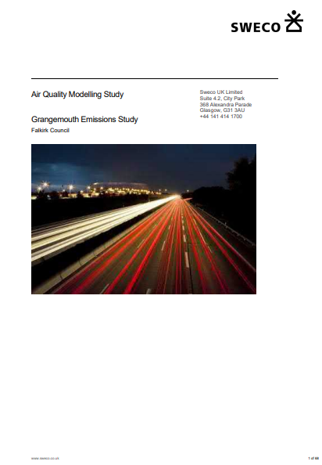

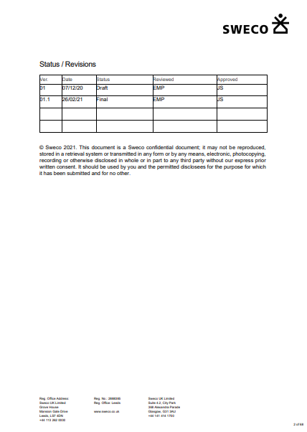

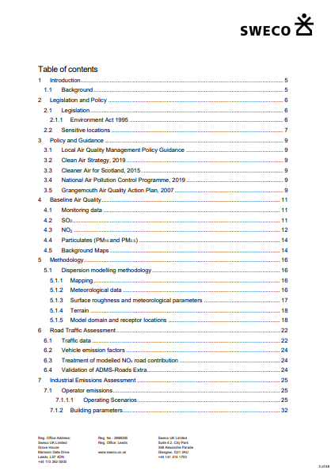

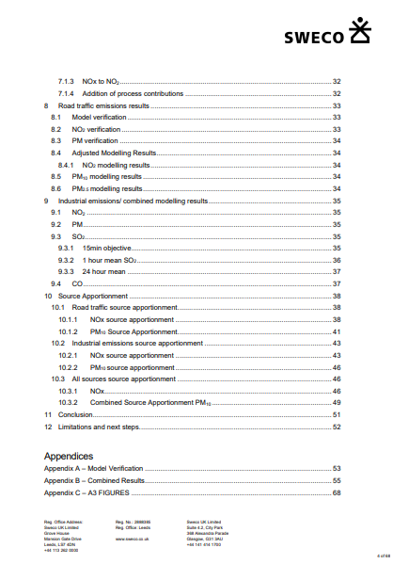

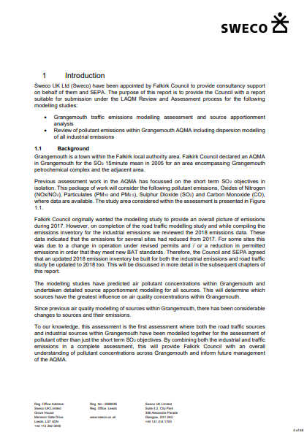

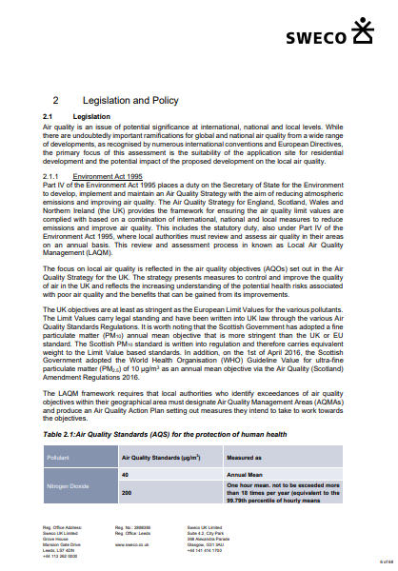

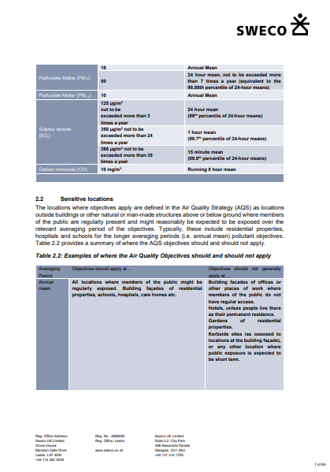

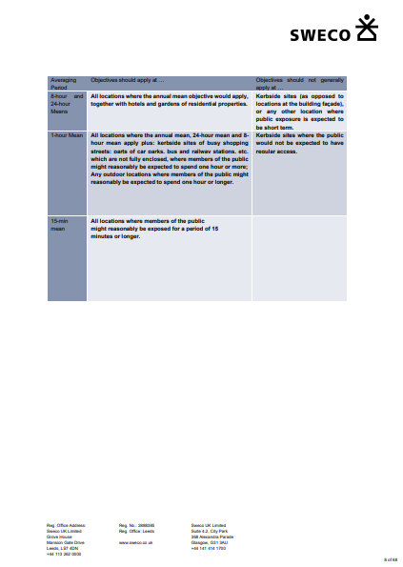

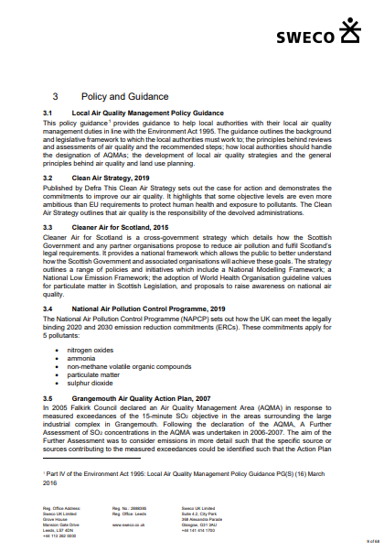



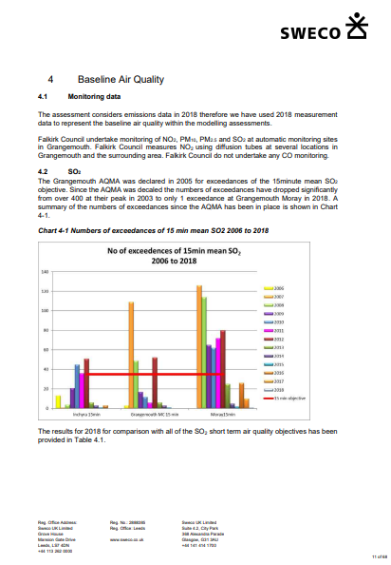

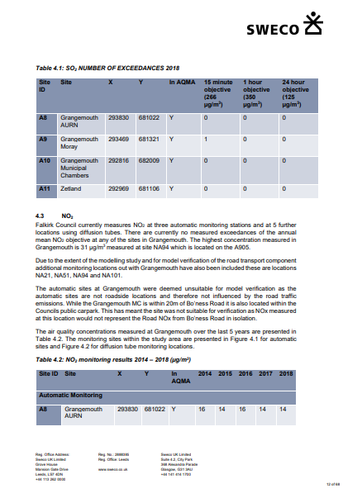

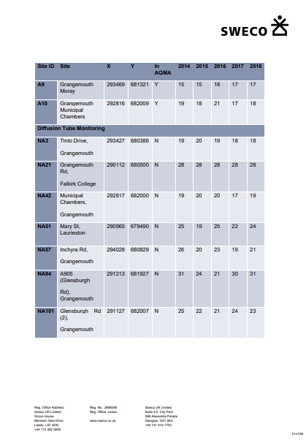

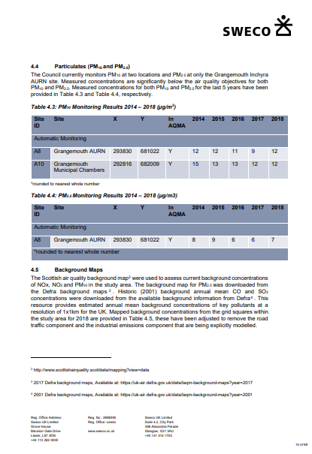

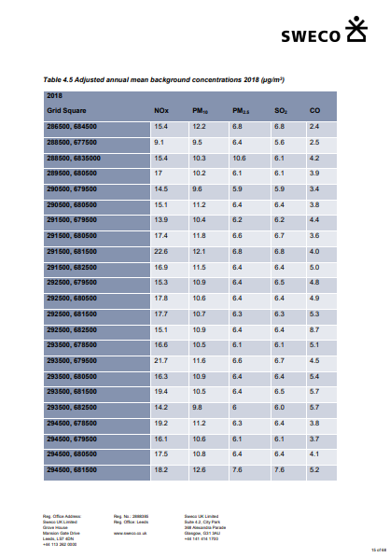

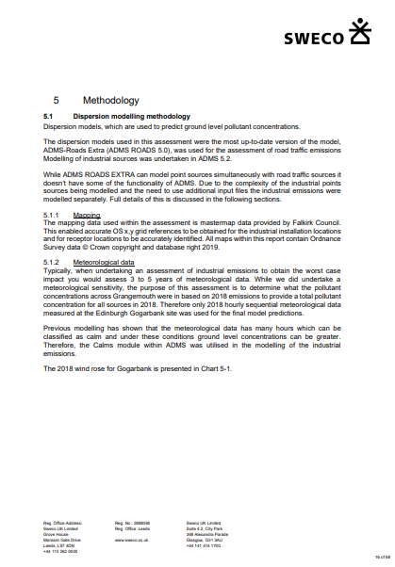

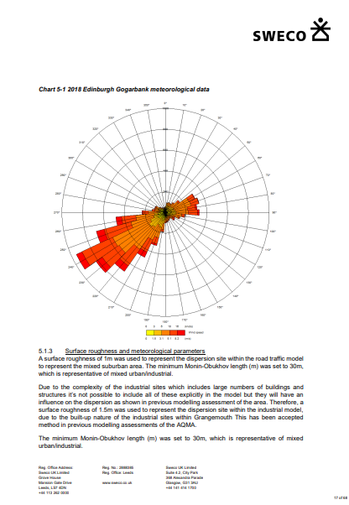

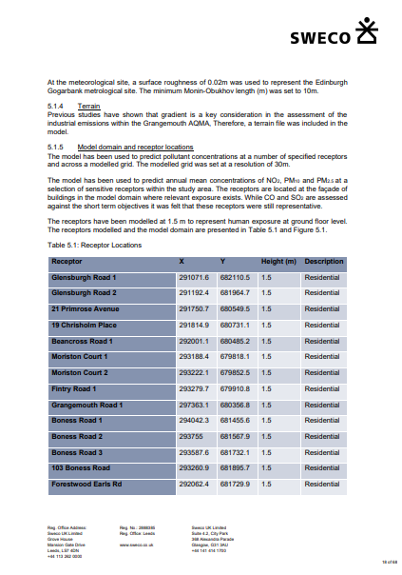

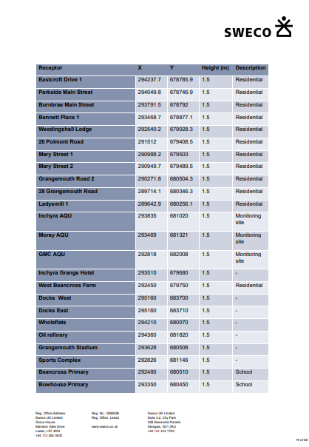

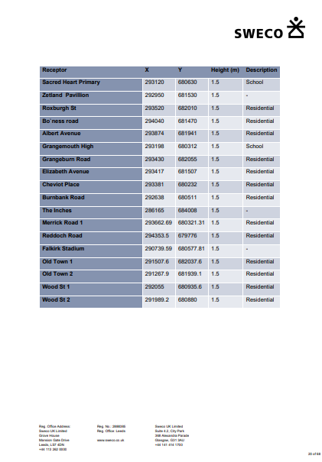

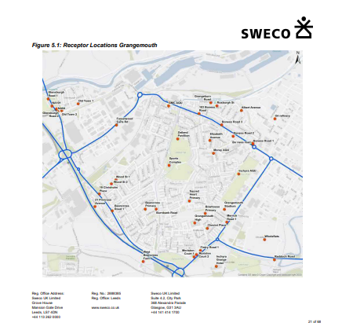

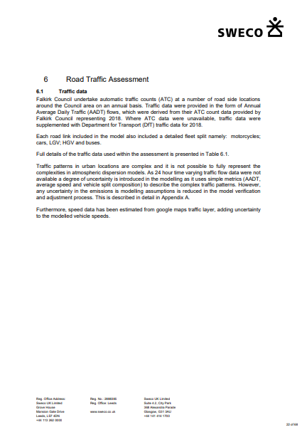

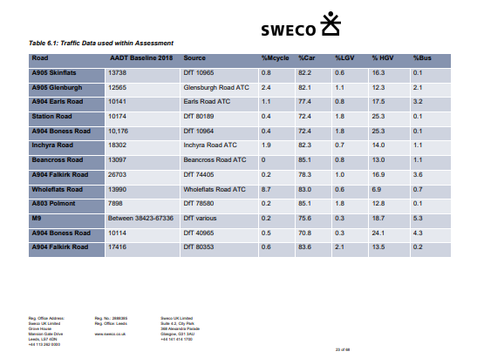

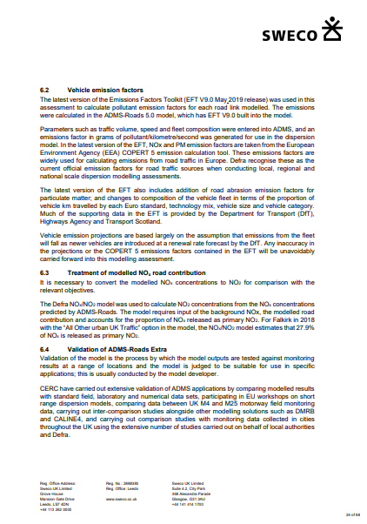

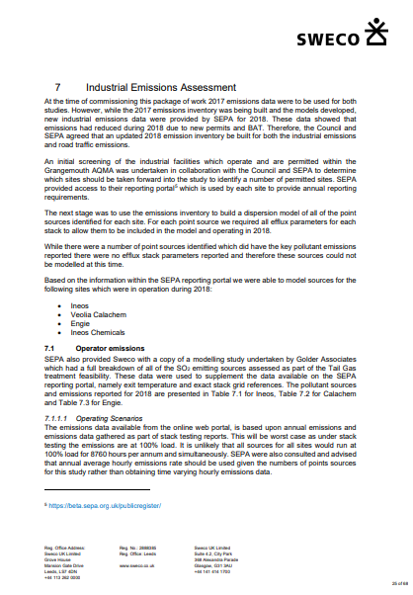



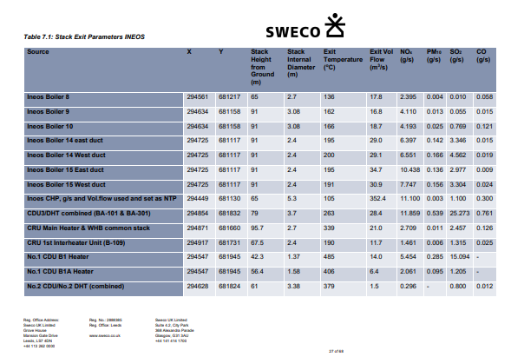

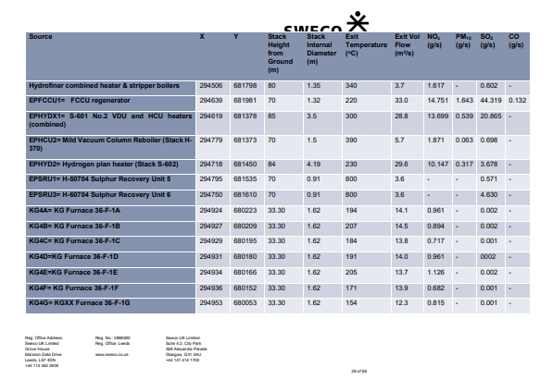

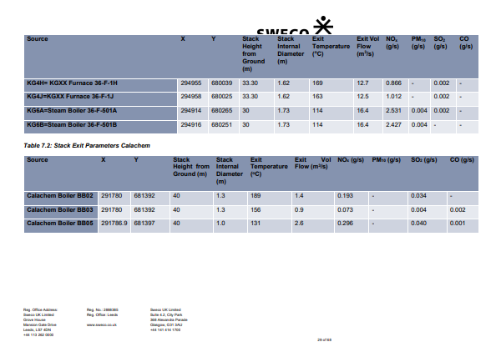

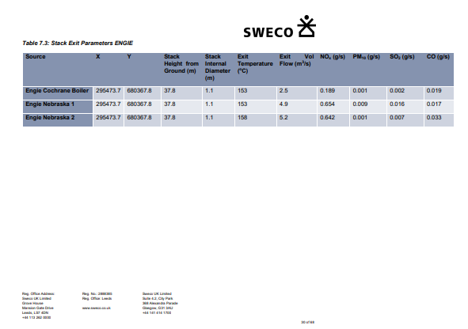

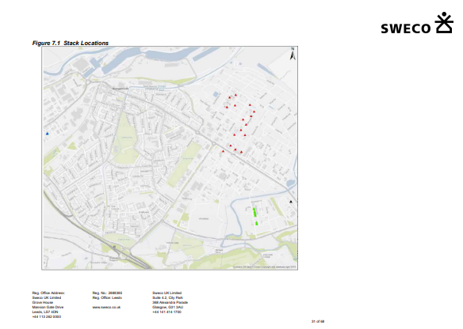

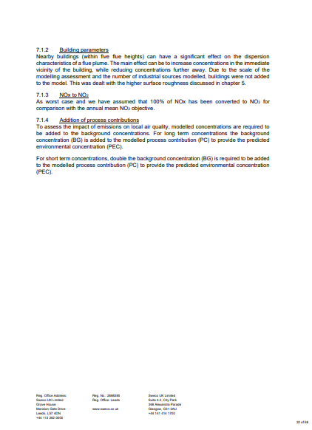

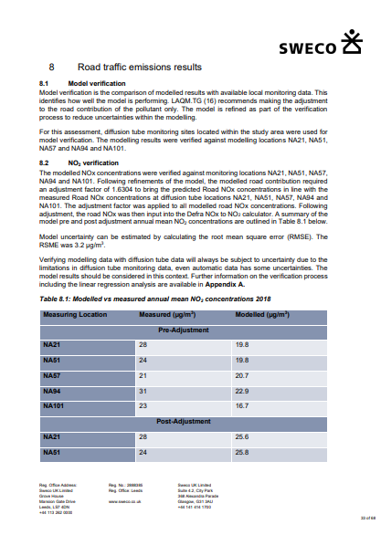

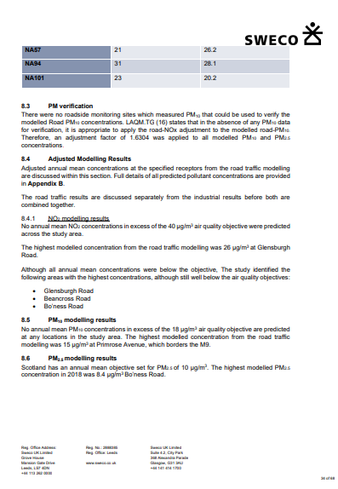

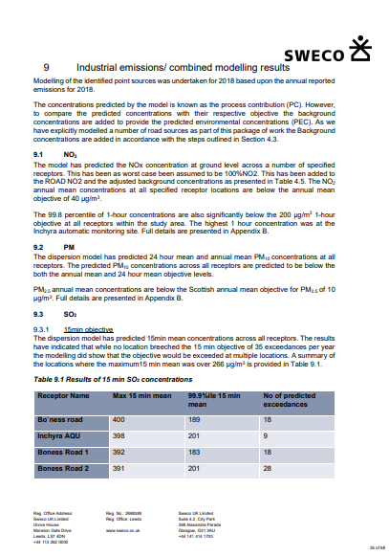

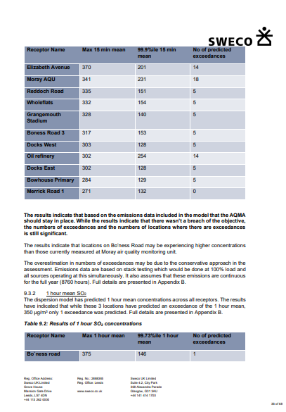

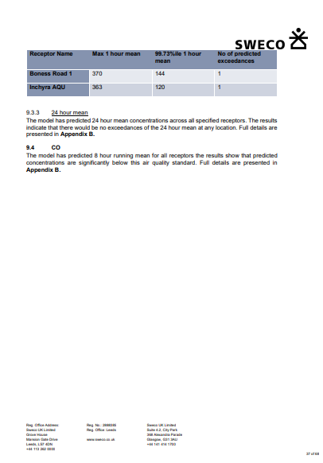

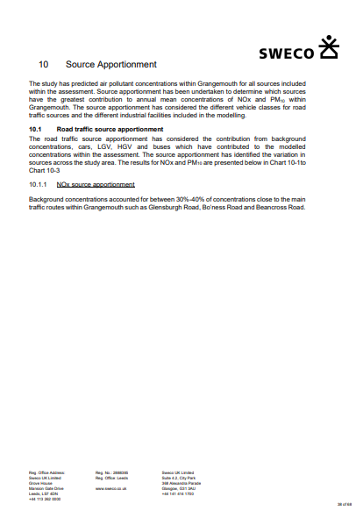

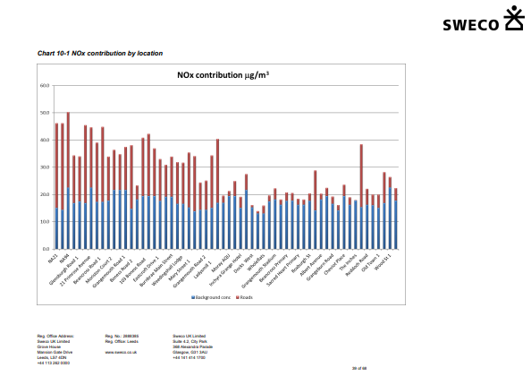

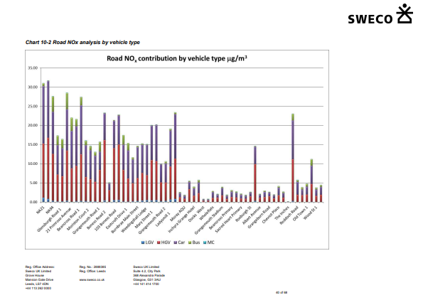

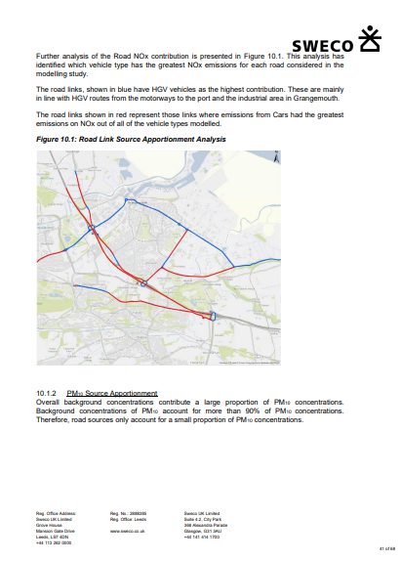

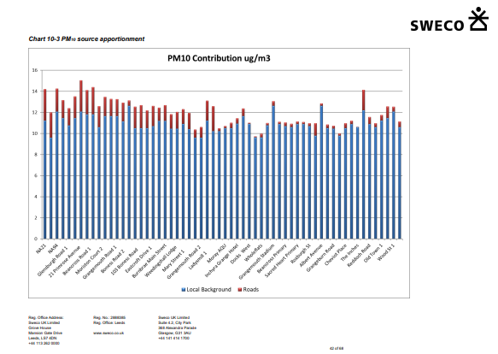

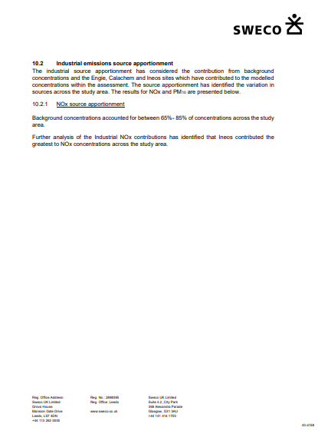

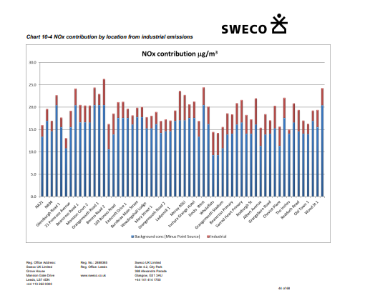

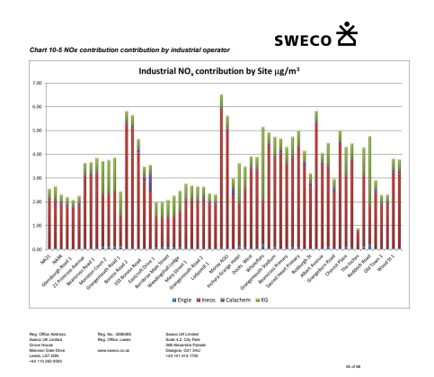

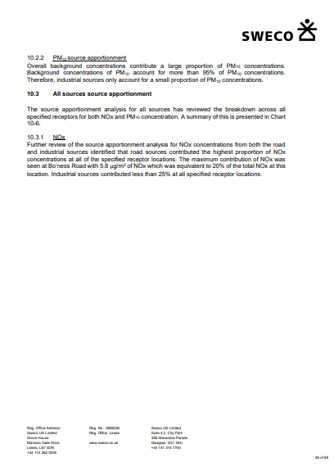

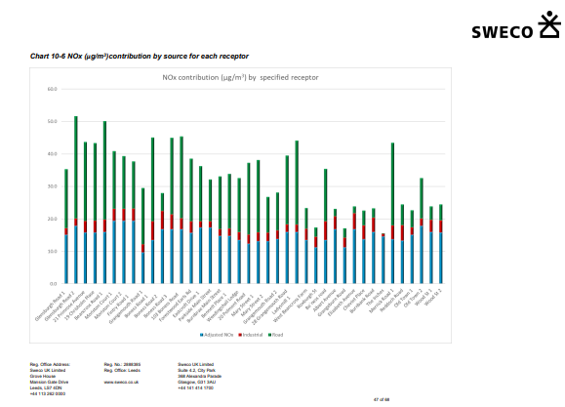

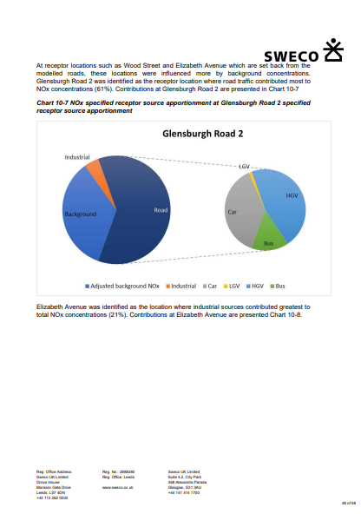

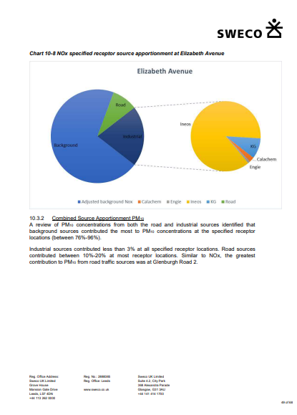

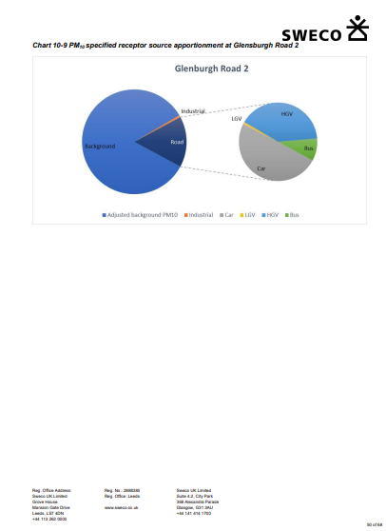

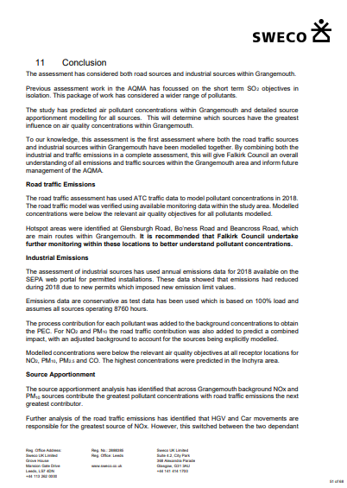

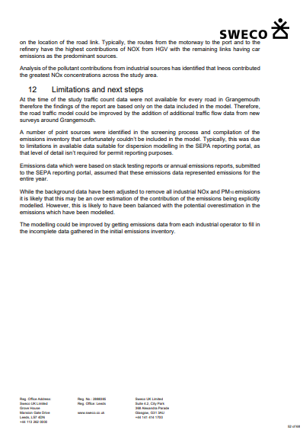

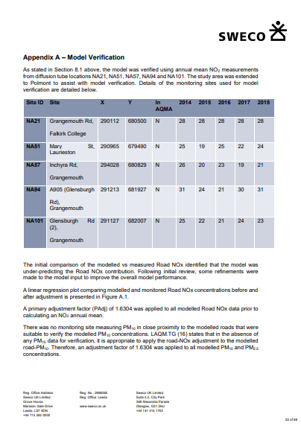

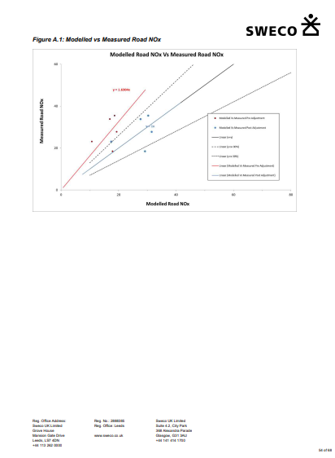

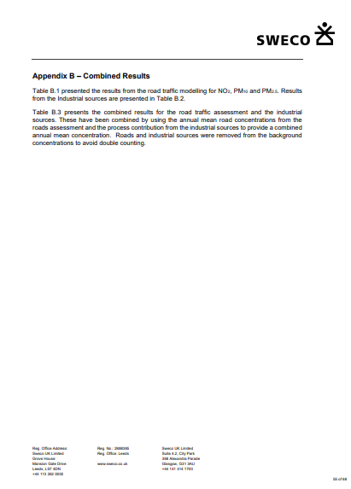

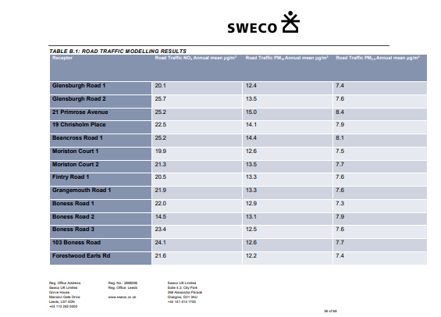

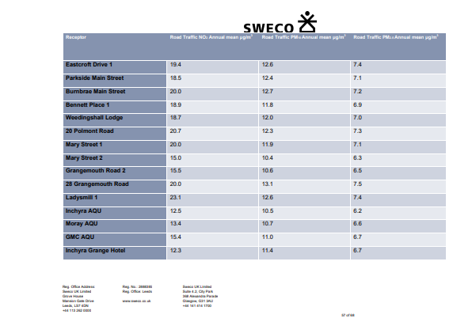

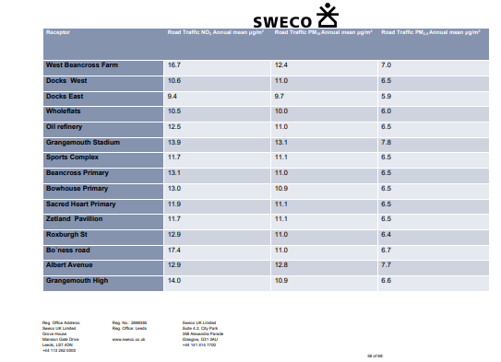

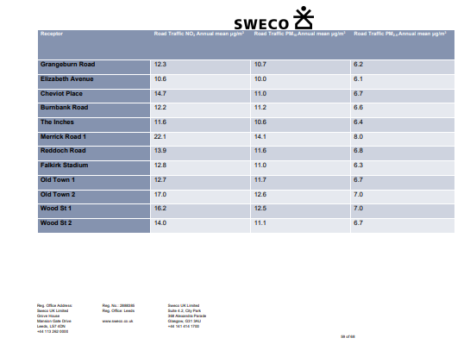

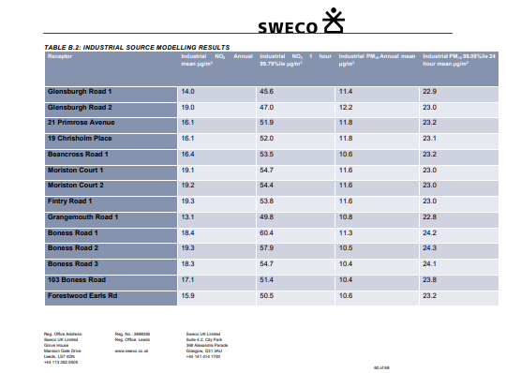

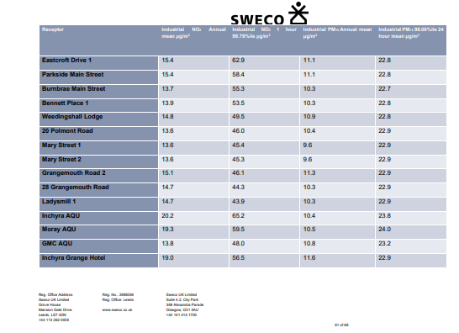

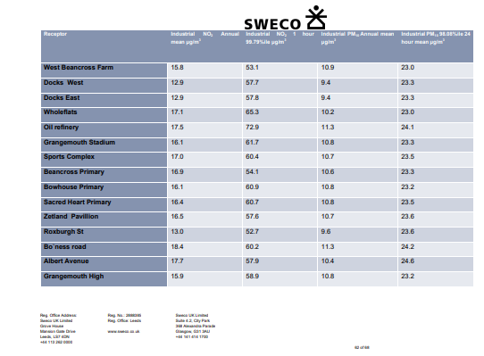

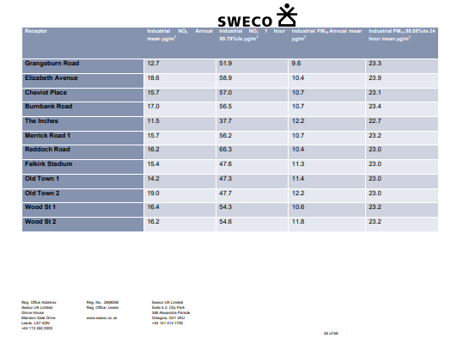

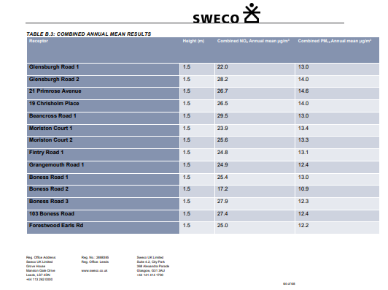

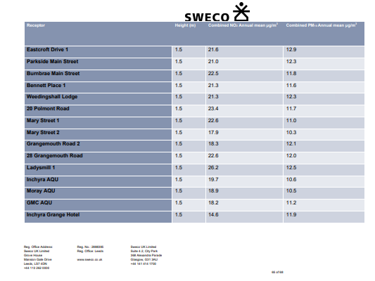

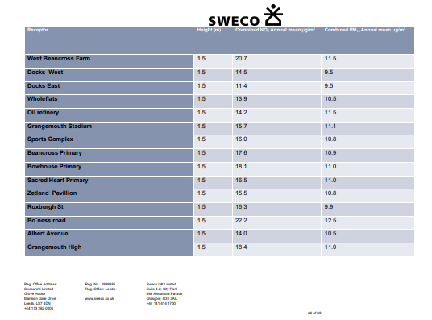

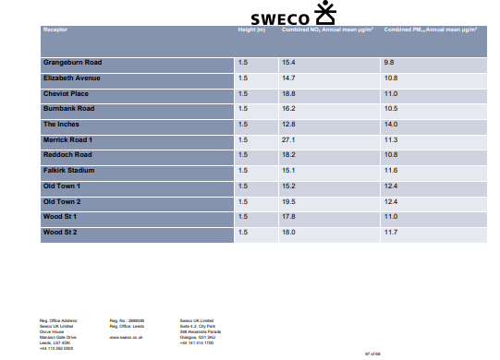



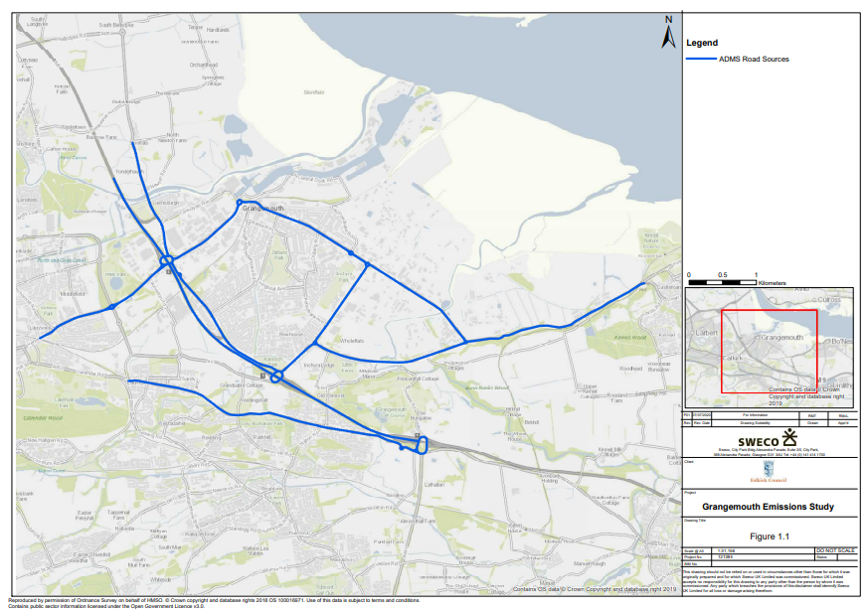

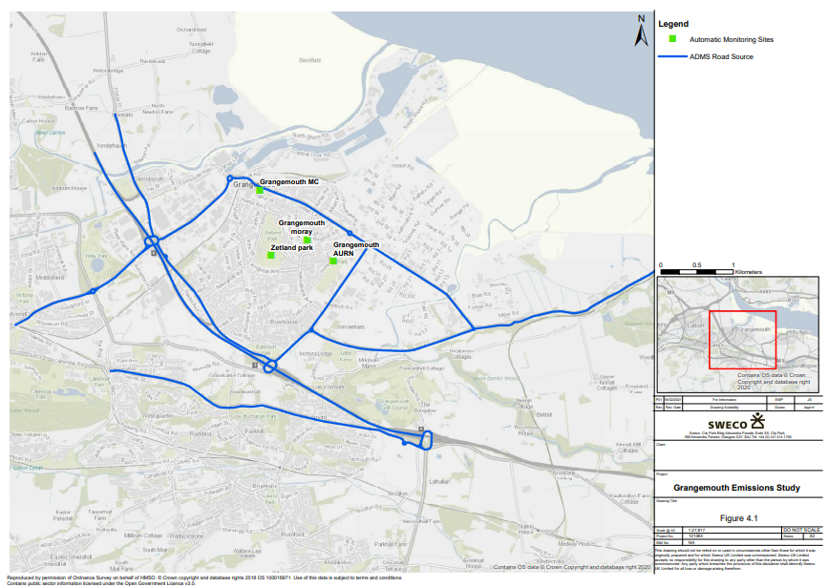

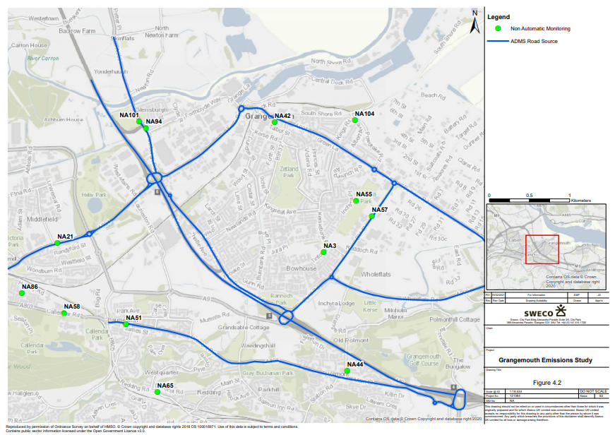

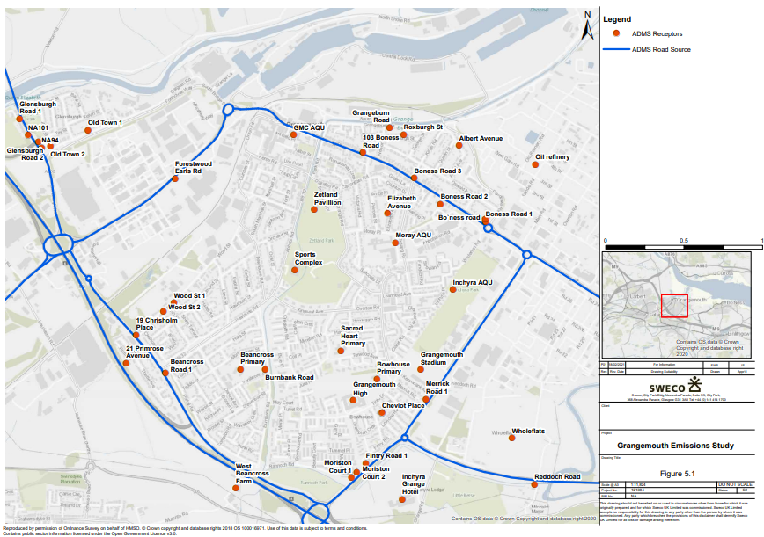

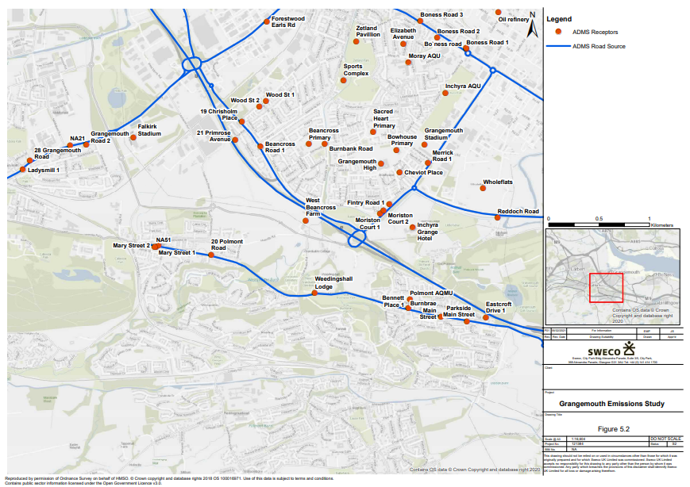

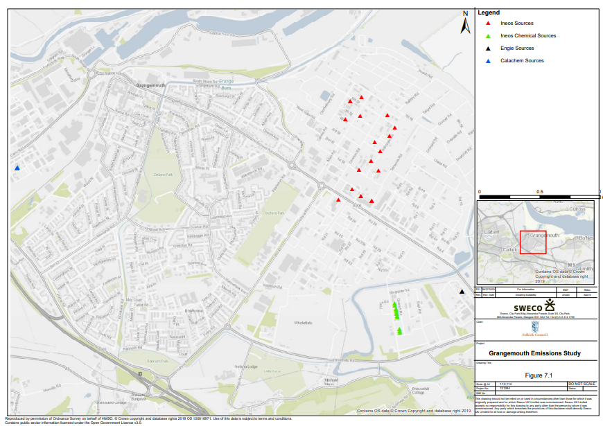

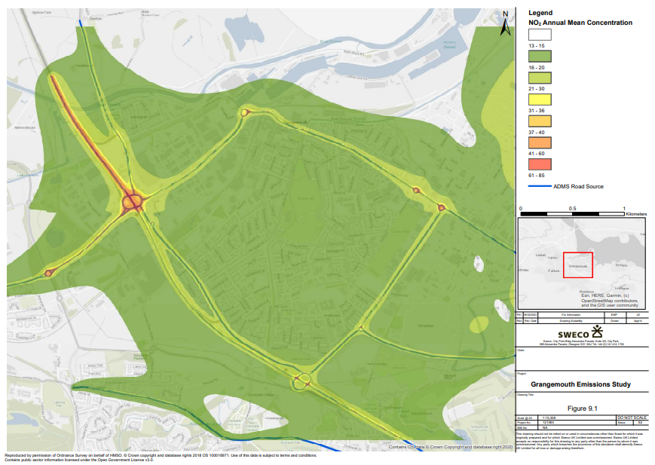

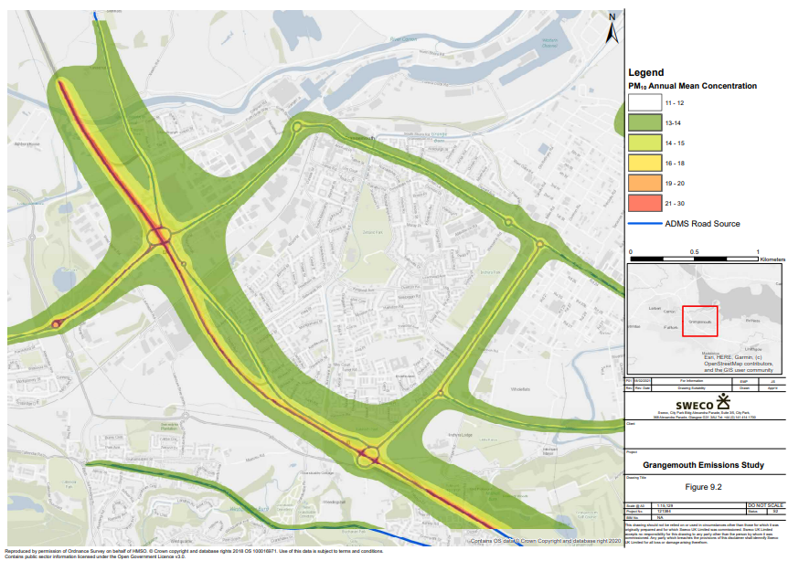

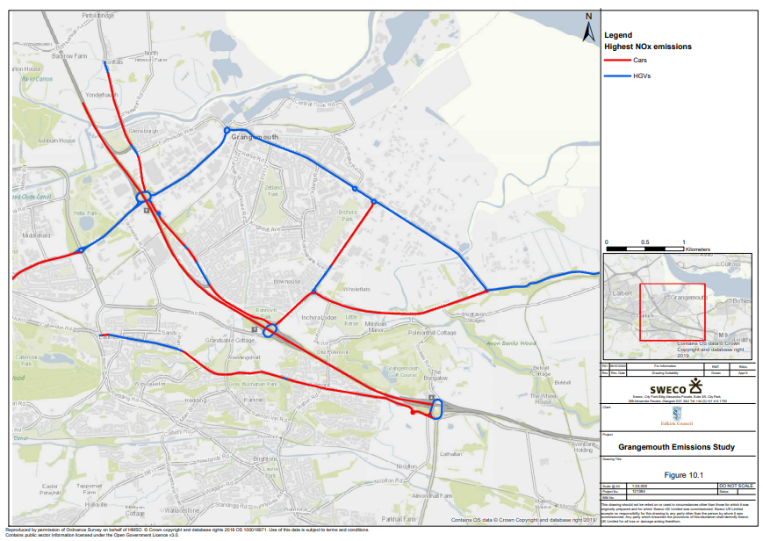
Falkirk Council Proposal for Revocation of Haggs AQMA

QA/QC of Diffusion Tube Monitoring
In 2020 the nitrogen dioxide (NO2), benzene and 1, 3-butadiene ambient air diffusion tubes deployed by Falkirk Council were supplied and analysed by Gradko International Ltd. The analysis method used for the NO2 tubes is 50% tri-ethanolamine (TEA) and 50% acetone. The benzene tube type is Carbograph 1TD (thermal desorption / gas chromatography) and for 1, 3-butadiene the tube type is Carbopack X (ATD) with analysis using TD-GCMS. The diffusion tube monitoring has been completed in adherence with the DEFRA 2020 Diffusion Tube Calendar . The March 2020 sampled diffusion tubes were not changed as normal in early April 2020 due to the Scottish Government ‘Stay at Home’ Scottish Coronavirus (COVID-19) adviceRef 1.
Nitrogen Dioxide Diffusion Tubes
In 2020, the NO2 diffusion tube analysis was completed by Gradko International Ltd. Gradko adheres to the DEFRA guidance for the preparation and analysis of the NO2 diffusion tubes. All the results relating to the concentration of NO2 present on the diffusion tube are within the scope of Gradko’s United Kingdom Accreditation Service (UKAS) accreditation.
The full set of monthly NO2 diffusion tube results are shown in Table B.1 in Appendix B.
1, 3-Butadiene Diffusion Tubes
Gradko International Ltd. Performed the quantitative analysis of 1, 3-butadiene on diffusion tubes by TD-GCMS. Analysis has been completed in accordance with in-house method GLM 13-6 under UKAS fixed scope accreditation.
The full set of monthly 1, 3-butadiene diffusion tube results are shown in Table B.2 in Appendix B.
Benzene Diffusion Tubes
Gradko International Ltd. Analysed Falkirk Council’s benzene diffusion tubes by ATD-GC- MS. Analysis has been completed in accordance with Gradko’s in-house method ‘GLM 4’ under UKAS fixed scope accreditation. The full set of monthly Benzene diffusion tube results are shown in Table B.3 in Appendix B.

Diffusion Tube Annualisation

All diffusion tube monitoring locations within Falkirk Council recorded data capture of 75% therefore it was not required to annualise any monitoring data. In addition, any sites with a data capture below 25% do not require annualisation.

Diffusion Tube Bias Adjustment Factors

Falkirk Council have applied a local bias adjustment factor of 0.94 to the 2020 monitoring data. A summary of bias adjustment factors used by Falkirk Council over the past five years is presented in C.1.

Table C.1 – Bias Adjustment Factor

Year | Local or National | If National, Version of National Spreadsheet | Adjustment Factor
2020 | Local | - | 0.94
2019 | Local | - | 0.94
2018 | Local | - | 0.88
2017 | Local | - | 0.93
2016 | National | 03/17 V2 | 1.03
NO2 Diffusion Tube Bias Adjustment Factor (Local and National)
In accordance with LAQM TG16Ref 2, a locally derived Bias Adjustment Factor has been calculated for the 2020 NO2 diffusion tube results based on the following two co-location sites: NA42 Grangemouth Municipal Chambers and NA111 Falkirk West Bridge Street. The local results have been submitted to the LAQM Helpdesk to contribute to the national bias factor.
The results of the locally derived bias adjustment factor spreadsheets are shown in Figure 27 A) and B)
The national diffusion tube bias adjustment factor spreadsheet is displayed in Figure 28 for comparison purposes. The overall national bias factor in 2020 was 0.82.
A comparison in summary form of the local and national bias factor summary is shown in table C.2.

Table C.2 – Comparison of Local vs National Bias Factor Summary

Local NO₂ Bias Adjustment Factor | 0.94
National NO₂ Bias Adjustment Factor | 0.82
Difference | -0.12
In accordance with LAQM TG16Ref 2 Box 7.11 – data quality checks of the local bias adjustment spreadsheet have been assessed as ‘good’ for both co-location sites. Falkirk Council have a full years’ worth of co-location data at the representative locations (A10 Grangemouth Municipal Chambers: Urban background / Industrial – typical off-street urban location that is likely to measure traffic and industrial emissions. A7 West Bridge Street: roadside – traffic related, elevated NO2 levels at typical daytime peak traffic periods).
Using the above reasons, it has been decided to apply the locally derived bias adjustment factor for the 2020 NO2 diffusion tube results.

NO2 Fall-off with Distance from the Road

No diffusion tube NO2 monitoring locations within Falkirk Council required distance correction during 2020.


Without CV>20 With all data 41% 41%
19.0% 19.0%
50%

25%

0%
Without CV>20% With al l da ta

-25%

-50%
Diffusion Tube Bias B
Figure 28 – NO2 Locally Derived Bias Adjustment Factor Spreadsheets


- A10 Grangemouth Municipal Chambers
Checking Precision and Accuracy of Triplicate Tubes
It is necessary to have results for at least two tubes in order to calculate the precisi
(Check average CV & DC from Accuracy calculations)
Jaume Targa, for AEA
Version 04 - February 2011
Diffusion Tubes Measurements
Period | Start Date  dd/mm/yyyy | End Date  dd/mm/yyyy | Tube 1  µgm ⁻³ | Tube 2  µgm ⁻³ | Tube 3  µgm ⁻ ³ | Triplicate Mean | Standard Deviation | Coefficient  of Variation (CV) | 95% CI  of mean
1 | 08/01/2020 | 04/02/2020 | 16.3 | 21.1 | 21.2 | 20 | 2.8 | 14 | 6.9
2 | 05/02/2020 | 03/03/2020 | 16.7 | 16.8 | 19.4 | 18 | 1.5 | 9 | 3.8
3 | 04/03/2020 | 31/03/2020 | 13.7 | 15.0 | 13.9 | 14 | 0.7 | 5 | 1.7
4 | 01/04/2020 | 28/04/2020
5 | 29/04/2020 | 02/06/2020 | 10.0 | 9.2 | 9.8 | 10 | 0.4 | 4 | 1.0
6 | 03/06/2020 | 30/06/2020 | 11.0 | 10.8 | 10.7 | 11 | 0.2 | 2 | 0.5
7 | 01/07/2020 | 28/07/2020 | 9.6 | 9.4 | 9.8 | 10 | 0.2 | 2 | 0.5
8 | 29/07/2020 | 01/09/2020 | 12.8 | 12.6 | 12.7 | 13 | 0.1 | 1 | 0.2
9 | 02/09/2020 | 29/09/2020 | 16.3 | 16.7 | 15.1 | 16 | 0.8 | 5 | 2.0
10 | 30/09/2020 | 03/11/2020 | 17.2 | 15.7 | 18.3 | 17 | 1.3 | 8 | 3.3
11 | 04/11/2020 | 01/12/2020 | 23.0 | 23.8 | 23.7 | 23 | 0.4 | 2 | 1.0
12 | 02/12/2020 | 05/01/2021 | 25.0 | 26.2 | 25.8 | 26 | 0.6 | 2 | 1.4
13

Grangemouth Municipal Chambers
Site Name/ ID:
 | Automatic Method |  | Data Quality Check
 | Period Mean | Data  Capture (% DC) | Tubes  Precision Check | Automatic  Monitor Data
 | 15 | 95 | Good | Good
 | 15 | 97 | Good | Good
 | 15 | 99 | Good | Good
 | 9 | 98 |  | Good
 | 8 | 77 | Good | Good
 | 7 | 92 | Good | Good
 | 5 | 100 | Good | Good
 | 7 | 99 | Good | Good
 | 11 | 100 | Good | Good
 | 12 | 97 | Good | Good
 | 16 | 99 | Good | Good
 | 21 | 99 | Good | Good
on of the measurements Overall survey --> |  |  | Good  precision | Good  Overall DC
Precision 11 out of 11 periods have a CV smaller than 20%

Accuracy (with 95% confidence interval)
without periods with CV larger than 20%
Bias calculated using 11 periods of data Bias factor A 0.75 (0.66 - 0.87)
Bias B 34% (15% - 53%)
Diffusion Tubes Mean: 16 µgm⁻³
Mean CV (Precision): 5
Automatic Mean: 12 µgm⁻³ Data Capture for periods used: 96%
Adjusted Tubes Mean: 12 (11 - 14) µgm⁻³

Accuracy (with 95% confidence interval)
WITH ALL DATA
Bias calculated using 11 periods of data Bias factor A 0.75 (0.66 - 0.87)
Bias B 34% (15% - 53%)
Diffusion Tubes Mean:  Mean CV (Precision): | 16 µgm⁻³  5
Automatic Mean: 12 µgm⁻³ Data Capture for periods used: 96%
Adjusted Tubes Mean: | 12 (11 - 14) | µgm⁻³

- A7 Falkirk West Bridge St

Checking Precision and Accuracy of Triplicate Tubes

Diffusion Tubes Measurements
Period | Start Date  dd/mm/yyyy | End Date  dd/mm/yyyy | Tube 1  µgm ⁻³ | Tube 2  µgm ⁻³ | Tube 3  µgm ⁻ ³ | Triplicate Mean | Standard Deviation | Coefficient  of Variation (CV) | 95% CI  of mean
1 | 08/01/2020 | 04/02/2020 | 35.2 | 35.3 | 34.0 | 35 | 0.7 | 2 | 1.8
2 | 05/02/2020 | 03/03/2020 | 30.5 | 37.4 | 33.2 | 34 | 3.5 | 10 | 8.6
3 | 04/03/2020 | 31/03/2020 | 29.3 | 29.3 | 31.7 | 30 | 1.4 | 5 | 3.5
4 | 01/04/2020 | 28/04/2020
5 | 29/04/2020 | 02/06/2020 | 22.5 | 23.3 | 22.6 | 23 | 0.4 | 2 | 1.1
6 | 03/06/2020 | 30/06/2020 | 29.8 | 29.7 | 30.2 | 30 | 0.3 | 1 | 0.6
7 | 01/07/2020 | 28/07/2020 | 19.9 | 22.1 | 22.1 | 21 | 1.3 | 6 | 3.2
8 | 29/07/2020 | 01/09/2020 | 35.8 | 36.6 | 33.2 | 35 | 1.7 | 5 | 4.3
9 | 02/09/2020 | 29/09/2020 | 34.5 | 33.9 | 34.1 | 34 | 0.3 | 1 | 0.7
10 | 30/09/2020 | 03/11/2020 | 30.9 | 36.1 | 32.4 | 33 | 2.7 | 8 | 6.7
11 | 04/11/2020 | 01/12/2020 | 36.3 | 36.4 | 39.6 | 37 | 1.8 | 5 | 4.6
12 | 02/12/2020 | 05/01/2021 | 44.2 | 43.4 | 45.9 | 45 | 1.3 | 3 | 3.2
13

It is necessary to have results for at least two tubes in order to calculate the precisi
 | Automatic Method |  | Data Quality Check
 | Period Mean | Data  Capture (% DC) | Tubes  Precision Check | Automatic  Monitor Data
 | 24 | 99 | Good | Good
 | 27 | 100 | Good | Good
 | 28 | 100 | Good | Good
 | 22 | 100 |  | Good
 | 16 | 88 | Good | Good
 |  |  | Good
 | 17 | 81 | Good | Good
 | 29 | 100 | Good | Good
 | 28 | 100 | Good | Good
 | 30 | 100 | Good | Good
 | 28 | 100 | Good | Good
 | 35 | 100 | Good | Good
on of the measurements Overall survey --> |  |  | Good  precision | Good  Overall DC
Precision 11 out of 11 periods have a CV smaller than 20%

Falkirk West Bridge Street
Site Name/ ID:

Accuracy (with 95% confidence interval)
without periods with CV larger than 20%
Bias calculated using 10 periods of data Bias factor A 0.8 (0.75 - 0.86)
Bias B 25% (16% - 34%)
Diffusion Tubes Mean: 33 µgm⁻³
Mean CV (Precision): 5
Automatic Mean: 26 µgm⁻³ Data Capture for periods used: 97%
Adjusted Tubes Mean: 26 (25 - 28) µgm⁻³


(Check average CV & DC from Accuracy calculations)
Without CV>20 With all data 26% 26%
8.7% 8.7%
50%

25%

0%
Without CV>20% With al l da ta

-25%

-50%
Diffusion Tube Bias B
Accuracy (with 95% confidence interval)
WITH ALL DATA
Bias calculated using 10 periods of data Bias factor A 0.8 (0.75 - 0.86)
Bias B 25% (16% - 34%)
Diffusion Tubes Mean:  Mean CV (Precision): | 33 µgm⁻³  5
Automatic Mean: 26 µgm⁻³ Data Capture for periods used: 97%
Adjusted Tubes Mean: | 26 (25 - 28) | µgm⁻³

Jaume Targa, for AEA Version 04 - February 2011

- Calculation of Two Colocation Results: A10 Grangemouth Municipal Chambers and A7 Falkirk West Bridge St

 | FWBS (%) | GMC (%) | Average (%) | 2 Locations Factor | Inverse to give Bias Adjustment factor
Bias Factor B | 25 | 34 | 29.5 | 1.065 | 0.94

QA/QC of Automatic Monitoring
Table C. 3 – Details of the QA / QC at the Automatic Monitoring Stations in 2020

QA / QC in 2020
Site | Analyser | Network
A3. Bo’ness | SO2 | SAQN
A4. Falkirk Haggs | NOx | SAQN
A4. Falkirk Haggs | PM10+2.5 (Fidas) | SAQN
A5. Falkirk Hope St | NOx | SAQN
A5. Falkirk Hope St | SO2 | SAQN
A5. Falkirk Hope St | PM10+2.5 (Fidas) | SAQN
A7. Falkirk West Bridge St | NOx | SAQN
A7. Falkirk West Bridge St | PM10+2.5 (Fidas) | SAQN
A8. Grangemouth AURN (Inchyra) | NOx | AURN
A8. Grangemouth AURN (Inchyra) | PM10 (BAM) | AURN
A8. Grangemouth AURN (Inchyra) | PM2.5 (BAM) | AURN
A8. Grangemouth AURN (Inchyra) | SO2 | AURN

LAQM Annual Progress Report 2021

A9. Grangemouth Moray | NOx | AURN
A9. Grangemouth Moray | SO2 | SAQN
A10. Grangemouth Municipal Chambers | NOx | SAQN
A10. Grangemouth Municipal Chambers | PM10+2.5 (Fidas) | SAQN
A10. Grangemouth Municipal Chambers | SO2 | SAQN
A11. Grangemouth Zetland Park | SO2 | SAQN
A11. Grangemouth Zetland Park | PM10+2.5 (Fidas) | SAQN
A14. Banknock 3 | PM10+2.5 (Osiris) | Local
A15 Main St Bainsford | NOx | SAQN
A15 Main St Bainsford | PM10+2.5 (Fidas) | SAQN

Local sites:
- Analyser data is downloaded, and a flow check is completed on a fortnightly basis.
- A filter change is completed on an approximate four weekly basis, although this is dependent on the weather and filter loading. The filters are retained for analysis.
- As with the other sites all LSO site visits are completed by Falkirk Council staffs that are audited to AURN standards.
- The Turnkey Osiris at Banknock 3 site is serviced on an annual basis and covered by a service agreement for any breakdowns, both are completed off-site.
AURN and Scottish AQ network sites:
- All NOx and SO2 analysers receive fortnightly zero and span checks and filter changes.
- TEOM heads are cleaned and the filter changed on a four weekly basis or more frequently if the filter loading increases above 90%.
- BAM PM10 and PM2.5 nozzles are cleaned and tapes are changed every eight weeks.
- All LSO site visits are carried out by Falkirk Council staffs that are audited to AURN standards.

- Analysers are covered by an emergency callout contract and receive a service every six months.
- QA / QC are conducted to AURN / ‘national’ standards.
- Falkirk Council also checks the data on its internal systems and is in regular communication with Ricardo to ensure the best data quality is collected / presented. Unscaled data is supplied by Falkirk Council to Ricardo for the Scottish AQ Network sites on a six-monthly basis to improve data capture

PM10 and PM2.5 Monitoring Adjustment
All PM10 R&P TEOM data from 2008 onwards has been adjusted using the King’s College London Volatile Correction Method (VCM). This was carried out by Ricardo for the sites affiliated to the Scottish Air Quality Network in 2015 as part of the Scottish Government’s contract.
The PM10 monitor at the A8 Grangemouth AURN site has been a FDMS since April 2009 and so no correction factor has been applied to the data after this date. The VCM has been applied to the 2008 and 2009 AURN TEOM data by King’s College under contract to DEFRA. A PM10 Met One 1020 BAM analyser has replaced the R&P TEOM FDMS at the A8 Grangemouth AURN site on 06/06/2018 and no correction factor has been applied to this PM10 data since the installation of this analyser.
Estimating PM2.5 from PM10 Measurements
LAQM TG (16) ^{Ref} ² describes two methodologies for estimating PM2.5 from PM10 measurements. Method one is to apply a locally derived correction ratio calculated from local sites measuring both PM10 and PM2.5. The second is to apply a nationally derived correction ratio of 0.7. The national correction ratio should only be used where no appropriate local sites measuring both PM10 and PM2.5 are available. The locally derived correction ratio should only be used at sites of the same classification.
In 2020, Falkirk Council had five local sites monitoring both PM10 and PM2.5 these were the A4 Haggs, A7 Falkirk West Bridge St, A8 Grangemouth AURN, A10 Grangemouth Municipal Chambers and A14 Banknock 3 sites.
Using the guidance stated in LAQM TG (16)^{Ref} ² the PM2.5 / PM10 ratios were calculated for the A5 Falkirk Hope Street and A15 Main Street Bainsford sites only as although these sites now have a combined PM10+2.5 analyser (Palas Fidas 200) installed in early 2021 there is insufficient data available for 2020 as these sites operated with R&P TEOM

analysers. The ratio derived from the A4 Haggs data was applied to sites classified as ‘roadside (non-urban)’, the ratio derived from the A8 Grangemouth AURN data was applied to sites classified as ‘urban background / industrial’ and the ratio derived from the A7 Falkirk West Bridge St data was applied to sites classified as ‘roadside (urban)’.
The local correction ratios were used to estimate PM2.5 from PM10 measurements at the following sites: A5 Falkirk Hope Street and A15 Main St Bainsford. Results are shown in Table A12 in Appendix A. Table C. 1 displays how the local ratios have been derived.

Table C.2 – Locally Derived PM2.5 / PM10 Correction Ratio

Site | Site Type | Annual Average PM10 (µg/m³), 2020 | Annual Average PM2.5 (µg/m³),  2020 | Ratio
A4 Haggs | Roadside (Non-urban) | 10 | 5 | 0.5
A7 Falkirk West Bridge St | Roadside (Urban) | 7 | 4 | 0.57
A8 Grangemouth AURN | Urban Background / Industrial | 9 | 6 | 0.67

Automatic Monitoring Annualisation

From assessing all automatic and non-automatic monitoring results, the sites and associated pollutants that required annualisation are as follows:
Site ID | Site Type | Monitoring Type | Valid Data Capture for  Monitoring Period (%) (1) | Valid Data Capture 2020  (%) (2) | NO2 Annual Mean Concentration (µg/m³) ⁽³⁾
 |  |  |  |  | 2016 | 2017 | 2018 | 2019 | 2020
A15 | Main St, Bainsford | Automatic | 65 | 65 | 24 | 23 | 22 | 25 | 20.8

Annual Mean PM10 Monitoring Results (µg/m³)
Site ID | Site Type | Valid Data Capture for Monitoring Period (%) ⁽¹⁾ | Valid Data Capture 2020 (%)  (2) | 2016 | 2017 | 2018 | 2019 | 2020
A4 | Falkirk Haggs | 56 | 56 | 14 | 12 | 14 | 14 | 10
A7 | Falkirk West Bridge St | 38 | 38 | 15 | 10 | 6 | 11 | 8.4
A10 | Grangemouth Municipal Chambers | 63 | 63 | 13 | 12 | 12 | 14 | 9.6
A14 | Banknock 3 | 63 | 63 | n/n | 7 | 6.9 | 7.9 | 7.8
Annual Mean PM2.5 Monitoring Results (µg/m³)
Site ID | Site Type | Valid Data Capture for Monitoring  Period (%) (1) | Valid Data Capture 2020 (%) (2) | 2016 | 2017 | 2018 | 2019 | 2020
A4 | Falkirk Haggs | 29 | 29 |  |  |  |  | 5
A7 | Falkirk West Bridge St | 38 | 38 | 6 | 6 | 6 | 6 | 4.4
A10 | Grangemouth Municipal Chambers | 63 | 63 |  |  |  |  | 4.4
A14 | Banknock 3 | 63 | 63 | n/a | 3 | 4 | 4.6 | 3.6

NO2 Fall-off with Distance from the Road

No automatic NO2 monitoring locations within Falkirk Council required distance correction during 2020.

Table C.2 – Annualisation Summary (concentrations presented in µg/m3)

NO2 Annual Mean Concentration (µg/m³)
Site ID | Annualisation Factor:  A4 Haggs | Annualisation Factor: A7 Falkirk West Bridge St | Average Annualisation Factor | Raw Data Annual Mean | Annualised Annual Mean | Comments
A15 Main Street Bainsford | 1.3 | 1.3 | 1.3 | 16 | 20.8 | Period Mean: Jan – Sep 2020
Annual Mean PM10 Monitoring Results (µg/m³)
Site ID | Annualisation Factor:  A5 Falkirk Hope St | Annualisation Factor: A8 Grangemouth AURN | Average Annualisation Factor | Raw Data Annual Mean | Annualised Annual Mean | Comments
A4 Haggs | 1 | 1 | 1 | 10 | 10 | Period Mean: Jan-Apr, Sep-Dec
A7 Falkirk West Bridge Street | 1.2 | 1.1 | 1.2 | 7 | 8.4 | Period Mean: Jan, Sep-Dec
A10 Grangemouth Municipal Chambers | 1.1 | 1.2 | 1.2 | 8 | 9.6 | Period Mean: May - Dec
A14 Banknock 3 | 0.9 | 1 | 1 | 7.8 | 7.8 | Period Mean: Jan - Aug
Annual Mean PM2.5 Monitoring Results (µg/m³)
Site ID | Annualisation Factor: A8 Grangemouth AURN |  | Average  Annualisation Factor | Raw Data Annual Mean | Annualised  Annual Mean | Comments
A4 Haggs | 1.2 |  | 1.2 | 5 | 6 | Grangemouth AURN was the only site in 2020 to achieve  above 85% data capture. Period Mean: Aug - Dec
A7 Falkirk West Bridge Street | 1.1 |  | 1.1 | 4 | 4.4 | ““Period Mean: Jan, Sep-Dec

NO2 Annual Mean Concentration (µg/m³)
Site ID | Annualisation Factor:  A4 Haggs | Annualisation Factor: A7 Falkirk West Bridge St | Average Annualisation Factor | Raw Data Annual Mean | Annualised Annual Mean | Comments
A10 Grangemouth Municipal Chambers | 1.1 |  | 1.1 | 4 | 4.4 | ““Period Mean: May - Dec
A14 Banknock 3 | 0.9 |  | 0.9 | 4 | 3.6 | ““Period Mean: Jan - Aug

Table C.3 – Local Bias Adjustment Calculations

 | Local Bias Adjustment Input 1 – Falkirk West Bridge Street | Local Bias Adjustment Input 2 – Grangemouth Municipal Chambers
Periods used to calculate bias | 11 | 11
Bias Factor A | 0.8 (0.75 – 0.86) | 0.75 (0.66 – 0.87)
Bias Factor B | 25% (16% - 34%) | 34% (15% - 53%)
Diffusion Tube Mean (µg/m³) | 33 | 16
Mean CV (Precision) | 5 | 5
Automatic Mean (µg/m³) | 26 | 12
Data Capture | 97% | 96%
Adjusted Tube Mean (µg/m³) | 26 (25 – 28) | 12 (11 – 14)
Notes:
A combined local bias adjustment factor of 0.94 has been used to bias adjust the 2020 diffusion tube results.

Glossary of Terms

Abbreviation | Description
AADT | Annual Average Daily Traffic – total volume of vehicle traffic on a highway or road for a year divided by 365 days.
AQAP | Air Quality Action Plan – A detailed description of measures, outcomes, achievement dates and implementation methods, showing how the LA intends to achieve air quality limit values’
AQMA | Air Quality Management Area – An area where air pollutant concentrations exceed / are likely to exceed the relevant air quality objectives. AQMAs are declared for specific pollutants and objectives
APR | Annual Progress Report in relation to air quality
AURN | Automatic Urban and Rural Network (UK air quality monitoring network)
BAM | Beta Attenuation Monitor
CAFS | Cleaner Air for Scotland
DEFRA | Department for Environment, Food and Rural Affairs
DMRB | Design Manual for Roads and Bridges – Air quality screening tool produced by Highways England
ECSVEP | East Central Scotland Vehicle Emissions Partnership
EfW | Energy from Waste
EIA | Environmental Impact Assessment
EPUK | Environmental Protection UK
EU | European Union
FEL | Forth Environment Link
FDMS | Filter Dynamics Measurement System
FPS | Flood Prevention Scheme
GCMS | Gas Chromatography–Mass Spectrometry - analysis method
HDV | Heavy Duty Vehicle
LAQM Annual Progress Report 2021

IAQM | Institute of Air Quality Management
LAQM | Local Air Quality Management
LDV | Light Duty Vehicle
MCPD | Medium Combustion Plant Directive
NAQS | National Air Quality Strategy
NO2 | Nitrogen Dioxide
NOx | Oxides of Nitrogen
PDU | Public Display Unit
PM10 | Airborne particulate matter with an aerodynamic diameter of 10µm (micrometres or microns) or less
PM2.5 | Airborne particulate matter with an aerodynamic diameter of  2.5µm or less
PV | Photovoltaic (in relation to solar energy)
QA/QC | Quality Assurance and Quality Control
SEA | Supporting Environmental Appraisal
SEPA | Scottish Environment Protection Agency
SO2 | Sulphur Dioxide
TD | Thermal Desorption – Analysis Method
TEOM | Tapered Element Oscillating Microbalance
TGT | Tail Gas Treatment

References
  - https://www.gov.scot/coronavirus-covid-19/ The Scottish Government ‘Coronavirus (Covid-19) in Scotland’ Information, 11 May 2021.
  - https://laqm.defra.gov.uk/technical-guidance/ DEFRA and Devolved Administrations, April 2021.
  - Civil Aviation Authority, UK Airport Statistics, CAA, Accessed June 2021.
  - Institute of Air Quality Management (IAQM) 'Guidance on the Assessment of Dust from Demolition and Construction'. Version 1.1, February 2014.
  - IAQM Land-Use Planning & Development Control: Planning for Air Quality January 2017

LAQM Annual Progress Report 2021

